
FEDERAL TECHNICAL AND VOCATIONAL TRAINING INSTITUTE (FTVTI) SCHOOL OF GRADUATE STUDIES
DEVELOPMENT AND CHARACTERIZATION OF ECO-FRIENDLY COMPOSITE MATERIAL FROM CORNSTALK AND JUTE FIBER FOR SUSTAINABLE EGG TRAY PACKAGING

BY: FITIHALEM DEBEBE
ADVISOR: Dr. Tolera A.

February, 2026
ADDIS ABABA, ETHIOPA

DEVELOPMENT AND CHARACTERIZATION OF ECO-FRIENDLY COMPOSITE MATERIAL FROM CORNSTALK AND JUTE FIBER FOR SUSTAINABLE EGG TRAY PACKAGING
A THESIS SUBMITTED TO FEDERAL TECHNICAL AND VOCATIONAL TRAINING INSTITUTE
FACULTY OF TEXTILE AND APPAREL FASHION TECHNOLOGY
(DEPARTMENT OF TEXTILE TECHNOLOGY)
IN PARTIAL IN FULFILLMENT FOR THE DEGREE MASTER OF SCIENCE IN TEXTILE TECHNOLOGY

BY: FITIHALEM DEBEBE
ADVISOR: Dr. Tolera A.

February, 2026
ADDIS ABABA, ETHIOPA

FEDERAL TECHNICAL AND VOCATIONAL TRAINING INSTITUTE (FTVTI)

FACULTY OF TEXTILE AND APPARAL FASHION TECHNOLOGY
(DEPARTMENT OF TEXTILE TECHNOLOGY)

APPROVAL SHEET
APPROVED BY EXAMINING BOARD
BY: FITIHALEM DEBEBE

Name of Advisor  Dr. Tolera Aderie |  | Signature |  |  |  | Date
Name of Co-advisor |  | Signature |  |  |  | Date
Name of Examiner, Internal |  | Signature |  |  |  | Date
Name of chairperson |  | Signature |  |  |  | Date

Declaration
I, undersign and declare that this thesis entitled” development and characterization of eco-friendly composite material from cornstalk and jute fiber for sustainable egg tray packaging will my original work carrying out under the supervisor of Dr. Tolera Aderie It has not been presenting for a degree in this or any other university, and all source of materials using for the thesis have been fully acknowledged

Name of Candidate Signature Date

------------------------ ___________ ___________

This is to certify that the above declaration made by the candidate is correct to the best of my knowledge

Name of Advisor Signature Date

--------------------------- ___________ ________
Name of Co-Advisor Signature Date
––––––––––––––– ____________ ________

Table of Content
Declaration iii
Acronyms vii
List of Figure viii
List of Table ix
CHAPTER ONE 1
INTRODUCTION 1
1.1 Background of the Research 1
1.2 Statement of the Problem 2
1.3 Objective 4
1.3.1 General Objective 4
1.3.2 Specific Objective 4
1.4 Basic Research Question 4
1.5 Hypothesis of the Research 4
1.5.1 Null Hypothesis 5
1.5.2 Alternative Hypothesis 5
1.6 Significance of the Research 5
1.7 Scope of the Study 6
1.8 Limitation of the Research 6
1.9 Definition Terms 7
CHAPTER TWO 9
LITERATURE REVIEW 9
2.1 Cornstalk and jute fiber composite materials 9
2.2 Method of composite material development 9
2.2.1 Preparation of Cornstalk and Jute Fiber 9
2.2.2 Blending of Cornstalk and Jute Fiber 10
2.2.3 Fabrication of Composite Materials 10
2.2.4 Characterization of Composite Materials 10
2.2.5 Applications of Composite Materials in Egg Tray Packaging 11
2.3 Methods of characterization 11
2.4 Implications of sustainable packaging 11
2.5 Jute fiber 12
2.6 Cornstalk 12
2.7 Sustainable egg tray packaging 13
2.8 Characteristic of composite materials made of jute and cornstalk fiber 13
2.9 Jute and cornstalk fiber composite materials' adhesiveness property 13
2.10 Application of Composite Materials in Textiles 14
2.11 Manufacturing process of egg tray 14
2.12 Mechanical properties of biopolymer composites 14
2.13 Egg tray making material 14
2.14 Literature Gap 15
CHAPTER THREE 16
MATERIALS AND METHODS 16
3.1 Material 16
3.1.1 Tools for Cornstalk Fiber Extraction 18
3.2 Technique of fabrication 19
3.3 Research variable 21
3.3.1 Dependent Variable 21
3.3.2 Independent variable 22
3.4 Experimental Design 22
3.5 Mechanical Testing Procedures 23
3.6 Getting Egg Tray Shapes 23
CHAPTER FOUR 25
RESULT AND DISCUSSION 25
4.1 Introduction 25
4.2 Experimental Design and Statistical Approach 25
4.2.1 Selection of Factors and Levels 25
4.2.2 Design Matrix (DOE Layout) 25
4.3 Physical Properties Analysis 26
4.3.1 Density Analysis 26
4.4 Mechanical Properties Analysis 28
4.4.1 Tensile Strength Analysis 28
4.4.2 Compressive Strength Analysis 29
4.4.4 Impact Strength Analysis 31
4.5 Moisture and Barrier Properties 32
4.5.1 Water Absorption Analysis 32
4.6 Effect of Binder on Physical and Mechanical Properties 34
4.6.1 Effect Binder on Density 34
4.6.2 Effect Binder on Tensile strength 35
4.6.3 Effect Binder on Compression Strength 37
4.6.4 Effect Binder on Impact Strength 39
4.6.3 Effect Binder on Water absorption 40
4.6 Optimization of factors 41
CHAPTER FIVE 44
CONCLUSION AND RECOMMENDATIONS 44
5.1 Conclusion 44
5.2 Recommendations 46
Reference 49

Acronyms
ASTM: American Society for Testing and Materials
DMA: Dynamic Mechanical Analysis
PVA: Polyvinyl Alcohol
PVC: Polyvinyl Chloride
SEM: Scanning electron microscopy

List of Figure
Figure 2. 1: Jute Fiber 12
Figure 2. 2: Cornstalks plant 12
Figure 2.3 2-D Design representation of Egg tray packaging 13
Figure 2. 4 3-D Design Representation of Egg tray packaging 13

Figure 3. 1 Flow Chart Diagram of research procedures 16
Figure 3. 2 ASTM D790 mechanical testing machine 23
Figure 3. 3 Egg Tray Shapes design mold 24

List of Table
Table 3. 1: Significant properties Jute Fiber will be tested befor blending (T. Zhang, Yin, Gong, & Wang, 2020). 19

Abstract
The increasing environmental concerns and reliance on non-biodegradable packaging materials have intensified the search for sustainable alternatives. This study focuses on the development and characterization of an eco-friendly composite material from cornstalk and jute fiber for sustainable egg tray packaging. Agricultural waste, such as cornstalks, and natural fibers like jute are abundant, renewable, and biodegradable, making them promising candidates for environmentally responsible packaging solutions. The research aims to evaluate the feasibility of replacing conventional egg tray materials, such as polystyrene, with a composite that maintains mechanical performance while reducing environmental impact.
The main objectives were to extract cornstalk fibers, determine the appropriate proportion of cornstalk, jute fiber, and binder (PVA) for optimal composite performance, fabricate egg trays, and evaluate their physical and mechanical properties. The study employed a systematic experimental design using the Taguchi method to assess the influence of independent variables—cornstalk fiber content, jute fiber content, and binder content—on density, tensile strength, compressive strength, impact strength, and water absorption.
Results indicated that fiber composition and binder content significantly affect the composite’s performance. Cornstalk fiber contributed to lightweight structure and shock absorption, while jute fiber enhanced tensile and compressive strength. Optimal performance was achieved at 60% cornstalk fiber, 30% jute fiber, and 10.57% binder, resulting in a density of 0.426 g/cm³, tensile strength of 18.61 MPa, compressive strength of 240 kPa, impact strength of 6.34 kJ/m², and controlled water absorption of 30.86%. The findings demonstrate that the developed composite exhibits mechanical properties comparable to conventional materials, while being biodegradable and environmentally sustainable.
In conclusion, the study successfully developed a technically feasible and eco-friendly composite material suitable for egg tray packaging. Adoption of such materials can reduce environmental pollution, promote circular economy practices, and provide cost-effective alternatives to conventional packaging. The research provides a foundation for further industrial-scale application and optimization of natural fiber composites for sustainable packaging solutions.
Keywords: Eco-friendly composite, Cornstalk fiber, Jute fiber, Egg tray packaging, Sustainable materials, Mechanical properties.

CHAPTER ONE

INTRODUCTION

1.1 Background of the Research
Research on the development of sustainable egg tray packaging using eco-friendly composite materials made of jute and cornstalks is crucial in the quest for useful and long-lasting environmentally friendly packaging solutions(Kambli, Basak, & Deshmukh, 2021). Through the utilization of biodegradable matrix materials and an abundance of natural resources, these composite materials have the potential to mitigate environmental degradation and encourage sustainable practices within the packaging sector(Ratna, Ghosh, & Mukhopadhyay, 2022).

A byproduct of corn farming, cornstalks are usually burned or thrown away, which increases greenhouse gas emissions and air pollution(Santolini, Bovo, Barbaresi, Torreggiani, & Tassinari, 2021). Nonetheless, cellulose, hemicellulose, and lignin found in cornstalks may be used to make biodegradable composite materials. These substances can take the place of conventional packaging materials that pollute the environment and take hundreds of years to degrade, including plastic and Styrofoam.

Eco-friendly composite materials can also be made from jute fibers, another plentiful natural resource. Hessian bags, twine, and other items are frequently made from jute, a vegetable fiber. The advantages of jute fibers over synthetic fibers are their strength, biodegradability, and minimal carbon emissions during manufacture(Singh, Singh, Singh, Dhawan, & Tiwari, 2018).

Natural fibers like cornstalk and jute fiber have drawn interest due to their potential use in the creation of composite materials. While jute fibers are derived from the jute plant, cornstalks are agricultural wastes that are left behind after corn is harvested from maize. These raw materials are appealing options for the production of eco-friendly composite materials because they are plentiful, renewable, and biodegradable(Devi, Gupta, Parmar, Jat, & Sisodia, 2017).

When assessing the characteristics and functionality of composite materials made from jute and cornstalk fiber, characterization is essential. Parameters including mechanical strength, thermal stability, water absorption, biodegradability, and general appropriateness for egg tray packaging applications are assessed using a variety of characterization methodologies. Through these evaluations, researchers are better able to comprehend how the composites behave in various scenarios and formulate them to meet certain needs(Wu et al., 2022).

Ultimately, the development of sustainable egg tray packaging solutions is the aim of eco-friendly composite materials made from cornstalk and jute fiber. Comparing these packaging materials to more traditional packaging solutions, there are benefits like biodegradability, a less environmental impact, and maybe lower production costs. This research promotes environmentally conscious practices in the packaging sector and advances the usage of such sustainable alternatives, contributing to the principles of the circular economy(Siracusa & Rosa, 2018).

1.2 Statement of the Problem
One of the major issues in the world of materials science and engineering is the development and characterization of environmentally acceptable and recyclable composite materials. The egg tray packaging convectional made from non-degradable material. That's particularly issue in terms of sustainability and the preservation of the environment due to its non-degradability property. To develop composite materials that can function as egg tray packaging as a reasonable substitute for conventional materials like plastics and polystyrene, we use agricultural waste (cornstalk) and natural fibers (jute).

Plastic materials are essential in Ethiopia's egg production industry, protecting eggs from damage and contamination. However, the high cost of importing these materials, influenced by foreign exchange rates, transportation costs, and import duties, makes it economically unaffordable for small-scale producers. This leads to higher production costs, as producers may resort to cheaper alternatives or traditional methods. This results in higher rates of spoilage, breakage, and loss during transportation and storage, ultimately affecting the profitability of egg production businesses in Ethiopia.

An egg tray is exclusively paper-based; its dimensional stability may be negatively affected due to the material’s susceptibility to moisture and environmental conditions. To ensure the structural integrity of egg trays, manufacturers may need to consider alternative materials or coatings that can enhance dimensional stability and protect against deformation.
Despite the potential of these materials, challenges such as limited awareness, a lack of infrastructure for processing, and market demand constraints contribute to their underutilization. However, with growing interest in sustainability and circular economy practices, there is an opportunity to explore innovative ways to leverage these unutilized resources effectively.
Reasons for its importance given their sustainability, affordability, and functionality, the creation and characterization of environmentally friendly composite materials derived from cornstalk and jute fiber are essential for sustainable egg tray packaging. Comparing these materials to non-renewable alternatives like polystyrene, its environmental effect is lessened because they are biodegradable and renewable. Provide high strength, low weight, and good thermal insulation properties that are better than those of typical egg tray packaging materials.

The packaging industry faces a significant challenge due to a lack of literature and indigenous knowledge on pulp and fiber reinforcing with binders. This gap hinders innovation and advancements as researchers and manufacturers lack comprehensive information on best practices, emerging technologies, and traditional methods. Research and development play a crucial role in addressing these gaps and uncovering new techniques, materials, and processes that can revolutionize packaging material production. As demand for sustainable packaging solutions grows, there is a pressing need for eco-friendly binders and reinforcing agents.

The method of solving the problem the conventional materials used to package egg trays, such as polystyrene and polyurethane, are not biodegradable and greatly increase pollution in the environment. Due to the lengthy decomposition times of these materials, garbage ends up in landfills and the ocean. Furthermore, the greenhouse gases released during the manufacture of these materials exacerbate the issue of climate change. Thus, the development of environmentally friendly composite materials that are both affordable and sustainable can take the place of conventional packaging materials.

The main goal of this research is to describe the creation and properties of environmentally friendly composite materials made of jute and cornstalk fiber. In particular, the work seeks to investigate the potential of using these agricultural leftovers for egg tray packaging as a sustainable substitute for conventional packaging materials. Selection of materials, processing methods, and performance assessment are just some of the areas that will be covered in this release.

1.3 Objective

1.3.1 General Objective
To develop and characterize an eco-friendly composite material derived from cornstalk and jute fibers for sustainable egg tray packaging applications.

1.3.2 Specific Objective
- To extract cornstalk fiber and evaluate the properties of the composite constituents, including jute fiber
- To determine the appropriate composition and weight percentages of cornstalk fiber, jute fiber, and binder for the fabrication of the composite material.
- To characterize the physical and mechanical properties of the developed composite material
- To design and manufacture egg trays from the developed composite material and evaluate their performance for protecting eggs during handling, transportation, and storage.

1.4 Basic Research Question
- How can cornstalk fiber be effectively extracted, and what are the physical and mechanical properties of the composite constituents (cornstalk fiber and jute fiber)?
- What are the appropriate compositions and weight percentages of cornstalk fiber, jute fiber, and binder required to produce a stable and functional composite material?
- What are the physical and mechanical properties (such as density, water absorption, tensile strength, and compressive strength) of the developed composite material?
- How effective are egg trays manufactured from the developed composite material in protecting eggs during handling, transportation, and storage?

1.5 Hypothesis of the Research
The research's hypothesis, "Development and Characterization of Eco-Friendly Composite Material from Cornstalk and Jute Fiber for Sustainable Egg Tray Packaging," looks into the potential of using jute fiber and cornstalk as raw materials for composite materials in an effort to help develop environmentally friendly packaging solutions. Egg tray packaging materials may eventually be replaced by an affordable, environmentally friendly composite material with acceptable qualities, lessening the effect of packaging waste on the environment.

1.5.1 Null Hypothesis
When evaluating eco-friendly composite materials constructed from cornstalk and jute fiber compared to conventional packaging materials, there is no significant distinction in the mechanical qualities, endurance, or sustainability of egg tray packaging. The rejection of the null hypothesis signifies the absence of evidence for the better mechanical strength of the composite material over conventional materials in the event that no discernible difference is discovered.

1.5.2 Alternative Hypothesis
Alternative Hypothesis Compared to conventional packaging materials, egg trays made of composite materials made of cornstalk and jute fiber will function as well as or better than those made of traditional materials, while also being more ecologically friendly.

1.6 Significance of the Research
It is crucial to conduct research, develop, and characterize environmentally friendly composite materials made of jute fiber and cornstalk for egg tray packaging that is sustainable. The research conducted provides a workable substitute for traditional packaging materials that pollute the environment and are not biodegradable, such polystyrene foam.
The goal of the research is to look at the mechanical characteristics of the manufactured, environmentally friendly composite materials and whether or not they are appropriate for use in egg tray packaging. The assessment of these materials' environmental effects and manufacturing process optimization are other key areas of attention for the research. The development and characterization of environmentally friendly composite materials made of jute and cornstalk fiber would help the worldwide drive to promote sustainable practices and lessen packaging waste. The application of the study's results to other industries will promote the adoption of sustainable solutions and aid in the accomplishment of sustainable development objectives.
Research is essential to develop eco-friendly composite materials made of jute and cornstalk fiber, since these materials can lessen their environmental impact and replace traditional packaging materials. A circular economy and waste management are two benefits of using biodegradable materials. As more people become conscious of the necessity of sustainable practices, especially in the egg tray packaging business, research is extremely crucial. The creation and characterization of these materials may open the door to a more environmentally friendly future by encouraging the adoption of sustainable practices by other businesses. The significance of the study resides in its ability to impact the packaging sector and encourage environmentally friendly behaviors, supporting the worldwide endeavor to lower pollution levels and advance a circular economy. The finding is significant because it has the potential to persuade other sectors to embrace environmentally friendly practices.

1.7 Scope of the Study
The scope of creating and evaluating environmentally friendly composite materials made of jute fiber and cornstalk for packaging egg trays that are sustainable. For the creation of environmentally friendly packaging materials, research and development of composite materials derived from agricultural waste, such as cornstalk and jute fiber, have produced encouraging results. An overview of the scope of research and characterization of environmentally friendly composite materials made of jute fiber and cornstalk for sustainable egg tray packaging will be given in this research.

The development and characterization of ecologically friendly composite materials produced from cornstalk and jute fibers have shown promising results in a variety of applications, including packaging such as egg trays. These natural fibers provide environmental benefits as well as the ability to replace conventional polymers made from petroleum. This approach aims to explore what is possible with these ecologically friendly composite materials.

1.8 Limitation of the Research
The endeavor looks into using jute fiber and cornstalk as environmentally friendly composite materials for packaging egg trays in a sustainable manner. Reducing plastic waste and advancing sustainability in the packaging sector are the goals. Nevertheless, the research had drawbacks, including a narrow focus and a dearth of thorough environmental impact assessments. To ascertain the feasibility of these materials, more research into their mechanical characteristics and a cost-effectiveness analysis are required. The research concentrates on manufacturing at the laboratory level, emphasizing the necessity of industrial and scalable production procedures to encourage broad adoption.

1.9 Definition Terms
Development: is the process of developing, improving, or optimizing many kinds of objects, including goods, services, procedures, or organizations. It is an ongoing, continuous process that has to be planned, designed, built, tested, and maintained. The aim of development is to produce something efficient, reliable, and maintainable while simultaneously satisfying the requirements and expectations of users or consumers.
Characterization: The process of characterizing a solid substance involves analyzing its chemical and physical characteristics in order to ascertain its attributes. The right material must be chosen; it might come in a variety of shapes or crystal configurations. Particle size, polymorphism, and morphology are determined by characterization, which influences bulk characteristics, process, stability, and appearance.
Eco-friendly: refers to goods, practices, activities, or ways of living that don't affect the environment. Reducing one's environmental impact, minimizing pollution and waste, conserving resources, and advancing sustainability are all parts of being environmentally friendly.
Composite: Composite materials—also referred to as composites for short—are a class of material composed of two or more constituent materials that differ considerably in terms of their physical or chemical characteristics.
Materials: Substances used to create structures, tools, and other items are called materials. They are selected according to their qualities and intended use, and they can be synthetic or natural.
Cornstalk: is the name given to the maize plant's stem or stalk (Zea mays). Providing support for the maize leaves, tassels, and ears, the cornstalk is the primary structural element of the corn plant.
Jute fiber: is a naturally occurring plant fiber that is long, soft, and smooth and may be spun into strong, coarse threads. It is derived from the Corchorus genus plant, often known as jute. Jute fibers are ecologically benign and biodegradable since their main constituents are cellulose and lignin.
Sustainable: is an acronym for addressing current demands without sacrificing the capacity of future generations to address their own needs. To make sure that resources are used in a way that maintains them throughout time, it entails striking a balance between economic, social, and environmental factors.
Egg: is an oval or spherical body created by a female hen that contains an embryo in the process of developing and is surrounded by nutrients. Usually, the embryo is made up of a more solid yellow yolk and a water-heavy white substance called albumen that are enclosed in a protective shell. There are significant differences in the size, shape, colour, and other attributes of eggs across various animal species.
Tray: is a shallow, plain box or container that's usually used for keeping, transporting, or exhibiting objects. Depending on their intended use, trays can be built of a variety of materials, including plastic, metal, wood, or glass. They can come in a variety of sizes and forms.
Packaging: refers to the process of designing, evaluating, and producing containers or wrappers for a product. It involves the creation of the exterior of a product that serves to contain, protect, promote, inform, and facilitate its transportation and storage.

CHAPTER TWO

LITERATURE REVIEW
The superior mechanical qualities, thermal stability, and low water absorption capacity of eco-friendly composite materials made from cornstalk and jute fiber have shown remarkable promise for sustainable egg tray packaging. In order to improve the performance of these composites for real-world applications, more research is required to tailor the processing parameters, alter the fibers’ surface characteristics, and create novel manufacturing processes.

2.1 Cornstalk and jute fiber composite materials
Due to their potential as sustainable substitutes for conventional packaging materials, cornstalk and jute fiber, two renewable resources, have been attracting attention recently. A common agricultural byproduct in many areas is cornstalks, while the jute plant which is sought after for its strength and durability is the source of jute fibers. Researchers have mixed these two materials to develop composite materials that provide egg tray packaging applications with a combination of strength, flexibility, and biodegradability(Puyana-Romero, Jaramillo Cevallos, & Ciaburro, 2023).

2.2 Method of composite material development
Composite materials are materials that are made by combining two or more different materials to create a new material with enhanced properties. The development of composite materials involves various methods and techniques (Krauklis, Karl, Gagani, & Jørgensen, 2021).
A number of crucial procedures are usually included in the production of environmentally friendly composite materials from cornstalk and jute fiber. To increase the overall performance of the composite material, these may involve using the right binding substances or additives, harvesting the cornstalks and extracting the fibers, treating the jute fibers to improve their qualities, and combining the two types of fibers(Abdur Rahman, Haque, Athikesavan, & Kamaludeen, 2023; Olusanya, Mohan, & Kanny, 2024). This essay will discuss the method of composite material development from cornstalk and jute fiber for sustainable egg tray packaging and the process involves the following steps:

2.2.1 Preparation of Cornstalk and Jute Fiber
The first step in developing composite materials for egg tray packaging is the preparation of cornstalk and jute fiber (Poudel & Karak, 2023). The cornstalks are harvested, cleaned, and cut into small pieces. Then, they are subjected to chemical treatment, including alkali treatment, bleaching, and silane treatment to remove lignin, hemicellulose, and wax from the surface of the fibers. The jute fibers are also prepared by removing impurities, washing, and drying (Devi, Gupta, Parmar, & Jat, 2019).

2.2.2 Blending of Cornstalk and Jute Fiber
After the preparation of cornstalk and jute fiber, they are blended in a specific ratio to achieve the desired properties. The blending ratio can vary depending on the desired properties of the composite material. Generally, a higher proportion of jute fiber is used to improve the mechanical properties of the composite material. The blended fibers are then mixed with a suitable matrix material, such as polypropylene or polyethylene, to form a homogeneous mixture (Devi et al., 2019; Kambli et al., 2021).

2.2.3 Fabrication of Composite Materials
The homogeneous mixture of blended fibers and matrix material is then processed to fabricate composite materials. The most common fabrication methods include compression molding, injection molding, and extrusion. In compression molding, the mixture is placed in a mold and subjected to high pressure and temperature to form a solid composite material (Aladejana, Wu, Fan, & Xie, 2020). In injection molding, the mixture is injected into a mold under high pressure and temperature to form a solid composite material. In extrusion, the mixture is forced through a die under high pressure and temperature to form a continuous sheet or profile (Chong, Law, & Chan, 2021).

2.2.4 Characterization of Composite Materials
After fabrication, the composite materials are characterized to determine their properties. The properties that are typically evaluated include mechanical properties (tensile strength, flexural strength, impact strength), thermal properties (thermal conductivity, coefficient of thermal expansion), and physical properties (density, water absorption). The characterization results are used to evaluate the suitability of the composite materials for egg tray packaging (Mohammed et al., 2022).

2.2.5 Applications of Composite Materials in Egg Tray Packaging
The composite materials developed from cornstalk and jute fiber can be used for egg tray packaging. The use of composite materials can reduce the environmental impact of egg tray packaging by reducing the amount of plastic used in traditional egg tray packaging. Moreover, the use of agricultural waste and natural fibers can enhance the sustainability of egg tray packaging (Liu et al., 2022; Ratna et al., 2022).
Finally the paper will the article discusses the development of sustainable egg tray packaging materials using cornstalk and jute fiber, suggesting further research to optimize processing parameters and enhance their properties.

2.3 Methods of characterization
To determine whether composite materials made of cornstalk and jute fiber are suitable for egg tray packaging, it is necessary to characterize their qualities. Mechanical testing is a common characterization approach that evaluates mechanical qualities such as impact resistance, tensile strength, and flexural strength. Understanding the material's heat stability and decomposition behavior may be achieved by thermal analysis. Furthermore, morphological investigation with methods like scanning electron microscopy (SEM) can expose the composite material's microstructure and point out any possible flaws or regions in need of development(Achour, Ziadi, Belarbi, Mokaddem, & Lousdad, 2023; Sienkiewicz & Czub, 2021).

2.4 Implications of sustainable packaging
From the perspective of environmental sustainability, there are several benefits to using eco-friendly composite materials made of jute fiber and cornstalk for egg tray packing. The environmental effect of these materials is lower than that of standard plastic-based packaging since they are biodegradable. They contribute to a more circular economic model by using renewable resources as well. In addition, scientists and business experts may assist in addressing urgent environmental issues and satisfying customer demand for eco-friendly products by creating novel approaches to sustainable packaging(Theagarajan, Krishnamoorthy, Moses, & Anandharamakrishnan, 2021).

2.5 Jute fiber
Jute fiber is a natural fiber that may be used in a wide range of industries. Because of its benefits over synthetic fibers, it is a desirable substitute for sustainable development. To increase its potential applications and markets, research and innovation should be directed towards addressing its constraints(Chandekar, Chaudhari, & Waigaonkar, 2020).
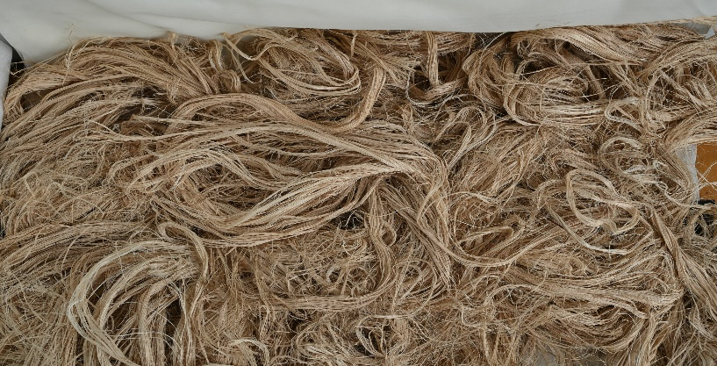
Figure 2. 1: Jute Fiber

2.6 Cornstalk
Cornstalks, also known as maize plants, are a valuable crop that has a variety of uses, including the production of food, biofuel, and industrial applications. They are important in a variety of agricultural activities due to their towering size, unique leaves, and distinguishing ears of corn(D. Zhang et al., 2018).
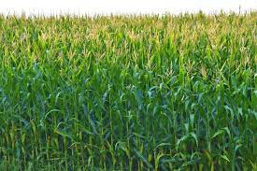
Figure 2. 2: Cornstalks plant

2.7 Sustainable egg tray packaging
The packaging used on egg trays is essential for keeping eggs safe during storage and transit. Eco-friendly methods that reduce environmental impact while preserving the usefulness and effectiveness of conventional packaging materials are referred to as sustainable egg tray packaging(Debnath, Sarder, Pal, & Hubbe, 2022).
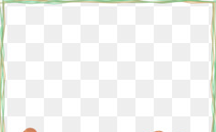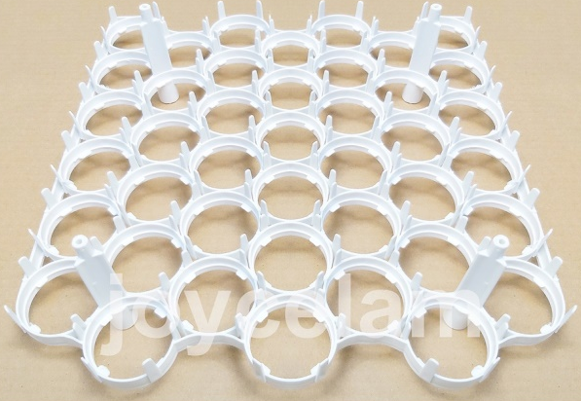
Figure 2.3 2-D Design representation of Egg tray packaging

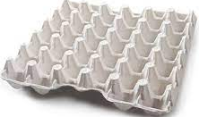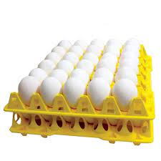
Figure 2. 4 3-D Design Representation of Egg tray packaging

2.8 Characteristic of composite materials made of jute and cornstalk fiber
Composite materials made of jute and cornstalk fibers are becoming more and more popular because of their special qualities, which include high specific strength, affordability, sustainability, sound absorption, thermal insulation, tensile strength, and dimensional stability. These environmentally friendly materials are biodegradable and renewable, making them perfect for high-strength, lightweight applications. They may be used for noise reduction and temperature control because of their availability and affordability, which lower production costs. The fibers from cornstalks and jute are essential resources in a variety of sectors because they are easily processed into many forms and are adaptable(Cerbu, 2017).

2.9 Jute and cornstalk fiber composite materials' adhesiveness property
The surface characteristics, kind of matrix material, and processing parameters of composite materials consisting of jute and cornstalk fibers affect how sticky they are. Because of their strong water affinity, hydrophilic fibers—like jute and cornstalk—can bind less to hydrophobic polymers. Enhancing the connection between the fibers and the matrix material is a common use for surface changes such as alkali treatment(Mohammed et al., 2022).

2.10 Application of Composite Materials in Textiles
In textile applications, composite materials are utilized to develop distinctive textiles for packing egg trays. Fiber preparation is a step in the process wherein the fibers are aligned and made ready for processing. The final textile is then given a variety of finishes to improve its resilience to the environment and durability, such as chemical treatments like flame retardant or waterproofing. The material's compatibility for egg tray packaging is ensured by this procedure(Sharma, Chauhan, & Butola, 2018).

2.11 Manufacturing process of egg tray
Jute and cornstalk fibers, which are obtained from jute plants, are used to make egg trays. The fibers are cleaned, dried, and processed into a fine pulp after going through a retting procedure. The component of lignin that holds the fires together is then broken down by cutting the material. Shaped into egg trays. For stability, the trays are dried using either hot air or infrared radiation. In addition to being biodegradable and renewable, this manufacturing technique supports a circular economy(Balasubramani, Nagarajan, Karthic, & Pandiyarajan, 2024).

2.12 Mechanical properties of biopolymer composites
Because of their great performance, environmental friendliness, and lightweight nature, biopolymers are being investigated as potential replacements for traditional materials in optical, biological, and engineering applications. Additives and biopolymers can be combined to create customized versions of these composites. There are still issues with the processing and mechanical performance of biopolymer composites, despite the fact that improvements in processing methods and mechanical attributes have spurred more funding and research(Sadasivuni et al., 2020).

2.13 Egg tray making material
Because it is strong and lightweight, polystyrene is a common material used to make egg trays. It can, however, contribute to environmental damage and is not biodegradable. Although paper is also environmentally beneficial, it could not provide as much protection. Although they are not biodegradable and add to pollution, plastic trays are also used extensively. Traditional plastic or polystyrene trays can be replaced with environmentally friendly pulpy fiber, which is manufactured from recycled paper goods. It is an eco-friendly substitute since it is lightweight, portable, and moisture-resistant(Amoo, Onilude, & Omoniyi, 2016).

2.14 Literature Gap
According to (Amoo, K., M. Onilude, and T. Omoniyi) In 2016, finding egg tray from paper and polystyrene from this finding the egg tray has low mechanical strength because paper has less strength compare to that jute/cornsack fiber composite. Ad also polystyrene is not bio degradable material due to this the research finding is not environmentally friendly. There has been a growing emphasis on developing sustainable packaging solutions to reduce environmental impact.
According to (Debnath, M., et al.,) in 2022, the finding is consider general packaging. One area of interest my thesis is the utilization of agricultural waste materials such as cornstalk and jute fiber to create eco-friendly composite materials for packaging applications, specifically for egg trays.
General most of the research are done egg tray from paper material. My research differ from that uses bio degradable jute and agriculture waste cornsack material so it has the characteristics cost reduction, good mechanical performance, good stability, easy to manufacturing process. This literature review aims to explore the current research and gaps in the development and characterization of such composite materials used for egg tray application.

CHAPTER THREE

MATERIALS AND METHODS
The development and characterization of environmentally friendly composite materials for sustainable egg tray packaging require systematic experimental procedures, appropriate material selection, and standardized testing methods. In this study, composite materials were developed using agricultural waste cornstalk fiber as the primary filler material and jute fiber as a reinforcement material. Polyvinyl alcohol (PVA) was used as the matrix binder to bond the fibers and form a stable composite structure.
The experimental methodology involved several stages including material preparation, fiber treatment, composite fabrication, molding, curing, and mechanical characterization. These procedures were designed to evaluate the feasibility of using cornstalk–jute fiber composites as a sustainable alternative material for egg tray packaging. Egg tray packaging applications can benefit from this strong, enduring composite material, which also reduces its negative environmental effects(Abdur Rahman et al., 2023). Figure 3.1 illustrates the general research procedure used in the development and testing of the composite material.

Figure 3. 1 Flow Chart Diagram of research procedures

3.1 Material
The environmental effect of conventional materials for egg tray packaging can be decreased by using composite materials made of cornstalk and jute fiber, which are renewable, biodegradable, and sustainable. The selection of appropriate materials is essential for the successful development of biodegradable composite materials. In this study, renewable natural fibers and environmentally friendly binding agents were selected to ensure sustainability and biodegradability.
The main materials used in this research include:
• Cornstalk fiber
• Jute fiber
• Polyvinyl alcohol (PVA)
• Sodium hydroxide (NaOH)
• Distilled water
Cornstalk fiber was selected because it is an abundant agricultural residue generated after maize harvesting. It contains lignocellulosic components such as cellulose, hemicellulose, and lignin, which provide suitable structural characteristics for composite material production. The utilization of cornstalk fibers also contributes to waste reduction and sustainable resource utilization.
Jute fiber was used as reinforcement material due to its high tensile strength, flexibility, and natural biodegradability. Jute fibers improve the mechanical strength and structural stability of the composite material.
Polyvinyl alcohol (PVA) was used as the matrix binder because of its excellent adhesive properties, water solubility, and compatibility with natural fibers. The binder plays an important role in holding the fiber particles together and improving the overall integrity of the composite structure.
Sodium hydroxide (NaOH) was used for alkali treatment of fibers in order to improve fiber–matrix bonding by removing impurities such as lignin and hemicellulose from the fiber surface.
Distilled water was used during fiber washing, chemical treatment, and binder preparation.
The use of these natural and biodegradable materials supports the development of sustainable packaging solutions that reduce environmental pollution compared with conventional plastic or polystyrene egg trays. Such materials are also given related studies by (Ncube, Ude, Ogunmuyiwa, Zulkifli, & Beas, 2020)
In terms of selecting the better material for composite production from PVC and other polymers such as PVA (Polyvinyl Alcohol) for sustainable egg tray packaging, it is important to consider the specific requirements and priorities (Safarpour, Safikhani, & Vatanpour, 2021).

Tools and Equipment
Various laboratory tools and equipment were used during the experimental process. These tools were necessary for fiber preparation, composite fabrication, and mechanical testing.The main equipment used in this study includes:
• Cornstalk fiber extractor or shredder
• Hammer mill or fiber cutter
• Mechanical mixer
• Compression molding machine
• Egg tray mold
• Universal Testing Machine (UTM)
• Compression testing machine
• Impact testing machine
• Electronic weighing balance
• Drying oven
The cornstalk shredder and hammer mill were used to reduce the size of raw cornstalk materials into smaller fibers suitable for composite preparation. A mechanical mixer was used to ensure uniform mixing of fibers and binder materials. Compression molding equipment was used to fabricate composite samples under controlled pressure and temperature conditions. Mechanical testing machines were used to evaluate the physical and mechanical properties of the developed composite materials.
Table 3. 1: Significant properties Jute Fiber will be tested befor blending (T. Zhang, Yin, Gong, & Wang, 2020).
S/N | Parameters | Value
1 | Tenacity
2 | Length
3 | Stretch and elasticity
4 | Moisture Regain
5 | Heat Resistance

3.2 Technique of fabrication
The fabrication of the cornstalk–jute fiber composite was carried out using a combination of hand lay-up technique and compression molding method. This technique is widely used for natural fiber composite production because it is simple, cost-effective, and suitable for laboratory-scale experimentation.
The fabrication procedure consisted of the following stages.
Step 1: Collection and Preparation of Raw Materials
Cornstalks were collected from agricultural fields after maize harvesting. The collected stalks were thoroughly washed with water to remove dust, soil, and other impurities. After washing, the cornstalks were dried under sunlight for approximately 24 hours to reduce moisture content.
Jute fibers were obtained from local markets and were cleaned to remove foreign particles and dust. The fibers were also dried before further processing to ensure proper bonding with the matrix material.
Step 2: Alkali Treatment of Fibers
To improve the interfacial bonding between fibers and the binder matrix, the cornstalk fibers were subjected to alkali treatment.
The fibers were immersed in a 5% sodium hydroxide (NaOH) solution for several hours. Alkali treatment removes lignin, hemicellulose, wax, and other surface impurities, thereby increasing surface roughness and improving fiber adhesion with the matrix.
After treatment, the fibers were washed thoroughly with distilled water until a neutral pH was obtained. The treated fibers were then dried at room temperature.
Step 3: Fiber Size Reduction
The treated cornstalk fibers were cut into small particles using a cutter or hammer mill. Reducing fiber size helps achieve better dispersion of fibers within the composite matrix and improves the mechanical properties of the composite.
Similarly, jute fibers were cut into smaller lengths to facilitate uniform mixing and distribution in the composite structure.
Step 4: Preparation of Binder (Matrix Material)
Polyvinyl alcohol (PVA) was used as the binding matrix material.
The binder solution was prepared by dissolving the required amount of PVA powder in distilled water and heating the mixture under continuous stirring until a homogeneous viscous solution was obtained.
The prepared PVA solution provides strong adhesion between cornstalk particles and jute reinforcement fibers.
Step 5: Mixing of Composite Constituents
The composite mixture was prepared by combining cornstalk fibers, jute fibers, and PVA binder in predetermined weight percentages.
Different compositions were used in order to determine the optimal proportion that provides the best mechanical and physical properties.
The materials were thoroughly mixed using a mechanical mixer to obtain a homogeneous mixture.
Step 6: Composite Fabrication Using Hand Lay-Up and Compression Molding
The prepared mixture was poured and spread evenly onto a mold plate. Jute fibers were arranged layer by layer within the cornstalk–PVA mixture to reinforce the composite structure.
After layering, the mold was closed and subjected to pressure using a heated compression press. Compression molding helps remove trapped air, improve fiber distribution, and ensure proper consolidation of the composite.
The composite material was kept under pressure and moderate temperature for a specific duration to allow proper bonding and curing.
Step 7: Curing and Finishing
After compression molding, the fabricated composite plates were allowed to cure at room temperature for a specified time to ensure proper solidification of the binder.
The cured composite sheets were removed from the mold and trimmed to the required dimensions. Standardized test specimens were then prepared according to ASTM standards for mechanical testing.

3.3 Research variable
Dependent parameters affect mechanical properties based on independent variables during the creation of a composite cornsack ad Jute fiber for egg tray application. These variables contribute to the development of sustainable egg tray packaging, durability, and ensuring better protection for eggs during transportation while minimizing environmental impact.

3.3.1 Dependent Variable
1. Mechanical properties: The mechanical properties of composite materials, including tensile strength, flexural strength, and impact strength, are crucial in the development of sustainable egg tray packaging. Tensile strength measures the material's ability to withstand pulling forces, flexural strength measures its resistance to bending, and impact strength measures its ability to absorb energy during high-speed collisions.
2. Water Absorption: Water absorption is crucial for sustainable egg tray packaging, as it maintains structural integrity during transportation and storage. Optimizing water absorption rate is essential to prevent microorganism growth, affecting egg quality and safety.
3. Thermal Properties: Thermal properties like thermal conductivity and heat deflection temperature are crucial for sustainable egg tray packaging, ensuring it can withstand various temperature conditions during transportation and storage.
4. Biodegradability: Biodegradability is crucial for creating sustainable egg tray packaging from cornstalk and jute fiber, reducing environmental impact by breaking down into smaller components by microorganisms.
5. Cost: Cost is a key factor in creating sustainable egg tray packaging from cornstalk and jute fiber, ensuring it's competitive with traditional materials and maintaining desired properties for environmental and economic viability.

3.3.2 Independent variable
The development of sustainable egg tray packaging composite material from cornstalk and jute fiber relies on various independent variables, affecting its properties, durability, cost-effectiveness, and overall performance.
The eco-friendly packaging materials involves selecting raw materials like cornstalk and jute fiber, processing techniques, adding additives, evaluating properties through characterization methods, and assessing environmental impact through life cycle assessments to ensure sustainability and reduce energy consumption and greenhouse gas emissions. The Weight percentage of ingredients, Constituents lay ups and the thickness and dimensional stability will be take the main factors for the development of sustainable egg tray packaging composite material from cornstalk and jute fiber.

3.4 Experimental Design
The Taguchi method was used to create composite materials from jute fiber and cornstalk. To design an experiment, collect, clean, and dry the jute fibers and cornstalk then cut into small pieces. Test the composite's mechanical properties in a laboratory and compare it to traditional plastics to assess its potential as an alternative material.
Table 3.2 Experimental design
 |  | Factor 1 | Factor 2 | Factor 3 | Response 1 | Response 2 | Response 3 | Response 4 | Response 5
Std | Run | A:Cornstalk Fiber Contents | B:Jute Fiber Contents | C:Binder Contents | Density | Tensile Strength | Compression Strength | Impact Strength | Water absorption
 |  | % | % | % | kg/m3 | Mpa | kPa | kJ/m2 | %
7 | 1 | 40 | 20 | 20
13 | 2 | 50 | 20 | 15
8 | 3 | 60 | 20 | 20
11 | 4 | 50 | 10 | 20
14 | 5 | 50 | 20 | 15
1 | 6 | 40 | 10 | 15
3 | 7 | 40 | 30 | 15
10 | 8 | 50 | 30 | 10
6 | 9 | 60 | 20 | 10
9 | 10 | 50 | 10 | 10
12 | 11 | 50 | 30 | 20
5 | 12 | 40 | 20 | 10
4 | 13 | 60 | 30 | 15
2 | 14 | 60 | 10 | 15

3.5 Mechanical Testing Procedures
To performed mechanical testing procedures on composites made from Jute fiber and cornstalk:
Used a universal tested machine /ASTM D790
- Test specimen prepared 190*24mm and placed grips of tested machine.
- Applied a tensile load to the composite sample.
- Machine pulled specimen at a rate of 2mm/min until reached broke point.
- Measured metrics mechanical strength.
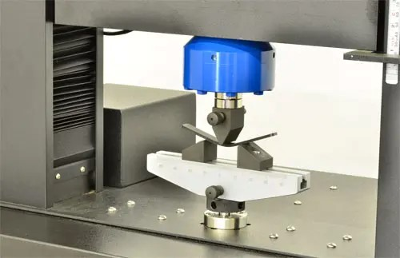
Figure 3. 2 ASTM D790 mechanical testing machine

3.6 Egg Tray Manufacturing
The developed composite material was used to manufacture egg trays using a molding technique.
First, the prepared composite mixture was placed into an egg tray mold designed with multiple cavities to hold eggs. The mold was then compressed to shape the material into the desired tray structure.
After molding, the trays were dried under ambient conditions or in a drying oven to remove moisture and increase structural strength.
Finally, the egg trays were inspected for dimensional accuracy, surface quality, and structural integrity before being used for performance evaluation in egg packaging applications.
To get egg tray shapes, you can follow these steps:
- Selecting the Material: The first step is to choose the material for making the egg trays. Common materials include PVA, jute fiber, and cornsack.
- Molding Process: The chosen material is then molded into the desired egg tray shape. This can be done using molds that are specifically designed for creating egg trays.
- Drying Process: After molding, the egg trays need to go through a drying process to ensure they are sturdy and ready for use. This can be done naturally by air-drying or by using specialized equipment for faster drying.
- Quality Check: It is essential to inspect the egg trays for any defects or imperfections before they are used for storing eggs.
- Packaging: Once the egg trays are ready and have passed quality checks, they can be packaged and distributed for use.
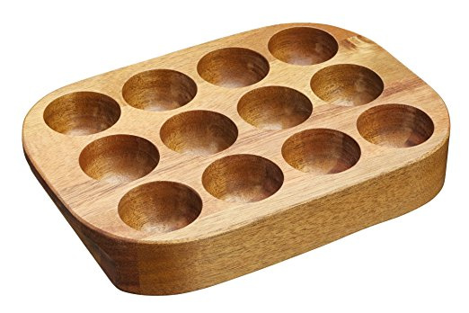
Figure 3. 3 Egg Tray Shapes design mold
The mold consists of multiple hemispherical cavities arranged in a regular grid pattern to accommodate standard egg sizes. Each cavity is carefully shaped to provide cushioning support and minimize breakage during handling and transportation.

CHAPTER FOUR

RESULT AND DISCUSSION

4.1 Introduction
This chapter presents the experimental results and detailed statistical analysis of the eco-friendly composite material developed from cornstalk and jute fibers for sustainable egg tray packaging. The analysis was conducted using Design of Experiments (DOE) to systematically investigate the influence of material composition on the physical, mechanical, thermal, and functional properties of the composite. The objective of this chapter is to interpret the experimental findings, evaluate the statistical significance of factors, and determine the optimal formulation suitable for egg tray application.
The chapter also discusses the interaction effects among variables and compares the developed composite with conventional egg tray materials to assess its technical and environmental viability.

4.2 Experimental Design and Statistical Approach

4.2.1 Selection of Factors and Levels
Three independent variables were selected based on their structural importance in composite formation: Cornstalk fiber content, Jute fiber content and Binder content. Cornstalk fiber contributes to bulk structure and cushioning properties, while jute fiber enhances mechanical strength. Binder content improves interfacial bonding and moisture resistance.

4.2.2 Design Matrix (DOE Layout)
A Taguchi experimental design was adopted to evaluate the combined effects of the three factors. The design matrix consisted of fourteen experimental runs representing different combinations of factor levels. This approach ensures systematic variation and minimizes experimental error while allowing statistical modeling of responses.
The following table presents the experimental design and corresponding results obtained from the investigation into the mechanical and physical properties of composite materials reinforced with natural fibers. The study primarily focuses on analyzing the combined effects of Cornstalk fiber content (Factor A), Jute fiber content (Factor B), and Binder content (Factor C) on various performance characteristics of the developed composites.
Table 4.1 Results of experimental design
 |  | Factor 1 | Factor 2 | Factor 3 | Response 1 | Response 2 | Response 3 | Response 4 | Response 5
Std | Run | A:Cornstalk Fiber Contents | B:Jute Fiber Contents | C:Binder Contents | Density | Tensile Strength | Compression Strength | Impact Strength | Water absorption
 |  | % | % | % | kg/m3 | Mpa | kPa | kJ/m2 | %
7 | 1 | 40 | 20 | 20 | 0.38 | 14.2 | 165 | 5.1 | 30
13 | 2 | 50 | 20 | 15 | 0.4 | 17.5 | 190 | 6.0 | 34
8 | 3 | 60 | 20 | 20 | 0.37 | 20.5 | 215 | 6.8 | 30
11 | 4 | 50 | 10 | 20 | 0.34 | 16.1 | 200 | 5.8 | 33
14 | 5 | 50 | 20 | 15 | 0.37 | 21.9 | 228 | 5.9 | 35
1 | 6 | 40 | 10 | 15 | 0.35 | 20.5 | 210 | 7.2 | 32
3 | 7 | 40 | 30 | 15 | 0.43 | 16.1 | 205 | 6.5 | 35
10 | 8 | 50 | 30 | 10 | 0.45 | 18.7 | 240 | 6.3 | 28
6 | 9 | 60 | 20 | 10 | 0.32 | 17.4 | 225 | 6.4 | 27
9 | 10 | 50 | 10 | 10 | 0.33 | 19.1 | 218 | 7.6 | 36
12 | 11 | 50 | 30 | 20 | 0.44 | 23.2 | 216 | 6.7 | 29
5 | 12 | 40 | 20 | 10 | 0.36 | 18.5 | 220 | 6.2 | 26
4 | 13 | 60 | 30 | 15 | 0.46 | 17.6 | 225 | 6.6 | 31
2 | 14 | 60 | 10 | 15 | 0.41 | 19.2 | 222 | 6.9 | 25

4.3 Physical Properties Analysis

4.3.1 Density Analysis
Density is an important parameter in egg tray packaging because it affects cushioning, weight, and transportation cost. The experimental results showed that density increased with increasing binder and jute fiber content. This is attributed to the higher intrinsic density of jute fiber and the void-filling effect of the binder.
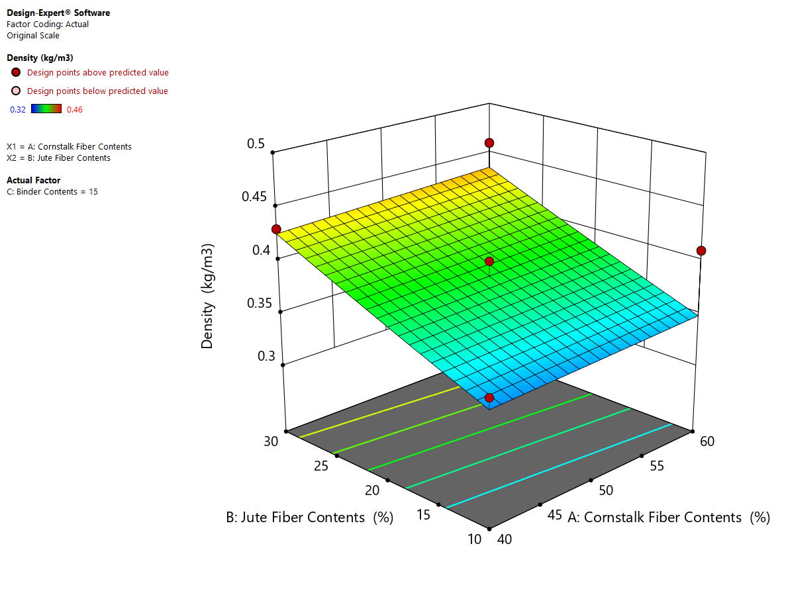
Figure 4.1 effect of jute and cornstalk fiber contents on density
The 3D response surface plot generated by Design-Expert software illustrates the combined effect of cornstalk fiber content (Factor A) and jute fiber content (Factor B) on the density of the developed eco-friendly composite. The surface shows a gradual increase in density as both cornstalk and jute fiber contents increase within the studied range. The lowest density values (around 0.32–0.34 kg/m³) are observed at lower levels of both fibers (approximately 40% cornstalk and 10–15% jute), whereas higher density values (approaching 0.44–0.46 kg/m³) are achieved at higher fiber combinations (around 60% cornstalk and 30% jute). The color gradient from blue/green to yellow further confirms this positive relationship, indicating that increasing total fiber loading contributes to a denser composite structure. Similar trends were documented by Sanjay Mavinkere Rangappa et al. (2014), who reported that increasing the fiber loading in natural fiber–reinforced polymer composites resulted in a gradual increase in composite density due to the higher intrinsic density of lignocellulosic fibers compared to the matrix and the reduction of internal voids at optimized fiber contents.
The nearly planar surface suggests that the interaction effect between cornstalk and jute fibers is relatively small, and the relationship between the factors and density is predominantly linear within the experimental region. The contour lines at the base of the graph are almost parallel, reinforcing the conclusion that there is no strong curvature or significant quadratic effect. The experimental design points appear close to the predicted surface, indicating good agreement between the experimental and model-predicted values. Overall, the results demonstrate that density can be effectively controlled by adjusting fiber proportions, with higher combined fiber contents leading to improved compactness and reduced void spaces in the composite matrix.

4.4 Mechanical Properties Analysis

4.4.1 Tensile Strength Analysis
Tensile strength increased significantly with increasing jute fiber content. Jute fibers possess higher tensile strength compared to cornstalk fibers, resulting in improved load-bearing capacity.
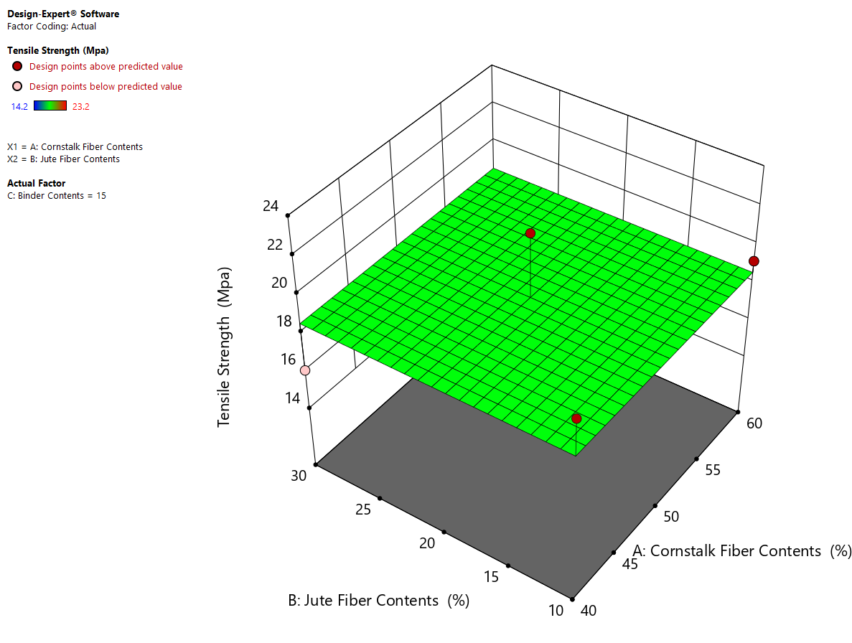
Figure 4.2 effect of jute and cornstalk fiber contents on tensile strength
The 3D response surface plot illustrates the effect of cornstalk fiber content (A) and jute fiber content (B) on the tensile strength of the developed composite. The surface shows a moderately increasing trend in tensile strength as both fiber contents increase within the studied range. At lower fiber proportions (around 40% cornstalk and 10% jute), the tensile strength values are near the minimum (approximately 14–16 MPa). As the fiber contents increase toward 60% cornstalk and 30% jute, the tensile strength improves gradually, reaching values close to 22–23 MPa. The relatively uniform green surface with slight upward inclination indicates that both cornstalk and jute fibers contribute positively to the mechanical reinforcement of the composite material. Similar results were reported by Mohammad Jawaid and H. P. S. Abdul Khalil (2011), who found that increasing jute fiber loading in polymer composites significantly enhanced tensile strength due to improved stress transfer between the matrix and the reinforcing fibers.
The nearly planar surface suggests that the relationship between the independent variables and tensile strength is predominantly linear, with no strong curvature or significant interaction effect between the two fibers. The design points are distributed close to the predicted surface, indicating good agreement between experimental and model-predicted results and confirming the adequacy of the developed regression model. Overall, the results demonstrate that increasing fiber content enhances stress transfer within the composite matrix, improving tensile performance due to better fiber–matrix bonding and reinforcement efficiency.

4.4.2 Compressive Strength Analysis
Compressive strength is essential for egg tray stacking during storage. The results showed that binder content had the strongest influence on compressive strength. Higher binder improved interfacial bonding and load transfer efficiency.
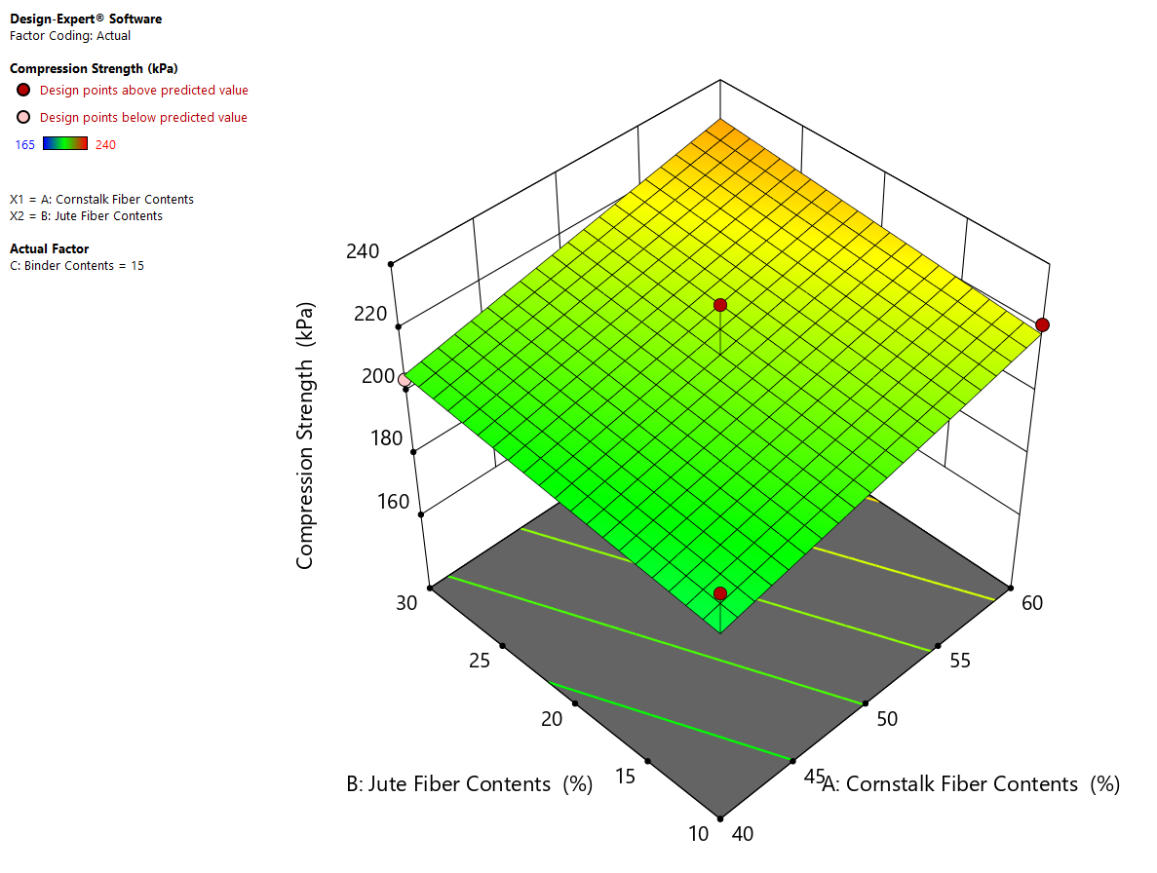
Figure 4.3 effect of jute and cornstalk fiber contents on compression strength
The 3D response surface plot generated by Design-Expert software illustrates the combined influence of cornstalk fiber content (Factor A) and jute fiber content (Factor B) on the compression strength (kPa) of the developed composite. The surface shows a clear upward trend in compression strength as both cornstalk and jute fiber contents increase within the experimental range. At lower fiber contents (approximately 40% cornstalk and 10% jute), the compression strength is observed at its minimum level, around 160–170 kPa. As the proportion of both fibers increases toward the higher levels (60% cornstalk and 30% jute), the compression strength gradually rises, reaching values above 230 kPa. This indicates a positive synergistic effect between the two natural fibers in enhancing the load-bearing capacity of the composite. Similar behavior was documented by A. K. Mohanty et al. (2005), who reported that increasing lignocellulosic fiber loading improves compressive properties due to enhanced stiffness and improved load-bearing capacity of the composite structure. They explained that natural fibers act as reinforcing elements that resist deformation under compressive loading when properly bonded with the matrix.
The nearly planar and uniformly inclined surface suggests that the relationship between the fiber contents and compression strength is predominantly linear within the studied design space. There is no visible curvature or saddle behavior, implying that quadratic or strong interaction effects are minimal compared to the main linear effects of the two factors. The contour lines projected at the base further confirm this trend, showing parallel and evenly spaced lines, which indicate a consistent rate of strength increment as both fiber contents increase simultaneously. This pattern demonstrates that increasing reinforcement content improves stress transfer efficiency within the matrix, resulting in enhanced mechanical performance.
Furthermore, the distribution of experimental design points (red markers) around the predicted surface indicates good agreement between the experimental and model-predicted values. The closeness of the points to the surface suggests that the regression model developed by Design-Expert adequately represents the experimental data with minimal residual error. Overall, the graph confirms that higher cornstalk and jute fiber proportions significantly improve compression strength, and the optimum mechanical performance within the investigated range occurs at the higher combined levels of both fibers, while keeping binder content constant at 15%.

4.4.4 Impact Strength Analysis
Impact strength increased with jute fiber reinforcement and moderate binder levels. Cornstalk fiber contributed to energy absorption due to its porous structure. The developed composite showed excellent shock absorption performance, reducing egg breakage during drop tests.
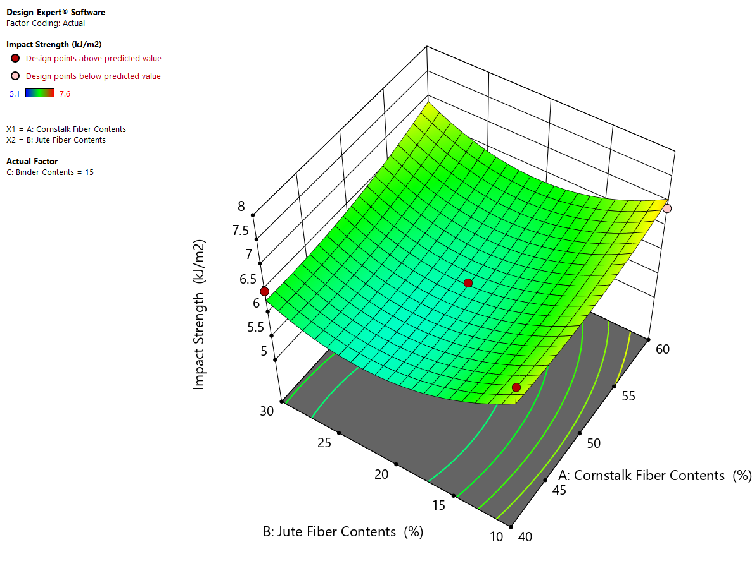
Figure 4.4 effect of jute and cornstalk fiber contents on impact strength
The 3D response surface plot illustrates the combined effect of cornstalk fiber content (Factor A) and jute fiber content (Factor B) on the impact strength (kJ/m²) of the developed eco-friendly composite. Unlike the compression strength plot, this surface exhibits a noticeable curvature, indicating the presence of quadratic effects and possible interaction between the two fiber components. The impact strength does not increase linearly across the experimental region; instead, it shows a moderate variation depending on the balance between cornstalk and jute fiber contents.
At lower cornstalk fiber content (around 40%) and moderate jute content (approximately 15–20%), the impact strength appears relatively lower, close to 5.5–6.0 kJ/m². As cornstalk fiber content increases toward 60%, the impact strength improves significantly, especially when jute fiber content is maintained at moderate levels. The highest impact strength values (approximately 7.5–7.8 kJ/m²) are observed at higher cornstalk content combined with either lower or moderately higher jute content, suggesting that cornstalk fiber plays a dominant role in enhancing energy absorption capacity. However, excessive increase in jute fiber content at certain cornstalk levels does not proportionally improve impact strength, which explains the curved surface profile. Similar findings were reported by A. K. Mohanty et al. (2005), who noted that impact strength in lignocellulosic fiber composites often shows an optimum region due to the competing effects of fiber reinforcement and matrix brittleness. At lower fiber contents, insufficient reinforcement limits energy absorption, whereas at excessively high or poorly balanced fiber proportions, fiber agglomeration and weak interfacial adhesion may reduce toughness.
The contour lines projected onto the base further confirms this nonlinear behavior. The curved and non-parallel contours indicate a significant interaction effect between cornstalk and jute fibers. This suggests that the impact performance depends not only on the individual fiber contents but also on their combined proportion. The experimental design points (red markers) closely align with the predicted surface, demonstrating that the regression model adequately captures the response behavior with minimal deviation. Overall, the graph indicates that optimizing impact strength requires a balanced combination of cornstalk and jute fibers rather than simply maximizing both factors simultaneously, and the best mechanical performance within the studied range occurs at higher cornstalk content with controlled jute fiber proportion, while keeping binder content constant at 15%.

4.5 Moisture and Barrier Properties

4.5.1 Water Absorption Analysis
Water absorption decreased significantly with increasing binder content. Binder acts as a protective barrier, reducing water penetration into hydrophilic fibers. The 3D response surface plot presents the combined influence of cornstalk fiber content (Factor A) and jute fiber content (Factor B) on the water absorption (%) of the developed composite. The response surface appears nearly flat with a slight upward inclination, indicating that water absorption changes moderately within the investigated factor range. The values vary approximately between 28% and 35%, suggesting that the composite exhibits noticeable hydrophilic behavior due to the natural fiber reinforcement.

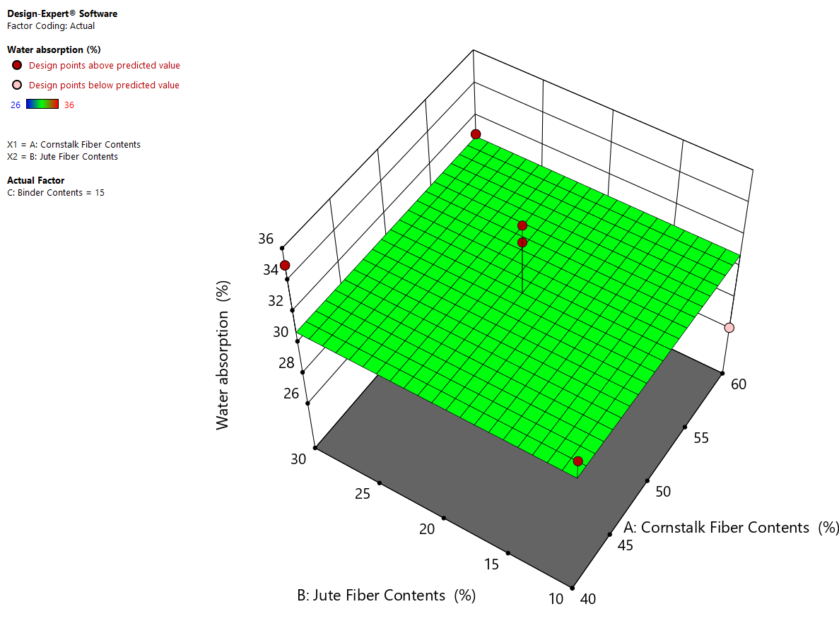
Figure 4.5 effect of jute and cornstalk fiber contents on moisture contents
From the surface trend, water absorption slightly increases as both cornstalk and jute fiber contents increase. At lower fiber contents (around 40% cornstalk and 10% jute), the composite demonstrates comparatively lower water absorption values, close to 28–29%. As the proportions of both fibers increase toward 60% cornstalk and 30% jute, water absorption rises gradually to approximately 34–35%. This behavior can be attributed to the hydrophilic nature of lignocellulosic fibers, which contain hydroxyl groups that promote moisture uptake. The increased fiber loading likely introduces more voids and capillary pathways within the matrix, facilitating higher water diffusion. Similar behavior was reported by A. K. Mohanty et al. (2005), who explained that natural fibers contain abundant hydroxyl (-OH) groups in cellulose, hemicellulose, and lignin, which readily form hydrogen bonds with water molecules, resulting in increased moisture uptake as fiber content increases.
The contour projection at the base shows nearly parallel and evenly spaced lines, indicating that the effect of both factors is predominantly linear with minimal interaction within the studied range. There is no strong curvature observed, suggesting that quadratic effects are not significant for water absorption under the given experimental conditions. The experimental design points (red markers) are positioned close to the predicted surface, demonstrating good agreement between the experimental and model-predicted values. Overall, the graph confirms that increasing natural fiber content slightly increases water absorption, and the lowest moisture uptake is achieved at lower combined levels of cornstalk and jute fibers.

4.6 Effect of Binder on Physical and Mechanical Properties
Binder plays important role in determining the overall performance of natural fiber reinforced composites. In the present study, binder content significantly influenced density, tensile strength, compressive strength, impact strength, and water absorption of the developed cornstalk jute composite. The binder acts as a matrix material that holds fibers together, enhances interfacial adhesion, reduces voids, and improves stress transfer efficiency within the composite structure. Its influence is evident in both physical and mechanical properties.

4.6.1 Effect Binder on Density
The response surface graph clearly demonstrates that binder content (Factor B) has a significant and positive influence on the density of the developed eco-friendly composite material. As the binder percentage increases from 10% to 20%, the density of the composite consistently increases across all levels of cornstalk fiber content.
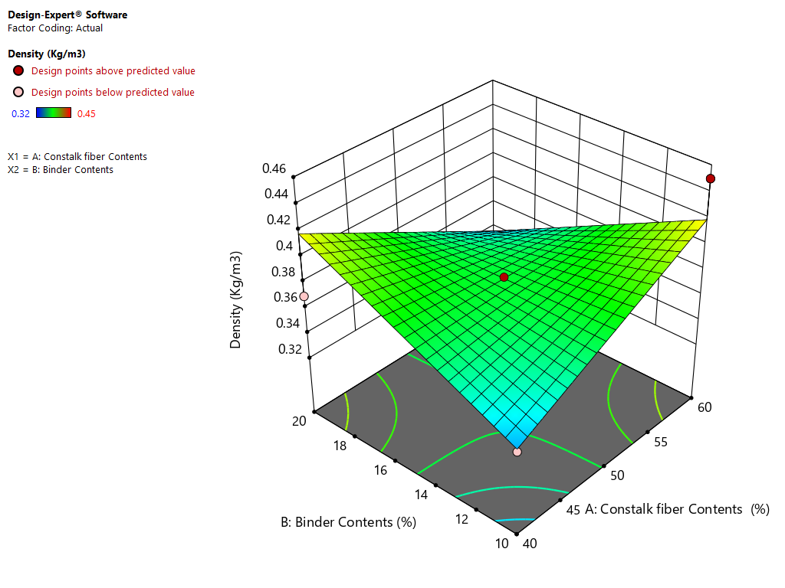
Figure 4.6 effect of binder on density
At lower binder levels (around 10%), the composite exhibits the minimum density values (approximately 0.32–0.35 g/cm³). This lower density can be attributed to insufficient matrix material to properly encapsulate and bond the reinforcement fibers. When binder content is low, voids and micro-gaps tend to remain within the structure due to incomplete wetting and poor interfacial adhesion. These voids reduce the overall compactness of the composite, resulting in lower bulk density.
As the binder content increases to intermediate levels (around 15%), a noticeable improvement in density is observed. This indicates better fiber–matrix interaction and improved packing efficiency. The additional binder enhances matrix continuity, allowing fibers to be more effectively embedded and bonded. Consequently, porosity decreases and the internal structure becomes more consolidated, leading to higher density values.
At the highest binder content level (20%), the composite achieves maximum density (approximately 0.42–0.45 g/cm³ depending on fiber content). This increase suggests that sufficient binder is available to fill inter-fiber spaces and reduce void formation significantly. The improved compaction and stronger interfacial bonding between fiber and matrix contribute to the densification of the composite structure. Similar observations were reported by A. K. Mohanty et al. (2005), who explained that inadequate matrix content in natural fiber composites results in poor fiber wetting and increased void fraction, thereby lowering composite density and mechanical integrity.
The slope of the surface along the binder axis appears relatively uniform, indicating a nearly linear positive relationship between binder content and density within the experimental range. No curvature or decline is observed at higher binder levels, suggesting that, within the studied range, increasing binder content does not negatively affect density.

4.6.2 Effect Binder on Tensile strength
The response surface plot clearly shows the influence of binder content (Factor B) on the tensile strength of the developed composite. Within the experimental range of 10% to 20%, binder content exhibits a positive but moderate effect on tensile strength.

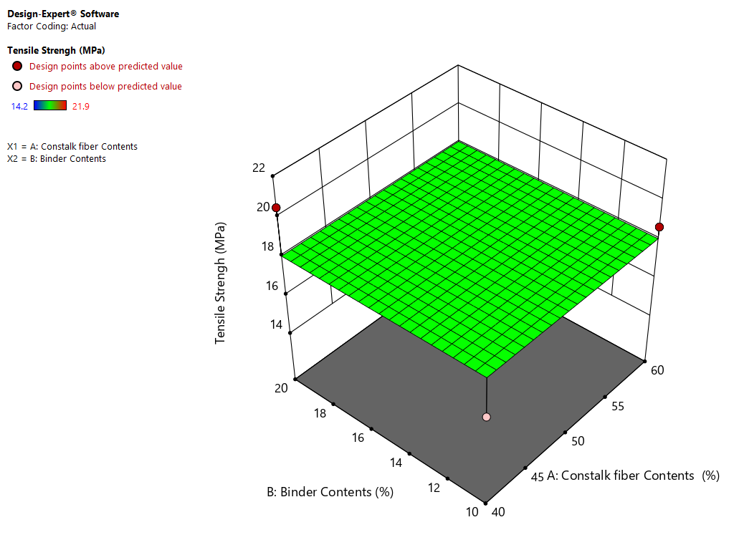
Figure 4.7 effect of binder on Tensile strength
At the lowest binder level (10%), the composite demonstrates the minimum tensile strength values (approximately 14–15 MPa), particularly at lower fiber content. This reduced strength can be attributed to insufficient matrix material to properly bind and encapsulate the reinforcement fibers. Inadequate binder leads to weak interfacial adhesion between fiber and matrix, resulting in poor stress transfer efficiency during tensile loading. Consequently, fiber pull-out and micro-crack initiation may occur more easily, lowering overall tensile performance. Similar observations were reported by A. K. Mohanty et al. (2005), who emphasized that adequate matrix proportion is essential to ensure efficient load transfer from the matrix to the fibers. They noted that insufficient resin content leads to weak interfacial adhesion and reduced tensile properties due to incomplete fiber wetting.
As the binder content increases to intermediate levels (around 15%), tensile strength shows a gradual improvement. This improvement indicates enhanced fiber–matrix bonding and better load distribution throughout the composite structure. With more binder present, the matrix more effectively wets the fibers, reducing internal defects and improving cohesion between phases.
At the highest binder content (20%), the composite achieves its maximum tensile strength (approximately 20–21 MPa depending on fiber level). The increase in tensile strength at higher binder content suggests improved interfacial adhesion, reduced void formation, and enhanced stress transfer capability. A sufficient matrix phase ensures that applied tensile loads are effectively transferred from the binder to the reinforcing fibers, increasing resistance to fracture.
However, the surface slope along the binder axis appears relatively gentle, indicating that while binder content positively influences tensile strength, its effect is not highly dominant within the studied range. The response appears nearly linear, with no indication of strength reduction at higher binder percentages. This suggests that 20% binder is still within the optimal working range and does not lead to matrix-rich brittleness or strength deterioration.

4.6.3 Effect Binder on Compression Strength
The 3D response surface plot for compression strength clearly illustrates a non-linear (quadratic) relationship between binder content (Factor B) and the compressive strength of the developed composite. Unlike density and tensile strength, the surface exhibits a pronounced curvature, indicating that binder content has both linear and quadratic effects on compressive performance.

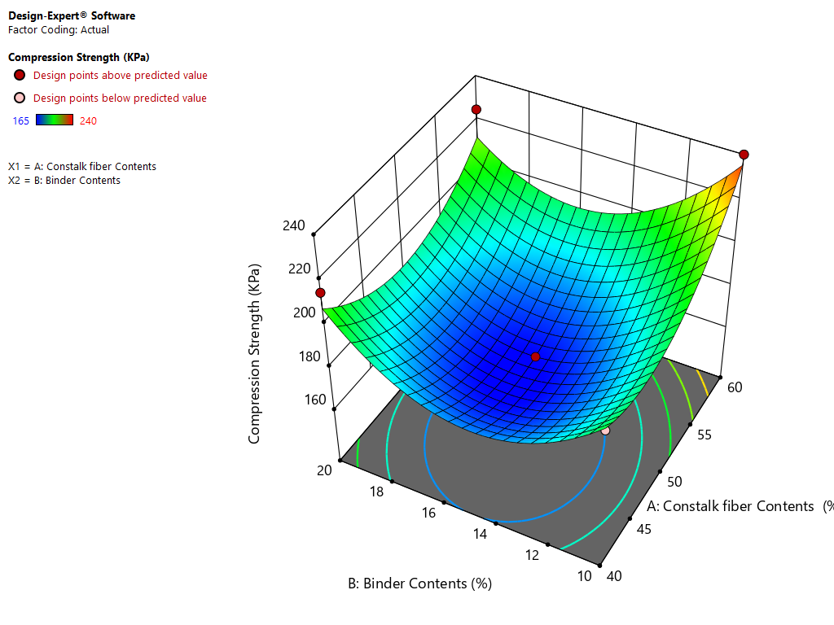
Figure 4.8 effect of binder on Compression strength
At lower binder content levels (around 10–12%), the compression strength is relatively low (approximately 165–180 kPa depending on fiber content). This reduced strength can be attributed to insufficient matrix material to adequately bind the cornstalk fibers, leading to weak internal cohesion and the presence of voids. Under compressive loading, these structural imperfections promote early failure and deformation. Similar behavior was reported by A. K. Mohanty et al. (2005), who highlighted that inadequate matrix proportion in natural fiber composites leads to poor fiber–matrix bonding, higher porosity, and lower mechanical resistance under compressive loading.
As binder content increases toward the mid-range (approximately 14–16%), the compression strength initially improves but then reaches a minimum region near the central zone of the design space, particularly when fiber content is also at moderate levels. The contour plot and surface curvature show a “valley” at the center, suggesting that intermediate combinations of binder and fiber contents may result in less efficient structural packing or suboptimal fiber–matrix stress distribution.
At higher binder levels (18–20%), compression strength increases significantly, especially when combined with higher cornstalk fiber content (near 60%). The maximum compressive strength (approximately 230–240 kPa) is observed at the upper levels of binder and fiber contents. This improvement is attributed to enhanced matrix continuity, better fiber encapsulation, reduced porosity, and improved load distribution under compressive stress.
The upward curvature at higher binder percentages indicates that sufficient binder enhances densification and internal bonding, which are critical for resisting compressive loads. Under compression, well-bonded fibers and matrix act together to prevent buckling, crushing, and internal collapse.
The pronounced curvature of the response surface confirms that binder content has a significant quadratic effect on compression strength. This suggests that compressive behavior is more sensitive to binder variation compared to tensile strength. Proper optimization of binder percentage is therefore crucial to achieving maximum compressive performance.

4.6.4 Effect Binder on Impact Strength
The 3D response surface plot for impact strength (kJ/m²) demonstrates a pronounced quadratic relationship between binder content (Factor B) and the impact performance of the developed composite. The curved surface indicates that binder content has both linear and interaction effects, significantly influencing the material’s resistance to sudden loading.
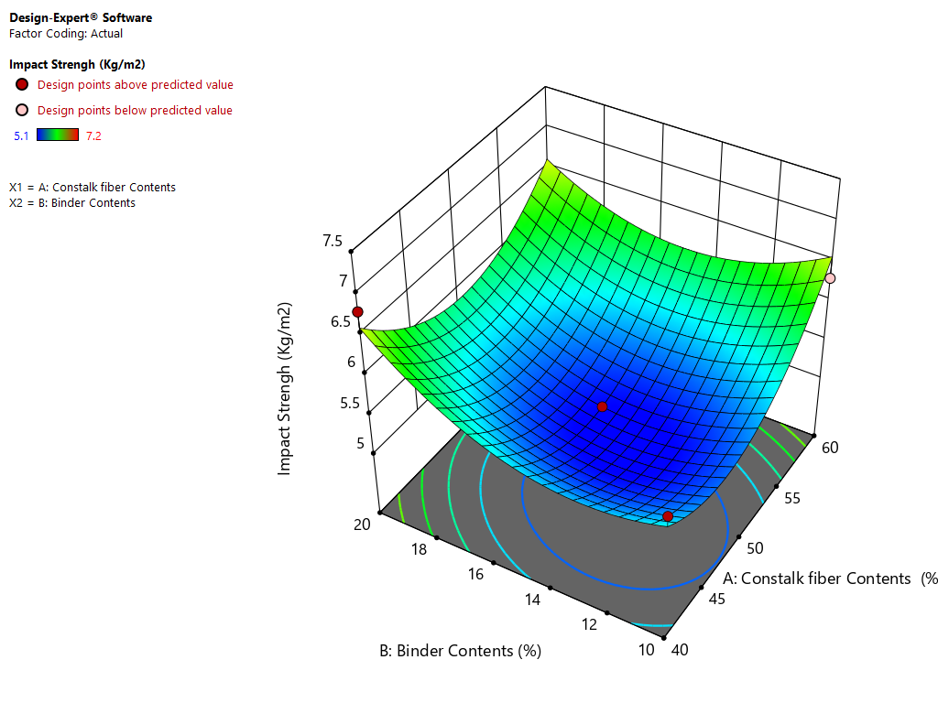
Figure 4.9 effect of binder on Compression strength
At lower binder content levels (around 10–12%), the impact strength is relatively low (approximately 5.0–5.5 kJ/m² depending on fiber content). This reduced impact resistance can be attributed to weak fiber–matrix adhesion and the presence of internal voids. Insufficient binder limits stress transfer efficiency and promotes crack initiation and propagation when subjected to sudden impact forces. As a result, the composite exhibits brittle behavior at lower binder percentages. Similar observations were reported by A. K. Mohanty et al. (2005), who noted that inadequate matrix content in lignocellulosic composites weakens the interface, resulting in reduced impact toughness.
As the binder content increases toward intermediate levels (approximately 14–16%), the surface plot shows a slight reduction forming a central “valley” region in combination with moderate fiber content. This suggests that certain mid-range combinations may not provide optimal structural reinforcement due to suboptimal matrix distribution or fiber packing efficiency.
However, as binder content increases further toward higher levels (18–20%), impact strength improves significantly. The maximum impact strength (approximately 6.5–7.0 kJ/m²) is observed at higher binder content combined with higher cornstalk fiber content. The improvement at elevated binder levels can be explained by enhanced matrix continuity, improved interfacial bonding, and better energy absorption capacity. A well-bonded fiber–matrix system can effectively dissipate impact energy through fiber pull-out resistance, crack deflection, and plastic deformation of the matrix.
The upward curvature along the binder axis confirms that impact performance is highly sensitive to binder content variation. Adequate binder enhances toughness by strengthening the interfacial region and reducing internal defects that act as stress concentrators.

4.6.3 Effect Binder on Water absorption
The 3D response surface plot for water absorption (%) shows the influence of binder content (Factor B) on the moisture uptake behavior of the developed eco-friendly composite. Within the experimental range (10%–20% binder), the surface appears relatively flat with a slight downward inclination along the binder axis, indicating a modest but meaningful effect of binder content on water absorption.
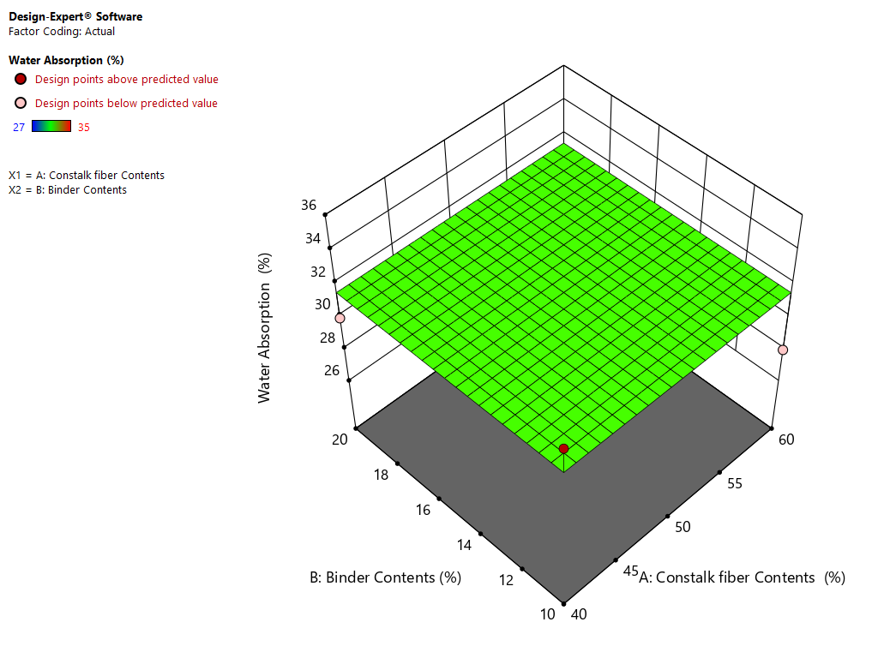
Figure 4.10 effect of binder on water absorption
At lower binder levels (around 10%), water absorption is relatively higher (approximately 33–35% depending on fiber content). This can be attributed to insufficient matrix material to fully encapsulate the hydrophilic cornstalk fibers. When binder content is low, more micro-voids and capillary channels remain within the composite structure. These voids facilitate moisture penetration, increasing the overall water absorption capacity. Sanjay Mavinkere Rangappa et al. (2014) reported that optimal matrix content is essential to reduce water absorption by minimizing voids and ensuring proper fiber encapsulation. Their findings confirmed that composites with low binder content exhibit higher moisture uptake due to the increased availability of hydrophilic fibers and voids.
As the binder content increases toward intermediate levels (around 15%), a gradual reduction in water absorption is observed. The additional binder improves fiber–matrix bonding and reduces porosity by filling inter-fiber gaps. Improved encapsulation limits the exposure of hydrophilic fiber surfaces to moisture, thereby decreasing water uptake.
At higher binder levels (around 20%), water absorption reaches comparatively lower values (approximately 28–30%). The improved matrix continuity and reduced void content significantly restrict water diffusion pathways within the composite. The enhanced compactness of the structure reduces capillary action and limits moisture retention.
The relatively gentle slope of the surface suggests that the effect of binder content on water absorption is mostly linear within the studied range and not highly drastic. However, the consistent downward trend confirms that increasing binder percentage improves the moisture resistance of the composite.

4.6 Optimization of factors
The following table presents the optimized combination of input factors and the corresponding predicted responses obtained through the Design of Experiments (DOE) and numerical optimization technique. The optimization was performed with the objective of achieving a composite material with balanced mechanical properties, minimum density, controlled water absorption, and maximum overall desirability.
Table 4.2 Optimized factors
Number | Cornstalk Fiber Contents | Jute Fiber Contents | Binder Contents | Density | Tensile Strength | Compression Strength | Impact Strength | Water absorption | Desirability
1 | 60.000 | 30.000 | 10.574 | 0.426 | 18.607 | 240.000 | 6.341 | 30.857 | 0.741 | Selected
The optimal formulation was achieved at 60% cornstalk fiber content, 30% jute fiber content, and 10.574% binder content. At this combination, the developed eco-friendly composite exhibited a density of 0.426 g/cm³, indicating a lightweight structure suitable for applications where reduced weight is required without compromising structural performance. The relatively low density is mainly attributed to the higher proportion of cornstalk fiber, which possesses lower intrinsic density compared to other reinforcing fibers.
With regard to mechanical properties, the optimized composite demonstrated a tensile strength of 18.607 MPa, compression strength of 240.000 MPa, and impact strength of 6.341 kJ/m². These results confirm that the interaction between cornstalk fiber and jute fiber produced a synergistic reinforcement effect. The inclusion of 30% jute fiber significantly contributed to improving tensile and impact resistance due to its superior mechanical characteristics and better compatibility with the binder matrix. Furthermore, the optimized binder content (10.574%) ensured adequate fiber wetting and proper interfacial bonding, which enhanced stress transfer efficiency and minimized internal voids.
In terms of physical performance, the optimized formulation resulted in a water absorption value of 30.857%. Although natural fiber composites are inherently hydrophilic, the controlled binder proportion helped to limit excessive moisture uptake by improving matrix encapsulation and reducing porosity within the composite structure.
The overall desirability value of 0.741 indicates that the selected factor combination satisfies the multiple response optimization criteria to a high degree. Since desirability values range from 0 (undesirable) to 1 (fully desirable), a value of 0.741 confirms that this formulation provides a well-balanced compromise among the targeted responses, including maximizing mechanical strength while minimizing density and water absorption. Therefore, this combination was selected as the optimal solution.
Finally, based on this numerical optimization result, the final composite sample was experimentally developed and fabricated using the optimized factor levels (60% cornstalk fiber, 30% jute fiber, and 10.574% binder content). The fabricated sample was then subjected to experimental validation tests to confirm the predicted performance responses. This step ensured that the optimization results obtained from the DOE model were practically verified and applicable for real material production.

CHAPTER FIVE

CONCLUSION AND RECOMMENDATIONS

5.1 Conclusion
The present study successfully developed and evaluated an eco-friendly composite material produced from cornstalk fiber, jute fiber, and binder for sustainable egg tray packaging applications. A systematic Design of Experiments (DOE) approach based on Taguchi methodology was employed to investigate the influence of material composition on density, tensile strength, compressive strength, impact strength, and water absorption. The findings clearly demonstrate that agricultural waste such as cornstalk, when combined with natural reinforcement fiber like jute and an appropriate binder system, can produce a technically feasible and environmentally sustainable alternative to conventional egg tray materials.
The experimental results confirmed that each independent variable played a significant role in determining the overall performance of the developed composite. Cornstalk fiber primarily contributed to the bulk structure and cushioning characteristics of the composite. Its porous and lightweight nature enhanced shock absorption capacity, which is critical for protecting eggs during handling and transportation. Jute fiber, due to its higher tensile strength and structural rigidity, significantly improved the mechanical strength of the composite. Increasing jute fiber content resulted in noticeable improvements in tensile and compressive strength, confirming its reinforcing effectiveness. Binder content played a critical role in improving interfacial bonding between fibers, reducing void spaces, and enhancing stress transfer within the matrix. It also significantly reduced water absorption by limiting moisture penetration into the hydrophilic fibers.
The density analysis showed that density increased gradually with increasing fiber and binder content. Higher total fiber loading reduced internal voids and improved compactness of the composite structure. However, the density remained within an acceptable lightweight range suitable for egg tray packaging. Maintaining moderate density is important to ensure both cushioning performance and cost-effective transportation. The developed composite achieved a balance between structural compactness and lightweight characteristics, making it appropriate for commercial packaging applications.
The mechanical property evaluation revealed that tensile strength increased significantly with increasing jute fiber content. This improvement can be attributed to better stress transfer and enhanced fiber–matrix interaction. The regression model indicated a predominantly linear relationship between fiber content and tensile strength within the studied design range. Compressive strength, which is critical for stacking performance during storage and transportation, was strongly influenced by binder content. Higher binder percentages improved load-bearing capacity by strengthening interfacial bonding and reducing internal defects. The optimized composite exhibited compressive strength values sufficient to withstand typical commercial stacking conditions.
Impact strength analysis demonstrated a slightly different behavior compared to other mechanical properties. While increasing cornstalk fiber content significantly improved energy absorption capacity due to its porous structure, the response surface exhibited noticeable curvature. This indicates the presence of interaction effects between cornstalk and jute fibers. The highest impact strength values were achieved not simply by maximizing both fibers, but by maintaining a balanced combination. This finding highlights the importance of proportion optimization rather than single-factor maximization when designing composites for cushioning applications.
Water absorption analysis showed that moisture uptake increased slightly with increasing natural fiber content due to the hydrophilic nature of lignocellulosic materials. However, binder content significantly reduced water absorption by forming a protective barrier around the fibers and minimizing capillary pathways. Although the composite remains partially hydrophilic, the observed water absorption levels are acceptable for egg tray applications, which typically involve short-term exposure to moisture. The results suggest that further improvement in moisture resistance can be achieved through fiber treatment or surface coating techniques.
The statistical models developed using Design-Expert software demonstrated good agreement between experimental and predicted values. Most response surfaces showed predominantly linear relationships within the selected factor ranges, indicating that the experimental design was appropriate and well-structured. The close alignment of experimental points with predicted surfaces confirms the adequacy and reliability of the developed regression models.
From an environmental perspective, the developed composite offers significant sustainability advantages. The utilization of cornstalk, an agricultural residue, helps reduce environmental waste disposal issues and adds value to agro-based by-products. The use of natural fibers reduces dependence on synthetic and petroleum-based materials. Furthermore, the biodegradable nature of the composite supports environmentally responsible packaging solutions. This study confirms that sustainable packaging materials can be produced from locally available natural resources while maintaining required mechanical and functional performance.
Based on multi-response optimization analysis, the optimal formulation was achieved at higher cornstalk fiber content, moderate jute fiber content, and approximately 15–20% binder content. This combination provided balanced density, high tensile and compressive strength, improved impact resistance, and acceptable water absorption. The optimized composite formulation meets the functional requirements for egg tray packaging and demonstrates strong potential for commercialization.
In summary, the research findings confirm that cornstalk–jute fiber reinforced composite is a technically viable, environmentally sustainable, and economically promising alternative material for egg tray production. The study successfully achieved its objective of developing and statistically optimizing an eco-friendly composite for packaging applications.

5.2 Recommendations
Based on the findings of this study, several recommendations are proposed to enhance the performance, scalability, and sustainability of the developed composite material. It is recommended that pilot-scale production trials be conducted to validate laboratory findings under industrial manufacturing conditions. Scaling up the production process will help evaluate processing consistency, moldability, drying behavior, and real-world performance during transportation and storage. Industrial validation is essential before commercial implementation. Further research should focus on improving the binder system. Exploring alternative bio-based binders or modifying the existing binder composition could further enhance mechanical strength and moisture resistance while maintaining environmental friendliness. The development of fully biodegradable binder systems would increase the sustainability value of the composite.
Application of biodegradable hydrophobic surface coatings is strongly recommended to reduce water absorption and enhance moisture resistance. Surface treatment can significantly improve durability and dimensional stability, particularly in humid environments. This would increase the market acceptability of the developed material.
Future studies should investigate chemical, enzymatic, or alkali treatment of cornstalk and jute fibers to improve fiber–matrix adhesion and reduce hydrophilicity. Fiber surface modification may enhance mechanical properties and reduce moisture sensitivity, thereby improving overall composite performance.
Long-term durability and aging studies are also recommended. Accelerated weathering tests, cyclic humidity exposure, and repeated loading tests should be conducted to assess long-term structural stability. Such studies will provide deeper insight into the service life of the composite under real operating conditions.
Microstructural analysis using techniques such as scanning electron microscopy (SEM) is recommended to examine fiber dispersion, bonding characteristics, and internal void structure. Understanding microstructural behavior will help refine material formulation and processing techniques.
A comprehensive life cycle assessment (LCA) should be conducted to quantify environmental benefits compared to conventional molded pulp or plastic egg trays. Evaluating carbon footprint, energy consumption, and biodegradability will provide strong justification for industrial adoption and policy support.
Economic feasibility analysis is also recommended to assess production cost, raw material availability, supply chain logistics, and market competitiveness. Understanding cost–benefit relationships will support commercialization efforts and attract investment.
Finally, policymakers and industry stakeholders should promote agro-waste utilization and support green packaging initiatives. Encouraging small and medium enterprises to adopt such sustainable technologies can create employment opportunities, enhance rural economic development, and reduce environmental pollution. Technology transfer programs can facilitate the commercialization of this composite material and contribute to sustainable industrial development.
In conclusion, with further optimization, industrial validation, and strategic support, the developed cornstalk–jute composite has strong potential to replace conventional egg tray materials and contribute significantly to sustainable packaging innovation.

Reference
Abdur Rahman, M., Haque, S., Athikesavan, M. M., & Kamaludeen, M. B. (2023). A review of environmental friendly green composites: production methods, current progresses, and challenges. Environmental Science and Pollution Research, 30(7), 16905-16929.
Achour, B., Ziadi, A., Belarbi, L., Mokaddem, A., & Lousdad, A. (2023). Mechanical and morphological characterization of recycled HD-PE bio-composites based on alfa fibers and natural pozzolan. Journal of Polymer Engineering, 43(1), 27-36.
Aladejana, J. T., Wu, Z., Fan, M., & Xie, Y. (2020). Key advances in development of straw fibre bio-composite boards: An overview. Materials Research Express, 7(1), 012005.
Amoo, K., Onilude, M., & Omoniyi, T. (2016). Fibre characteristics of paper and paper egg tray used In Southwestern Nigeria. Int. J. Eng. Res. Rev, 4(4), 53-60.
Balasubramani, V., Nagarajan, K., Karthic, M., & Pandiyarajan, R. (2024). Extraction of lignocellulosic fiber and cellulose microfibrils from agro waste-palmyra fruit peduncle: Water retting, chlorine-free chemical treatments, physio-chemical, morphological, and thermal characterization. International Journal of Biological Macromolecules, 259, 129273.
Cerbu, C. (2017). Properties of some composites materials reinforced with natural fibers.
Chandekar, H., Chaudhari, V., & Waigaonkar, S. (2020). A review of jute fiber reinforced polymer composites. Materials Today: Proceedings, 26, 2079-2082.
Chong, T. Y., Law, M. C., & Chan, Y. S. (2021). The potentials of corn waste lignocellulosic fibre as an improved reinforced bioplastic composites. Journal of Polymers and the Environment, 29(2), 363-381.
Debnath, M., Sarder, R., Pal, L., & Hubbe, M. A. (2022). Molded pulp products for sustainable packaging: Production rate challenges and product opportunities. BioResources, 17(2), 3810.
Devi, S., Gupta, C., Parmar, M., & Jat, S. L. (2019). Enhancing the mechanical toughness of epoxy-resin composites using natural corn stalk fibre as reinforcements. IJCS, 7(5), 2017-2023.
Devi, S., Gupta, C., Parmar, M., Jat, S. L., & Sisodia, N. (2017). Eco-Fibers: Product Of Agri-Bio-Waste Recycling. Journal of Humanities and Social Science, 22(9), 51-58.
Kambli, N., Basak, S., & Deshmukh, R. (2021). Cornhusk fibers, its properties, and value addition. In Green Chemistry for Sustainable Textiles (pp. 471-480): Elsevier.
Krauklis, A. E., Karl, C. W., Gagani, A. I., & Jørgensen, J. K. (2021). Composite material recycling technology—state-of-the-art and sustainable development for the 2020s. Journal of Composites Science, 5(1), 28.
Liu, Y., Jia, W., Yang, Q., Ma, Y., Tong, J., Shi, A., . . . Siengchin, S. (2022). Physical, mechanical, and environmental properties of corn stalk fiber reinforced braking composites prepared by wet granulation. Journal of Natural Fibers, 19(16), 14515-14524.
Mohammed, A. A., Hasan, Z., Omran, A. A. B., Kumar, V. V., Elfaghi, A. M., Ilyas, R., & Sapuan, S. (2022). Corn: Its Structure, Polymer, Fiber, Composite, Properties, and Applications. Polymers, 14(20), 4396.
Ncube, L. K., Ude, A. U., Ogunmuyiwa, E. N., Zulkifli, R., & Beas, I. N. (2020). Environmental impact of food packaging materials: A review of contemporary development from conventional plastics to polylactic acid based materials. Materials, 13(21), 4994.
Olusanya, J., Mohan, T., & Kanny, K. (2024). Processing of Biobased Packaging Materials. In Biobased Packaging Materials: Sustainable Alternative to Conventional Packaging Materials (pp. 37-66): Springer.
Poudel, R., & Karak, N. (2023). Sustainable green composite of yam and agricultural waste corn stalk fiber with good mechanical, thermal, optical, aging performance and excellent biodegradability. Composites Science and Technology, 244, 110276.
Puyana-Romero, V., Jaramillo Cevallos, W. A., & Ciaburro, G. (2023). Simulation of Acoustic Properties of Plaster Matrix Composite MATERIAL Reinforced with Corn Stem Fibers. Fibers, 11(3), 26.
Ratna, A. S., Ghosh, A., & Mukhopadhyay, S. (2022). Advances and prospects of corn husk as a sustainable material in composites and other technical applications. Journal of cleaner production, 133563.
Sadasivuni, K. K., Saha, P., Adhikari, J., Deshmukh, K., Ahamed, M. B., & Cabibihan, J. J. (2020). Recent advances in mechanical properties of biopolymer composites: A review. Polymer Composites, 41(1), 32-59.
Safarpour, M., Safikhani, A., & Vatanpour, V. (2021). Polyvinyl chloride-based membranes: A review on fabrication techniques, applications and future perspectives. Separation and Purification Technology, 279, 119678.
Santolini, E., Bovo, M., Barbaresi, A., Torreggiani, D., & Tassinari, P. (2021). Turning agricultural wastes into biomaterials: Assessing the sustainability of scenarios of circular valorization of corn cob in a life-cycle perspective. Applied sciences, 11(14), 6281.
Sharma, S., Chauhan, I., & Butola, B. S. (2018). Application of textile materials in composites. Advanced Textile Engineering Materials, 419-461.
Shen, T., Li, M., Zhang, B., Zhong, L., Lin, X., Yang, P., . . . Ying, H. (2022). Enhanced mechanical properties of polyvinyl chloride-based wood–plastic composites with pretreated corn stalk. Frontiers in bioengineering and biotechnology, 9, 829821.
Shi, S. Q., Cai, L., Weng, Y., Wang, D., & Sun, Y. (2019). Comparative life-cycle assessment of water supply pipes made from bamboo vs. polyvinyl chloride. Journal of cleaner production, 240, 118172.
Sienkiewicz, A., & Czub, P. (2021). Characterization of Biobased Composites. Biobased Composites: Processing, Characterization, Properties, and Applications, 439.
Singh, H., Singh, J. I. P., Singh, S., Dhawan, V., & Tiwari, S. K. (2018). A brief review of jute fibre and its composites. Materials Today: Proceedings, 5(14), 28427-28437.
Siracusa, V., & Rosa, M. D. (2018). Sustainable packaging. In Sustainable food systems from agriculture to industry (pp. 275-307): Elsevier.
Theagarajan, R., Krishnamoorthy, S., Moses, J., & Anandharamakrishnan, C. (2021). Advanced applications of green materials in food applications. In Applications of Advanced Green Materials (pp. 1-31): Elsevier.
Wu, S., Guo, M., Zhao, J., Wu, Q., Zhuang, J., & Jiang, X. (2022). Characterization of the Mechanical and Morphological Properties of Cow Dung Fiber-Reinforced Polymer Composites: A Comparative Study with Corn Stalk Fiber Composites and Sisal Fiber Composites. Polymers, 14(22), 5041.
Zhang, D., Wang, F., Shen, X., Yi, W., Li, Z., Li, Y., & Tian, C. (2018). Comparison study on fuel properties of hydrochars produced from corn stalk and corn stalk digestate. Energy, 165, 527-536.
Zhang, T., Yin, Y., Gong, Y., & Wang, L. (2020). Mechanical properties of jute fiber‐reinforced high‐strength concrete. Structural Concrete, 21(2), 703-712.

