
SCHOOL OF GRADUATE STUDIES
FACULTY OF TEXTILE AND APPARAL FASHION TECHNOLOGY
(DEPARTMENT OF TEXTILE TECHNOLOGY)

DEVELOPMENT AND CHARACTERIZATION OF WOOD PLASTIC COMPOSITE FOR HOME FURNITURE APPLICATIONS USING SAWDUST AND RECYCLED POLYETHYLENE TEREPHTHALATE

BY: DERBEW TESFA

ADVISOR: TOLERA ADERIE (PhD)

MARCH, 2026

ADDIS ABABA, ETHIOPA

DEVELOPMENT AND CHARACTERIZATION OF WOOD PLASTIC COMPOSITE FOR HOME FURNITURE APPLICATIONS USING SAWDUST AND RECYCLED POLYETHYLENE TEREPHTHALATE

A THESIS SUBMITTED TO FEDERAL TECHNICAL AND VOCATIONAL TRAINING INSTITUTE

FACULTY OF TEXTILE AND APPAREL FASHION TECHNOLOGY
(DEPARTMENT OF TEXTILE TECHNOLOGY)

IN PARTIAL FULFILLMENT FOR THE DEGREE MASTERS OF SCIENCE IN TEXTILE TECHNOLOGY

BY: DERBEW TESFA
ADVISOR: TOLERA ADERIE (PhD)

MARCH, 2026

ADDIS ABABA, ETHIOPA

APPROVAL SHEET

FEDERAL TECHNICAL AND VOCATIONAL TRAINING INSTITUTE (FTVTI)

FACULTY OF TEXTILE AND APPARAL FASHION TECHNOLOGY
(DEPARTMENT OF TEXTILE TECHNOLOGY)

BY:
DERBEW TESFA DESSIE
APPROVED BY EXAMINING BOARD

Name of Advisor  Dr. Tolera Aderie |  | Signature |  |  |  | Date
Name of Co-advisor |  | Signature |  |  |  | Date
Name of Examiner, Internal |  | Signature |  |  |  | Date
Name of Examiner, External |  | Signature |  |  |  | Date
Name of chairperson |  | Signature |  |  |  | Date

Declaration
I hereby declare that the work which is being presented in this thesis entitled “Development and Characterization of Wood Plastic Composite for Home Furniture Applications Using Sawdust and Recycled Polyethylene Terephthalate” is the original work of my own, has not been presented for a Degree in this or other universities and all sources of materials used for this thesis work have been fully acknowledged and proper cited.

Name: Derbew Tesfa (TTMR/137/15)
Signature: _______________________
Date of Submission: 02 Mar. 2026

This thesis has been submitted for examination with my approval as a TVTI advisor.
Dr. Tolera Aderie __ ____________
Advisor Name Signature Date

Acronyms and Abbreviations
AASTU: Addis Ababa Science and Technology University
AFP: Automated fiber placement
ASTM: American Standard Testing Method
ATL: Automatic Tape Laying
CMCs: Ceramic Matrix Composites
DSC: Differential Scanning Calorimetry
EDX: Energy-Dispersive X-ray
FRP: Fiber Reinforced Polymer
FTIR: Fourier-Transform Infrared Spectroscopy Analysis
GHG: Greenhouse Gas
HALS: Hindered Amine Light Stabilizers
HDPE: High density polyethylene
HDT: Heat Deflection Temperature
HP-RTM : High-Pressure Resin Transfer Molding
LCA: life-cycle assessments
LDPE: Low Density Polyethylene
LMIC: Low and Middle Income Country
MA: Maleic Anhydride
MAPE: Maleic Anhydride-Grafted Polyethylene
MAPP: Maleic Anhydride-Grafted Polypropylene
MDF: Medium-Density Fiberboard
PE: Polyethylene
PET: Polyethylene Terephthalate
PP: Polypropylene
PPE: Persona Protective Equipment
PVC: Polyvinyl Chloride
rPET: Recycled Polyethylene Terephthalate
RTM: Resin Transfer Molding
SEM: Scanning Electron Microscopy
Tc: Crystallization Temperature
Tg: Glass Transition Temperature
TGA: Thermogravimetric Analysis
Tm: Melting Temperature
UTM: Universal Testing Machine
UV: Ultra Violate
WPC: Wood Plastic Composite
WPCs: Wood Plastic Composites

Table of contents
Declaration i
Acronyms and Abbreviations ii
Table of contents iv
List of Tables viii
List of Figures ix
Abstract xi
CHPTER ONE 1
INTRODUCTION 1
1.1 Background of the research 1
1.2 Problem statements 3
1.3 Objective 5
1.3.1 General Objective 5
1.3.2 Specific objectives 5
1.4 Basic Research Question 5
1.5 Significance of the research 6
1.6 Scope and Limitation of the Research 6
1.7 Organizations of the paper 7
1.8 Operational Definitions of Key Terms 7
CHAPTER TWO 9
LITERATURE REVIEW 9
2.1 Introduction 9
2.2 Composite Materials 9
2.3 Properties of Composite Materials 11
2.4 Types of Composite Materials 12
2.5 Wood Plastic Composites (WPCs) 13
2.5.1 Composition of Wood Plastic Composite (WPC) Materials 13
2.5.2 Sawdust as Reinforcement in WPCs 14
2.5.3 Recycled Polyethylene Terephthalate (rPET) as a Matrix 15
2.5.4 Additive Materials for WPC Production 16
2.5.5 Advantages of maleic anhydride over other additives in the production of WPC 17
2.5.6 Advantage of WPC over MDF 18
2.6 Production Methods of WPCs 20
2.6.1 Extrusion Molding 20
2.6.2 Injection Molding 22
2.6.3 Resin Transfer Molding (RTM) 22
2.6.4 Compression Molding 23
2.6.5 Layup 24
2.6.6 Spray Up 24
2.6.7 Open Molding 25
2.6.8 Infusion 26
2.6.9 Pultrusion 26
2.6.10 Filament Winding 26
2.7 Parameters Affecting WPC Production 27
2.7.1 Temperature, Pressure, and Mixing Time 27
2.7.2 Sawdust Content 28
2.7.3 Use of Additives 28
2.7.4 Processing Conditions 28
2.7.5 Particle Size and Loading Ratios of Reinforcement and Matrix 28
2.8 Characterization of WPCs 29
2.8.1 Mechanical Properties 30
2.8.2 Physical Properties 31
2.8.3 Thermal Properties 32
2.8.4 Morphological Analysis 34
2.9 Applications of Wood Plastic Composites (WPCs) 35
2.10. Environmental Benefits of Using Sawdust and Recycled PET 37
2.10.1 Reduction of Plastic and Wood Waste 38
2.10.2 Decreased Reliance on Virgin Materials 38
2.10.3 Economic Feasibility of WPC Production 38
2.10.4 Potential for Large-Scale Manufacturing 39
2.10.5 Reduction of Carbon Footprint and Greenhouse Gas Emissions 39
2.10.6 Synthesis of Findings 40
CHAPTER THREE 43
METHODOLOGY 43
3.1 Introduction 43
3.2 Research Design 43
3.3 Materials Used 44
3.4 Equipment Used 45
.5 Technique of Production 46
3.5.1 Preparation of Raw Materials 47
3.5.2 Mixing and Compounding 48
3.5.3 Extrusion and Molding Process 49
3.6 Experimental Design 51
3.7 Characterization and Testing procedures 52
3.7.1. Specimens Preparations and Test Machines 53
3.7.2 Mechanical Properties 54
3.7.3 Physical Properties 57
3.7.4 Thermal Properties 58
3.7.6 Fourier-Transform Infrared Spectroscopy Analysis (FTIR) 60
3.8 Data Analysis Method 60
3.9 Ethical Considerations 61
CHAPTER FOUR: RESULTS AND DISCUSSION 62
4.1 Introduction 62
4.2 Test results 62
4.3 Mechanical Properties 63
4.3.1 Tensile strength and tensile modulus 63
4.3.2 Flexural Strength and Modulus 64
4.3.3 Impact Strength 66
4.3.4 Compressive Strength Test 67
4.4 Physical Properties 69
4.4.1 Density 69
4.4.2 Water Absorption Test 70
4.4.3 Thickness Swelling 71
4.5 Thermal Properties 73
4.5.1 Differential scanning Calorimetry (DSC) 73
4.5.2 Thermogravimetric Analysis (TGA) Test 75
4.6 Fourier-Transform Infrared Spectroscopy Analysis (FTIR) Test Result 76
4.7 Comparative Analysis of WPC and MDF 78
4.8 Comparative Analysis with Literature 80
4.8 Key Findings and Discussions 81
CHAPTER FIVE 84
CONCLUSIONS AND RECOMMENDATIONS 84
5.1 Conclusions 84
5.2 Recommendations and Future Research Directions 85
Reference 87
Appendixes 99

List of Tables
Table 2.1: Physical and chemical properties of PET 16
Table 2.2: A comparative differences between WPC and MDF 19
Table 3.1: Equipment and instruments were used throughout experimental work 45
Table 3.2: Standard maintained Temperature zones of compound 49
Table 3.3: Experimental factors and levels 52
Table 3.4: Experimental observation 52
Table 3.5: ASTM Standards specifications of specimen for preparations (Ntziouni et al., 2022) 54
Table 4.1: Test result of WPC samples in variety ratio 63
Table 4.2: Mechanical Properties Comparison (WPC vs MDF) 78
Table 4.3: Physical Properties Comparison 79
Table 4.4 Thermal Properties Comparison 79
Table 4.5: Durability & Environmental Performance 79
Table 4.6: Economic & Processing Comparison 80

List of Figures
Figure 2.1: WPC products for home furniture (Nukala et al., 2022) 11
Figure 2.2: PET repeating unit 16
Figure 2.3: Wood/plastic composite application (Burgada et al., 2021) 19
Figure 2.4: Fundamentals of composite materials (Schwarzkopf, 2023) 20
Figure 2.5: Schematic Diagram of Extrusion molding (Zhang et al., 2023) 22
Figure 2.6: schematic representation of injection molding (Khosravani & Nasiri, 2020) 22
Figure 2.7: The schematic Diagram of the RTM process (Miranda Campos et al., 2022) 23
Figure 2.8: Schematic diagram of Compression molding (Li et al., 2022) 24
Figure 2.9: Different fabrication methods 25
Figure 2.10: Schematic diagram of filament winding (Azeem et al., 2022) 27
Figure 2.11: Tensile strangeth of WPC from different sadust contents (Ayana et al., 2022). 32
Figure 2.12: Thermal Properties of WPCs (Cosse, 2025; Ramesh et al., 2022) 34
Figure 2.13: ASTM D790 measures the flexural properties test equipment different faces 35
Figure 2.14: WPC applications examples 36
Figure 3.1: Flow chart of research procedures (researcher outline) 44
Figure 3.2: Production flow of wood plastic composite 46
Figure 3.3: waste bottle collecting activity 47
Figure 3.4: Shredded and crashed materials (rPET & sawdust) 48
Figure 3.5: Maleic Anhydride 49
Figure 3.6: Schematic diagram of WPC extrusion line 50
Figure 3.7 Thermoforming center 911 machine 50
Figure 3.8: Different sawdust reinforced and rPET matrix composite sample 51
Figure 3.9: Preparing of standard samples to conduct different laboratory test 53
Figure 3.10: Typical samples for tensile strength 54
Figure 3.11: Typical specimen under tensile strength test 55
Figure 3.12: Typical representation of WPC sample for flexural strength test 55
Figure 3.13: Typical specimen under flexural strength test (ASTM D790) 55
Figure: 3.14: Typical notched specimen for impact test 56
Figure 3.15: Impact Teste machine 56
Figure 3.16: Typical reresentation of WPC smples for compressive test 57
Figure 3.17: Typical specimen on compression machine test 57
Figure 3.18: DSC testing machine 59
Figure 3.19 FTIR testing machine 60
Figure 4.1: WPC samples after rapture 63
Figure 4.2: Stress/strain graph of tensile strength and modulus 63
Figure 4.3: Stress/strain graph of Flexural Strength and Flexural Modulus 65
Figure 4.4: Sample of impact specimen after testing 66
Figure 4.5: Impact properties of wood sawdust reinforced, rPET matrix and coupling agent MAPE composites 66
Figure 4.6: Sample of compressive test specimen after testing 68
Figure 4.7: Compressive properties of WPC in different proportion of SD/rPET/MAPE(%) 68
Figure 4.8: Density properties of WPC sample 69
Figure 4.9: Water absorption of developed wood plastic composites 70
Figure 4.10: Thickness swelling of developed wood plastic composites 72
Figure 4.11: DSC graph of endothermic and exothermic heating cycle 73
Figure 4.12: TGA of WPCs with sawdust and rPET 75
Figure 4.13: FTIR Characterization of rPET, Sawdust and WPC 77

Abstract
The rapid increase in wood consumption and plastic waste generation presents a major environmental challenge, particularly in developing economies where material shortages and inadequate recycling infrastructures persist. This study introduce a value-added wood plastic composite WPC) engineered from two underutilized Ethiopian waste streams; sawdust and postconsumer polyethylene terephthalate (PET) and enhanced with maleic anhydride graphted polyethylene MAPE) as a compatibilizer. WPC formulation containing 10-30% sawdust, 67-88% rPET, and 2-4% MAPE were fabricated via extrusion followed by compression molding. Comprehensive characterization using tensile, flexural, and impact testing; thermogravimetric and derivative thermogravimetric (TGA) analysis; density and water absorption measurements was employed to elucidate structure property relationships. The results demonstrate that MAPE markedly improves fiber–matrix interfacial adhesion, leading to increases in tensile and flexural strength while mitigating void formation. Composites with higher rPET content exhibited superior thermal stability, with degradation onset temperatures comparable to or exceeding those reported for commercial WPC systems. Sawdust contributed to stiffness enhancement but required optimized loading to prevent deterioration in ductility and thermal softening. The test results on this material indicated that, compared to MDF, there was significantly less absorption of water and swelling. This is an advantage in terms of dimensional stability, making this material more suitable for use in indoor furniture. The research has established that sawdust/rPET/MAPE composites are technically viable and more eco-friendly than wood-based materials, offering a means of mass production of furniture without contributing to plastic and biomass waste in landfills. From the findings, the best formulation of the composites was obtained when the sawdust content, recycled PET concentration, and maleic anhydride polyethylene content were about 28%, 68%, and 4%, respectively. This indicates that the WPCs are strong, dimensionally stable, and have good adhesion. The paper has recognized a firm scientific foundation for innovation in circular materials and has a promising future in emerging economies.
Keywords/phrase: Wood Plastic Composite (WPC), sawdust, Recycled Polyethylene Terphthalate (rPET), MAPE, Extrusion, Sustainable Furniture; Ethiopia.

CHPTER ONE

INTRODUCTION

1.1 Background of the research
Wood-plastic composite materials (WPCs), as a new class of materials, have recently appeared on the scene. The materials are formulated with a specific mixture of plastic fibers and wood. The formulation may include sawdust, wood pulp, bamboo, peanut hulls, and other wood scraps like wood bark, etc., along with plastics like PET, polyethylene, polypropylene, PVC (Kılıç et al., 2023). The formulated materials are then molded to various colors, shapes, and sizes with different surface textures by employing techniques like extrusion, molding, injection molding (Morcillo et al., 2021).
Significant progress has been made in the development and characterization of wood-plastic composite materials for domestic furniture with sawdust and recycled PET (rPET), which is a notable milestone in the field of sustainable materials (Ramli, 2024). This has provided hope for addressing some of the environmental problems like waste disposal and scarcity of resources. The research has been initiated to address the problems of sustainable development and resource scarcity in Ethiopia, which are of prime concern for the country (Hailu et al., 2023). Wood-plastic composite materials are considered to be sustainable materials with minimal impacts on the environment and are more durable and versatile. The materials are formulated with wood fibers or flour and thermoplastics like polyethylene, polypropylene, PVC (Bhong et al., 2023). The materials are found to be suitable for domestic furniture and are of interest for development and characterization. The interest in wood-plastic composite materials has been increasing owing to their unique properties (Nukala et al., 2022).
Wood-plastic composites have been successfully utilized in different industries, including autos, aerospace, construction, and furniture. Their application can be attributed to their durability, moisture resistance, and mechanical properties, which lead to longer service lives, making them suitable for furniture due to changing environmental conditions (Ichim et al., 2024). Research has demonstrated that wood waste combined with recycled PET improves not only the mechanical properties of the wood-plastic composite but also reduces waste in landfills, which aligns with the principles of the circular economy for reusing waste materials. Wood-plastic composites have been utilized in construction for structural components such as covering walls, floors, decks, insulation, beams, and columns (Taufiq, 2021). Wood pulp composites can be utilized for making windows, door frames, interior car components, railings, fences, landscape timbers, claddings, sidings, park benches, molding, and home furniture, depending on the manufacturing process (Dolca et al., 2021).
Jayakumar et al. (2023) pointed out that the increasing demand for sustainable materials for home furniture, which have superior mechanical properties, has motivated scientists to find innovative solutions for wood-plastic composites. Among the innovations is wood plastic composites for home furniture, which combine wood fibers with thermoplastics to offer the advantages of wood, such as aesthetics, combined with the advantages of plastics, including durability (Nukala et al., 2022).
Technological improvements in recycling processes have been significant in improving the quality of wood-plastic composites. The mechanical recycling of waste plastics such as PET using chain extension techniques has been demonstrated to improve the thermal properties of recycled plastics (Ramesh et al., 2022). Research conducted to optimize the mixture of sawdust and recycled thermoplastics such as low-density polyethylene has demonstrated the effect of pressing time, temperature, and pressure on tensile strength for improved wood-plastic composites for different applications (Matar, 2022).
WPC technology has the potential to significantly benefit the furniture sector in Ethiopia. WPC can be made using sawdust from the wood sector and recycling opportunities in the country. Therefore, it is feasible and has the potential to make a significant impact in the country. This paper contributes to the eco-friendly materials that can be used in the country with regard to its industrial and environmental conditions, leading to a more sustainable future (Shakir & Ahmad, 2024).
This study aims to develop Wood Plastic Composites (WPCs) that can provide the best balance in terms of physical properties, durability, and appearance in home furniture. The physical properties of WPCs were characterized to determine their suitability for use in various applications. WPC can improve physical properties, thermal properties, and surface properties. WPC can provide a sustainable material with excellent properties that can fulfill consumer demands while contributing to the progress of sustainability and innovation in material science. The research is based on WPC as a sustainable material that can provide an eco-friendly alternative to traditional materials used in the manufacturing of home furniture.

1.2 Problem statements
The increasing demand for eco-friendly furniture has led researchers to investigate wood-plastic composites (WPCs). Rapid urbanization and population increase in Ethiopia have led to a demand for affordable and long-lasting furniture, while environmental sustainability and waste management are emerging issues (Tilahun et al., 2022). Wood is becoming scarce due to overuse, leading to deforestation, loss of biodiversity, and climate change (Fraser & Fraser, 2020).
According to Friedrich (2024b) discussion a potential material for WPC is recycled PET and sawdust. PET is widely used and difficult to dispose of which is a recycled material that can help reduce plastic waste and promote furniture production. Sawdust is a by-product of wood processing and is often wasted, leading to financial losses. Sawdust and recycled PET can be mixed and processed into WPC, which has better mechanical properties, durability, moisture resistance, and pest control (Rahman & Khondoker, 2024).
There is a limitation of research on WPC in Ethiopia. Existing research focuses on the mechanical and physical properties of WPC with different fillers and matrices (Loitareng’an, 2023). The research gap about WPC in Ethiopia provides an opportunity for researchers to investigate WPC made from sawdust and recycled PET for furniture production in Ethiopia. This research will help both academics and furniture manufacturers in Ethiopia and abroad (Ejigu & Yeshitela, 2024).
Additionally, existing literature shows that the mechanical properties of wood-plastic composites (WPCs) depend on various factors, such as the proportion of wood and plastic, and processing methods (Mokhena et al., 2021). For instance, the compatibility of sawdust and PET is crucial in order to enhance adhesion and improve the overall properties of WPCs. The effect of additives on WPC properties also needs to be investigated. The characteristics of WPCs were provide useful insights into their potential use in various areas of application, especially in the furniture sector, where aesthetics and functionality are of prime importance (Barbos et al., 2020).
While Dolca et al. (2021) states that developing WPCs for use in various home furniture applications, several issues are encountered, such as material selection, optimization of the process, ensuring weatherability, aesthetics and flexibility in design, cost-effectiveness, environmental sustainability, regulatory compliance, and market acceptability. The success of WPCs depends on material selection, ensuring proper blending of wood fibers and plastic materials, even distribution of materials, environmental sustainability, regulatory compliance, and market acceptability (Ohijeagbon et al., 2020). The process of manufacturing WPCs has to be optimized in order to ensure uniform mechanical properties and a visually appealing surface finish. The WPCs have to balance both aesthetics and flexibility in design, as well as structural integrity, since WPCs have to mimic the look and feel of natural wood, while offering flexibility in design (Dolca et al., 2021). WPCs have to meet regulatory requirements and ensure recyclability by understanding market trends and consumer preferences in order to provide a competitive advantage (Delviawan et al., 2019).
The other challenges explained by Kılıç et al. (2023) in the furniture industry are the depletion of natural wood resources, synthetic materials, and the durability of furniture products. Additionally, the disposal of PET waste, which is a type of plastic, is also a major environmental challenge because of its non-biodegradable characteristics. The formulation of wood plastic composite (WPC) for home furniture application could be a solution to these problems. However, no detailed studies have been conducted on the application of wood plastic composite in the furniture industry (Morcillo et al., 2021). This study aims to address this gap in the literature by formulating wood plastic composite for home furniture application, which could lead to the creation of sustainable, durable, and cost-effective furniture products. The utilization of sawdust and recycled PET contributed to waste reduction and environmental sustainability. The lower carbon footprint and degradation of the environment could be some of the advantages of wood plastic composite, which has been studied in this investigation (Korol et al., 2020).
The application of wood plastic composites (WPCs) for furniture has the potential to be advantageous, but no detailed studies have been conducted on the application of the best materials for furniture, considering their strength, durability, and appearance (Shahani et al., 2021). The current wood plastic composites have limitations because they cannot fully satisfy specific requirements. It is necessary to characterize wood plastic composites for a detailed analysis of their application for furniture materials. The sustainability of wood plastic composites is not well studied, but their impact on the environment is still unknown (Bhaskar et al., 2021).
The acceptability of WPC-based furniture is still questionable in terms of aesthetics, comfort, and quality (Tiruneh, 2021). There is a need for research and development in this area in order to enhance WPC in home furniture. Ethiopian waste management and material sustainability might benefit greatly from the production of WPC from sawdust and recovered PET (Ayana et al., 2022). The purpose of this study is to add to the body of knowledge already available in this field by offering details on the creation, processing, and assessment of WPC, which is crucial for guaranteeing sustainability in the manufacturing of furniture.

1.3 Objective

1.3.1 General Objective
The main objective of the research is to develop a sustainable and cost-effective wood plastic composite (WPC) for home furniture applications using sawdust and recycled PET. The project aims to characterize the developed WPC in terms of its mechanical properties, thermal properties, and water absorbency.

1.3.2 Specific objectives
- To develop Wood Plastic Composite using sawdust and recycled PET.
- To characterize the mechanical, thermal, physical, and morphological properties of the WPC.
- To test the suitability of the WPC for home furniture applications.
- To evaluate the test result and compared with the conventional MDF and related furniture products.

1.4 Basic Research Question
- How can a wood plastic composite (WPC) be developed using sawdust and recycled polyethylene terephthalate (PET)?
- What are the mechanical, thermal, and physical properties of the developed WPC?
- Is the developed WPC suitable for home furniture applications?
- How does the performance of the developed WPC compare to conventional furniture products?

1.5 Significance of the research
This paper will contribute to environmental sustainability by utilizing sawdust and recycled PET in developing and characterizing WPCs, encouraging waste recycling and minimizing raw material consumption in furniture making. The development of WPCs for making home furniture could result in a cost-effective and durable product. The characterization of WPCs will provide useful information for future research and development.
The use of WPCs is durable and resistant to decay, ensuring a long lifespan of furniture and minimizing waste. The research could also lead to the development of a new WPC with enhanced properties, opening doors for future opportunities in the furniture sector. The use of sawdust and recycled PET in developing and characterizing WPCs for making home furniture could boost economic growth by generating employment opportunities in WPC furniture making.
WPCs are eco-friendly and have been seen as a potential material in minimizing raw material consumption in making plastic products. The use of WPCs in making home furniture could provide useful information in developing durable products that meet consumers' performance requirements. The research provided useful insights for academics and professionals in materials science, WPCs, and furniture making.

1.6 Scope and Limitation of the Research
This work examined the processing, preparation, and characterization of Wood Plastic Composites (WPCs) incorporating sawdust, Recycled Polyethylene Terephthalate (rPET), and Maleic Anhydride-Grated Polyethylene (MAPE) as a coupling agent, with emphasis on their use in home furniture. Some of the key areas of this research involved preparation of materials, preparation of composites in different ratios, as well as laboratory-scale processing. The characterization of composites involved tensile, flexural, comprehensive, and impact tests, as well as other physical tests for density, water absorption, and thickness swelling. There were further analyses involving thermal gravity analysis (TGA) and differential scanning calorimetry (DSC), to identify a formulation for domestic furniture articles that would encourage sustainability in the manufacturing industries of Ethiopia.
However, several factors limited the generalizability of the results. The preparation of WPC samples was limited to lab mixing and pressing, excluding other industrial processing methods such as extrusion and injection molding, which may provide different performance results. Long-term environmental tests, including UV resistance, were also not performed, hence limiting the application of results to a controlled, indoor environment. The use of locally available materials limited variability in the composition of see-dust and rPET, which may affect their general application. Secondly, this study focused on MAPE as a coupling agent without addressing other agents that can improve MF properties of composites. This research also focused on mechanical properties, excluding performance tests of practical application, and only used TGA tests, excluding other tests of practical application in this characterization. Lastly, SEM analysis of composites was limited in this study due to a lack of detailed imaging analysis.

1.7 Organizations of the paper
This research paper is organized into five chapters to ensure a logical and comprehensive Chapter One introduces the concept of composite materials, including the aims of the study, the statement of the problem, scope, significance, and basic research questions. It also provides operational definitions of key terms. Chapter two reviews relevant literature on composite materials, focusing on the thermal and mechanical properties of composites and the various methods of composite production. Chapter three details the methods, materials, and fabrication processes used for test specimen preparation. This chapter also includes the experimental examination and analysis of the thermal and mechanical characteristics of the Wood Plastic Composite (WPC). The findings and discussion are provided in Chapter 4, where the mechanical and thermal characteristics of the composite material are thoroughly described and examined. The investigation is finally concluded in Chapter 5, which also includes a list of references and appendices, as well as scientific recommendations and ideas for more research.

1.8 Operational Definitions of Key Terms
A composite material: Composite materials are made by mixing two or more components with various qualities to achieve the required mechanical, chemical, and physical properties of a material (Bhong et al., 2023). Fibers, matrices, and additives or fillers are the primary components of composite material compositions. When combined, they create a material that is particularly made to perform a certain function, such being stronger, lighter, or electrically resistant. Additionally, they can improve strength and stiffness (Shahani et al., 2021).
Wood plastic composite (WPC): wood fibers or sawdust combined with plastic resin, like recycled polyethylene terephthalate (PET), to create a material. Materials combine wood fibers or particles with thermoplastic polymers to form a composite with unique properties that may be utilized for a range of items, including furniture (Jayakumar et al., 2023).
Sawdust: Fine particles of wood resulting from cutting or grinding wood, often used as a raw material in the production of WPC (Kılıç et al., 2023).
Recycled Polyethylene Terephthalate (PET): This kind of thermoplastic polymer is made from recycled PET bottles and is frequently added to WPC to improve its qualities (Kumar et al., 2025). Water and other PET-made containers are utilized in this paper.
Development: The process of making a product in this example, wood plastic composite made from sawdust and recycled water bottles gathered from the environment for use in home furnishings (Ohijeagbon et al., 2020).
Characterization: The process of analyzing and describing the properties and characteristics of the wood plastic composite, such as its mechanical, thermal, and chemical properties (Dolca et al., 2021).
Home furniture applications: The specific use of the wood plastic composite material in the production of furniture for residential settings (Shahani et al., 2021).

CHAPTER TWO

LITERATURE REVIEW

2.1 Introduction
The chapter gives a critical appraisal of literature dealing with composite materials, and more specifically wood plastic composites (WPCs). It describes WPCs' theoretical background, classifications, properties, manufacturing process, and applications in industries. In the appraisal of literature, WPCs' mechanical, thermal, and physical properties, processing techniques, and conditions influencing their performance are taken into account. Additionally, the economic and environmental implications of WPC manufacture are discussed and noted for their potential for waste prevention and market take-up. Furthermore, the chapter outlines the international and Ethiopian settings of WPC production oriented towards sustainability, waste management, market adoption, and potential applications in home furniture production. This review identifies the gaps in existing research and contextualizes the relevance of this study to Ethiopia's furniture industry, setting the foundation for the study’s objectives.

2.2 Composite Materials
Composite materials are manufactured by combining two or more dissimilar constituents in a way that they impart better qualities than the individual components. A composite generally contains a matrix phase and a reinforcement phase, and the matrix binds the reinforcements together and shares the stress with them (Kangishwar et al., 2023). This blend enables the composites to possess a better stiffness, strength, durability, and other desired characteristics. These products have wide usage in markets such as aerospace, construction, automotive, and furniture, by virtue of their performance advantages and versatility (Arulprasanna & Omkumar, 2024).
According to Hasanin et al. (2022), Wood plastic composites (WPCs) are a unique class of composites that consist of thermoplastic materials and lignocellulosic fillers, such as sawdust and wood fibers. They have received substantial attention and consideration as a sustainable material to replace existing materials due to their ability to effectively recycle waste resources, such as wood waste and plastic waste. They possess strength against insects, rot, and moisture, and they also look great, making them suitable for both interior and exterior applications, from decking and fencing to furniture (Ayana et al., 2024).
Recycled polyethylene terephthalate (PET) is among the most prevalent plastics in the world, being extensively used in WPCs as matrix due to its availability and mechanical strength. PET's recyclability also makes it more sought after, driving waste reduction and sustainability in the environment (Sousa et al., 2021). When mixed with sawdust, a plentiful byproduct of the wood processing sector, the resulting WPCs not only offer greater material efficiency but also vast environmental benefits, such as lower numbers of trees being harvested and lowered carbon emissions (Hasanin et al., 2022).
The quality of wood-plastic composites (WPCs) depends on the compatibility of the plastic and wood, and the manufacturing process used to produce the composites. The ratio of wood to plastic, the particle size of the fillers, and any additives used affect the properties of the composites (Azman et al., 2021). Through the creation of interfacial adhesion between the fillers and plastic, the strength of the composites can be ensured. Besides that, WPCs also provide an opportunity to balance aesthetics and functionality, hence a very strong contender for household furniture applications (Renner et al., 2021).
Durability of vehicle in WPC is another factor determining its application. Environmental factors like moisture, temperature, and UV radiation have been studied, with studies showing moisture exposure decreases mechanical strength and increases water absorption, while UV radiation exposure leads to decreased mechanical strength and surface deterioration (Jayakumar et al., 2023).
To link the point with this study it contributes to the existing knowledge on composite materials by exploring the potential use of sawdust and recycled PET in the production and characterization of WPCs targeting the furniture industry in Ethiopia. By bridging knowledge gaps concerning material compatibility, process strategy, and property evaluation, this study aims at contributing towards sustainable material production and application-oriented solutions for local industries.

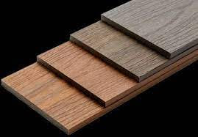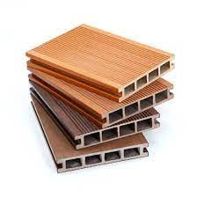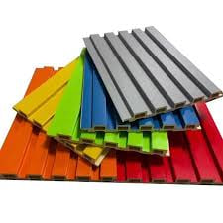
Figure 2.1: WPC products for home furniture (Nukala et al., 2022)

2.3 Properties of Composite Materials
Composite materials have several unique properties that make them ideal for a variety of applications that stated in short summary as the following (Gay, 2022):
High Strength-to-Weight Ratio: Composite materials are renowned for their enhanced strength-to-weight ratio, and therefore their application is demanded where weight reduction is demanded. They are lighter but stronger than traditional materials, and therefore they get their applications in aerospace, automotive, and sporting equipment (Bhong et al., 2023).
Corrosion Resistance: Composites are corrosion-resistant and have the capability of enduring harsh conditions and are therefore suitable for use in home tiles, marine applications, and infrastructure construction (Ngo, 2020).
Impact and Fatigue Resistance: Composites have high impact and fatigue resistances that are suitable for use in high-performance applications such as aerospace and automotive industries. Composites are capable of enduring repetitive loading without failure and impact loading without breaking or deforming and are therefore suitable for use in such applications (Wei et al., 2022).
Design Flexibility: Composites have the ability to be designed to suit specific requirements and are therefore suitable for use in custom applications (Gay, 2022).
Anisotropic Behavior: Composites have the ability to be designed such that they exhibit anisotropic properties, meaning their properties vary depending on the measuring direction. Composites are therefore suitable for use in applications where their properties are required to be tailored in specific directions of loading (Somireddy & Czekanski, 2020).
Chemical/environmental stability: Composite materials can possess excellent chemical and environmental stability, i.e., be resistant to corrosion, degradation, or damage when exposed to aggressive chemicals or environmental factors. This renders them suitable for application in corrosive or severe environments (Wei et al., 2022).
Electrical Properties: Composite materials like high-pressure fiberglass (G10) possess good electrical properties and can be used to make custom circuit boards (Bochkareva et al., 2023).
Thermal Properties: Composite materials also possess unique thermal properties such as thermal conductivity and coefficients of thermal expansion. These unique thermal properties can be used to meet specific requirements and can find potential applications in situations where thermal management is critical (Kashfipour et al., 2018).

2.4 Types of Composite Materials
Composite materials are of various types, one type for specific application based on the type of reinforcement and matrix. Composite materials are material fabricated from the combination of two or more constituent materials possessing predominantly distinct chemical or physical properties (Burgada et al., 2021). One of the most common is Metal Matrix Composites (MMCs), a metal matrix of materials such as titanium or aluminum strengthened with boron or silicon carbide fibers. They have high stiffness, strength, and resistance to heat, and are therefore suitable to be utilized in aerospace, automotive, and structural applications (Bhong et al., 2023). Another is Ceramic Matrix Composites (CMCs), which is a combination of a ceramic matrix; such as silicon carbide or alumina, strengthened with ceramic materials. CMCs have very good heat resistance, hardness, and toughness, and are commonly employed in areas where metals or polymers would deteriorate, e.g., in jet engine or cutting tools (Sumithra et al., 2023).
According to Ma and Elkin (2022) explanation the third category is Sandwich Composites, two thin, resilient outer facings held together by a light-weight core material. This structure is extremely stiff to weight and strong to weight, and it happens that sandwich composites are excellently suited to aerospace, marine, and construction use. A second highly prevalent category of composites is Fiber Reinforced Polymer (FRP) Composites, high-strength fibers glass, carbon, or aramid scattered in a polymer matrix. FRPs are valued for their low weight, corrosion resistance, and satisfactory mechanical performance, and are extensively used in the automobile, sports industries, and building materials (Rajak et al., 2021).
Wood Plastic Composites (WPCs) are widely recognized as a type of fiber-reinforced polymer composite that makes up a progressively developing market for composite materials. WPCs bridge the difference between wood’s appearance and stiffness, as well as plastic’s hardness and low maintenance needs (Mylsamy et al., 2024). WPCs are composed of a mixture of wood flour or sawdust and thermoplastics such as polyethylene, polypropylene, or polyvinyl chloride, which have numerous advantages such as moisture, insects, or rot resistance, as well as cost-effectiveness and eco-friendliness, thus making it a suitable substitute for natural wood products (Mitaľová et al., 2024). In most cases, wood plastic composites are prepared through an extrusion process that involves melting and softening a mixture of different constituents and then shaping it into a specific form through various types of extruder designs. Wood plastic composites are strong and recyclable materials with good aesthetic properties and are used in various applications such as domestic furniture, flooring, and construction, offering a sustainable option as opposed to deforestation and plastic waste issues (Boztoprak, 2024).

2.5 Wood Plastic Composites (WPCs)
Wood-plastic composites refer to materials made up of mixtures of lignocellulosic materials such as wood flour, sawdust, and natural fibers and thermoplastic materials such as polyethylene, polypropylene, and polyethylene terephthalate (PET) (Encina, 2021). In this case, the thermoplastic materials act as binders to the lignocellulosic materials and provide the lignocellulosic materials with resistance to water, and the lignocellulosic materials provide the materials with mechanical properties. This combined interaction between the reinforcement and matrix enhances the material to become even better than an addition of its components (Ramli, 2024).

2.5.1 Composition of Wood Plastic Composite (WPC) Materials
Wood plastic composite (WPC) materials are usually made by blending wood flour or fibers with thermoplastics, which include recycled plastics such as polyethylene terephthalate (PET). The choice of materials varies depending on the producer as well as the final product’s use (Elamin et al., 2020). Of the common materials used in the manufacture of WPC in home furniture production are:
Wood Fibers or flour: Wood fibers or flour, which are derived from hardwoods and softwoods, impart the natural look and touch of wood to composite items. The fibers are usually derived from wood waste or recycled wood items (Xu et al., 2023).
Thermoplastics: The binding agent of the Wood Plastic Composite (WPC) used here consists of thermoplastics. It consists of recyclable plastics such as PE, PET, PP, and PVC, which act as the binding agents of the WPC. These plastics not only add to the durability of the WPC but also to its weather resistance, as mentioned by Patti et al. (2020).
Additives: Additives can also be added to the composite material for enhancing the properties of the composite material. The commonly used additives include coupling agents, UV stabilizers, pigments, flame retardants, etc. (Shahani et al., 2021).

2.5.2 Sawdust as Reinforcement in WPCs
Sawdust is being widely used as a reinforcing material in wood plastic composites (WPCs) due to its low cost, natural origin, and mechanical properties. Being a byproduct from wood working industries such as sawmills and furniture production, sawdust provides a green and cost-effective source for composite production. Chemical characteristics and the properties of sawdust play a critical role in the behavior and performance of the resulting WPCs (Kılıç et al., 2023).
Rahman and Khondoker (2024) discussed that sawdust is a regular particle-size, high-availability material whose mechanical characteristics influence the interface interaction with the polymer matrix and dispersion significantly. Wood composites (WPCs) are reinforced with sawdust to increase their stiffness and resistance to deformation. Sawdust is a renewable resource that may be converted into a sustainable substance using green chemistry. With trace levels of extractives, it is composed of cellulose, hemicellulose, and lignin. Cellulose provides rigidity and strength due to its crystalline structure, whereas hemicellulose contributes water absorption and flexibility. Lignin is a natural adhesive that encourages heat stability (Matar, 2022).
Sawdust is a cost-effective and plentiful filler material for WPCs. Because of its reasonable price, it is a financially viable filler material for WPCs, where cost-effectiveness is a factor. Its light weight lowers the WPCs' overall density and facilitates handling and transportation. Its natural origin aligns with the growing need for sustainable materials and enhances their suitability for use in furniture applications (Sikhosana et al., 2025).
According to Teacă et al. (2023), sawdust presents challenges that range from being highly hydrophilic and having a high affinity for moisture absorption. Being hydrophilic means that it has an affinity for water; when it is mixed with hydrophobic polymer matrices, it leads to poor interfacial adhesion, which reduces its mechanical strength. Surface treatments, coupling agents, or chemical modifications are generally employed to overcome these issues (Robert et al., 2024). By identifying and maximizing sawdust characteristics and limitations, this research aims to produce WPCs that are cost-effective, sustainable, and durable for Ethiopian domestic furniture consumption.

2.5.3 Recycled Polyethylene Terephthalate (rPET) as a Matrix
Polyethylene Terephthalate (PET) is a polymer which has a chemical formula (C₁₀H₈O₄)_{n} with preferable mechanical, chemical, and thermal attributes. It utilized in packaging, textile and engineering plastic due to its high tensile strength, stiffness, and impact resistance (Ferahtia, 2021). Its thermal stability and minor thermal expansion coefficient qualify it as an excellent application for high temperatures. PET has excellent chemical resistance to nearly all acids, alkalis, and organic solvents and is thus well suited to barrier properties. Its optical clarity and transparency make it suitable to be used in clear visibility applications of packaging. PET-G and PET-P are high-performance materials that can be used for making automobile parts, electrical components, and medical devices (Ferede et al., 2024).
Wood plastic composites (WPCs) contain recycled polyethylene terephthalate as a green matrix material that improves its mechanical and thermal properties. The addition of recycled PET improves the recyclability of plastic wastes. The excellent properties of PET, its recyclability, and its ability to blend with reinforcement materials such as sawdust make it a highly sought-after versatile material that can be used for various applications (Singh et al., 2021).
PET is a strong and durable material that can be used for making various products due to its tensile strength and resistance to impact. Therefore, it is used for making food containers and beverage bottles (Sousa et al., 2021). Its recyclability spawns the issues of contamination and high energy processing. Mechanical recycling can diminish the polymer's properties, but chemical recycling is able to re-form it to its original virgin monomer form (Serra et al., 2021). rPET is thermally stable and mechanically robust, which can be utilized effectively in wood plastic composites (WPCs). Utilization of rPET is helpful in waste reduction and promotes sustainability by minimizing virgin plastic reliance and promoting circular economy practices, along with being cost-effective as an alternative for composite production (Ngo, 2020).
Table 2.1: Physical and chemical properties of PET
S/N | Property | Test method | Value
1 | Molecular weight |  | 192 g/mol
2 | Density |  | 1.41 g/cm³
3 | Glass transition temperature | DSC | 69-115 $℃$
4 | Melting temperature | DSC | 265 $℃$
5 | Breaking strength | Tensile | 50 Mpa
6 | Tensile strength |  | 1700 Mpa
7 | Impact strength | ASTM D256-86 | 90 J/m
8 | Water absorption (after 24 hrs.) |  | 0.5%

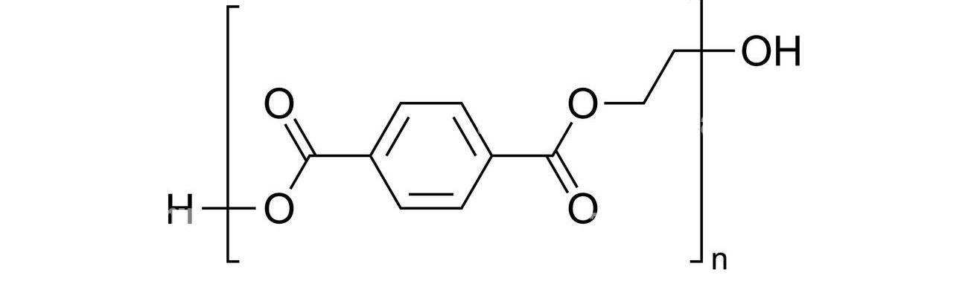
Figure 2.2: PET repeating unit
By exploiting the characteristics and properties of rPET, this study aims to produce WPCs that are cost-effective as well as eco-friendly. The application of rPET as a matrix material enhances the sustainability of the composite and meets performance requirements for domestic furniture use.

2.5.4 Additive Materials for WPC Production
Additives used to modify the performance, processability, matrix-endurance bonding of wood plastic composites (WPCs). Additives help in compensating for hydrophilic natural fiber-hydrophobic thermoplastic compatibility, moisture, heat stability, and mechanical strength problems. By applying sharp selection and addition of additives, WPC formulations can be optimized for enhanced structural integrity, appearance, and lifespan (Shahani et al., 2021).
As per the discussion by (Boztoprak, 2024), during manufacturing of WPC, additives are used to improve interfacial adhesion and mechanical properties of WPC. Coupling agents, such as maleic anhydride grafted polyethylene (MAPE), are used to improve compatibility between hydrophilic sawdust and hydrophobic PET, which improves interfacial adhesion and mechanical properties of WPC. Lubricants, including internal stearates and external paraffin wax, are used to reduce friction and wear of processing equipment so that energy is saved (Nechifor et al., 2022).
Colorants are employed to improve the aesthetic appeal of WPCs by replicating the natural wood or needed finishes. Organic and inorganic pigments may be used depending on application and required stability against colors. Colorants not only create visual appeal but also enhance the value of WPC products, especially for consumer-oriented applications like furniture (Marin et al., 2023).
Stabilizers, as proposed by (Burgada et al., 2021), are required to improve the UV and thermal stability of WPCs. This would prevent degradation of the WPCs during processing as well as during long-term exposure to ambient conditions. Thermal stabilizers, for example, calcium stearate or zinc oxide, are used to prevent degradation of the polymer during processing due to high temperatures. UV stabilizers, for example, hindered amine light stabilizers (HALS) or UV absorbers, are required to prevent degradation of WPCs due to exposure to UV radiation, which may cause discolouration, cracks, or loss of mechanical properties. These stabilizers are important in acquiring the lifespan of WPCs for exterior use (Korol et al., 2020).

2.5.5 Advantages of maleic anhydride over other additives in the production of WPC
As explained by Korol et al. (2020), reinforcement additives are pivotal in the improvement of the properties of wood-plastic composite (WPCs) by addressing the challenges involved in the integration of lignocellulosic fillers such as sawdust with thermoplastics such as recycled polyethylene terephthalate (rPET). The integration improves the properties, durability, and aesthetic value of WPCs (Shahani et al., 2021).
Maleic anhydride (MA), in the form of maleic anhydride-grafted polyethylene (MAPE) and maleic anhydride-grafted polypropylene (MAPP), is used in the production of WPCs as a coupling agent. Therefore, MA makes a significant contribution to the improvement of the mechanical and physical properties of WPCs. Compared to other reinforcement additives used in the production of WPCs, the following are the advantages of using MA in the production of WPCs (Nechifor et al., 2022).
Maleic anhydride is an effective and economical additive used in the production of WPCs. The additive improves the adhesion between the matrix and the fibers, thereby enhancing the mechanical and physical properties of WPCs in addition to improving the moisture resistance of the composite material (Serra et al., 2021). The efficiency of MA is attributed to the chemical reactions between the hydroxyl groups in the wood fillers and the matrix. The efficiency of MA in the production of WPCs improves the mechanical properties and the moisture resistance of the composite material. The enhancement of the properties of WPCs is attributed to the improvement in the adhesion between the matrix and the fillers. Maleic anhydride also improves the thermal stability of WPCs (Rindayatno et al., 2023). The enhancement of the thermal stability of WPCs is attributed to the ability of MA to improve the processing of the composite material at high temperatures without degrading the wood fillers. MA also improves the dispersion of the fillers in the matrix (Burgada et al., 2021). MA is compatible with PE- and PP-based WPCs. MA is also economical compared to other coupling agents used in the production of WPCs. MA does not require special treatment. MA is economical because the additive does not require special treatment during the blending of the composite material. The special treatment would increase the energy required during the blending of the composite material (Marin et al., 2023).

2.5.6 Advantage of WPC over MDF
The advantages offered by wood and plastic composites, such as durability, sustainability, low maintenance, cost-effectiveness, safety, and versatility, make them the preferred choice for replacing traditional wood and plastic materials (Dolca et al., 2021; Shahani et al., 2021). These composites can be used for making furniture for home use, as they offer the advantage of durability and longevity, even for heavy-duty use, such as outdoor furniture. They also offer the advantage of environmental sustainability, as they can be made from recycled plastics and wood, thereby promoting the current trend of going green in furniture making. Furthermore, wood and plastic composites can offer the advantage of cost-effectiveness compared to wood furniture (Nukala et al., 2022).
Medium-density fiberboards (MDF) are wood-based panels that contain synthetic adhesives and approximately 80% ligno-cellulosic fibers. These panels can be manufactured through a dry process that uses heat and pressure. Medium-density fiberboards find widespread application in the furniture industry because of the advantages they offer, such as low cost, a weight-to-strength ratio, and ease of processability (Dunky, 2025).
However, according to (Mohammed & Meincken, 2023), Wood Plastic Composite (WPC) has emerged as a product that offers more advantages compared to Medium Density Fiberboard (MDF) in its application in various sectors because of the advantages it possesses over MDF. These advantages include its high moisture and water resistance, durability, mechanical properties, sustainability, and low maintenance, making it more useful for application in furniture making compared to MDF. Its hydrophobic nature makes it more resistant to water, making it more useful for application in environments where water is present, and its composite nature makes it more resistant to impact and toughness, making it more useful for application in situations where these properties are required. Furthermore, its sustainability is an advantage over MDF, as it is made from recycled materials, making it more environmentally sustainable compared to MDF, whose disposal also causes environmental pollution. Its low maintenance is also an advantage over MDF, making it more cost-effective, even though it is more expensive compared to MDF (Xu et al., 2021).
Table 2.2: A comparative differences between WPC and MDF
Property | WPC | MDF | Conclusion
Moisture Resistance | Excellent | Poor | WPC superior
Mechanical Rigidity | Moderate | High | MDF superior
Durability | High | Moderate | WPC superior
Machinability | Difficult | Easy | MDF superior
Environmental Sustainability | High (recycled materials) | Moderate | WPC superior
Source: (Wiedl et al., 2022)
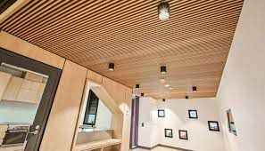
Figure 2.3: Wood/plastic composite application (Burgada et al., 2021)

2.6 Production Methods of WPCs
The manufacturing of wood plastic composites involves different processes aimed at mixing a thermoplastic material such as recycled polyethylene terephthalate (rPET) and lignocellulosic filler material such as sawdust in order to develop a product with preferred properties. The different manufacturing processes of wood plastic composites have different benefits depending on their use. The selection of a manufacturing process for wood plastic composites depends on different factors, including the shape of the product and its properties and quantity of production (Ribeiro et al., 2023).
Wood plastic composites are a class of plotted materials made of wood fibers/flour and a thermoplastic polymer. These materials are developed in a way that they have the best properties of both wood and plastics. Wood plastic composites have been researched in different ways for their use in home furniture (Schwarzkopf, 2023). Different factors have been found to play a crucial role in the properties of wood plastic composites for home furniture. These factors include the materials and process of production, characterization of wood plastic composites, and environmental factors (Nukala et al., 2022). The major composition of most composites includes only two phases: a dispersed phase and a continuous matrix phase. The properties of composites are usually related to the properties of the phases and their proportions and the shape of the dispersed phase (Migneault, 2024).
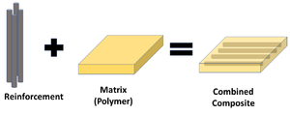
Figure 2.4: Fundamentals of composite materials (Schwarzkopf, 2023)
By mixing several components with unique qualities, composite materials are created using composite manufacturing procedures. These techniques involve shaping and curing the composite materials to achieve the desired final product, with some commonly used techniques being (Renner et al., 2021):

2.6.1 Extrusion Molding
Extrusion molding is one of the most common methods of composite material production, in which a heated barrel is used to shape the materials, such as thermoplastics and thermosetting polymers, to produce the required product (Zhang et al., 2023). The process of extrusion molding can be explained by the following steps:
- Material Selection and Preparation: The first step in the production of WPCs for home furniture is the selection of the required materials. High-quality wood fibers or flour, along with thermoplastics such as polyethylene, polypropylene, and PVC, is used in the production of WPCs (Azman et al., 2021; Shahani et al., 2021).
- Mixing and Blending: After the selection of the required materials, the next step in the production of WPCs is the mixing and blending of the materials, in which the wood fibers or flour is blended with the thermoplastics by the use of specialized equipment such as twin-screw extruders (Burgada et al., 2021; Renner et al., 2021).
- Extrusion and Molding: After the wood-plastic composite (WPC) is adequately mixed and blended, it is then pushed through an extrusion process to obtain the desired shape. This process allows for full control over the shape and look of the final product. The extruded wood-plastic composite can then be molded to obtain intricately designed furniture pieces through molding techniques such as injection molding and compression molding (Dolca et al., 2021; Shahani et al., 2021).
- Cooling and Solidification: After leaving the extruder die, the WPC compound is cooled to take the desired shape.
- Surface Treatment and Finishing: To give a superior look to WPC furniture components, surface treatment is done to ensure improved appearance and performance of the final products. This includes processes such as sanding, painting, or coating (Nečasová et al., 2019).
- Quality Control and Testing: During the development of WPCs, quality control is maintained to ensure that WPCs meet industry standards for home furniture components. This includes carrying out various quality tests to ensure that WPCs perform well in different climatic conditions (Bhaskar et al., 2021).
Extrusion molding is a highly efficient and cost-effective composite manufacturing technique that offers several advantages over other methods. It allows for rapid production rates, minimal material waste, and consistent material properties, resulting in high-quality products (Chohan et al., 2022). It can produce a wide range of shapes and sizes, making it suitable for various applications. There are various types of extrusion molding techniques, including continuous extrusion, batch extrusion, co-extrusion, and multi-layer extrusion. It is used in various industries, including automotive, aerospace, construction, and electrical and electronic applications (Shahani et al., 2021).
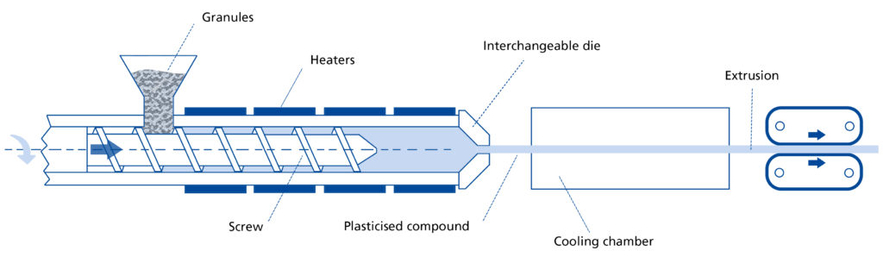
Figure 2.5: Schematic Diagram of Extrusion molding (Zhang et al., 2023)

2.6.2 Injection Molding
Injection molding is a manufacturing process that involves injecting molten thermoplastic material into a mold under high pressure, forming a solid composite part. This technique is commonly used in the electronics industry for small, complex parts (Rabbi et al., 2021). The process involves material selection, preparation, heating, cooling, and solidification. The composite material is then injected into a steel mold, which is designed to give the final product its desired shape and dimensions (Wang et al., 2021). The material then cools and solidifies, retaining its structural integrity. The final product is ejected from the mold cavity, which may undergo additional finishing processes. Injection molding offers advantages such as complex geometries, high strength-to-weight ratio, and cost-effectiveness for large quantities of composite parts (Jeong et al., 2022).
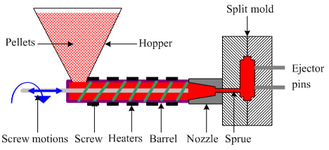
Figure 2.6: schematic representation of injection molding (Khosravani & Nasiri, 2020)

2.6.3 Resin Transfer Molding (RTM)
Resin transfer molding (RTM) is a closed-mold process that involves injecting resin into a pre-placed fiber reinforcement. The resin is injected under pressure, which allows it to completely saturate the reinforcement and produce a high-quality composite part. This technique is commonly used in the automotive and aerospace industries (Miranda Campos et al., 2022).
Resin Transfer Molding (RTM) is a process where resin is injected into a dry reinforcement stack using a pump or pressure pot at higher pressures. Injection pressures can range from 10-20 bar (150-300psi) and can reach up to 100 bar (1500psi) in high production methods like High-Pressure RTM (HP-RTM). This rapid injection and high temperature make RTM and compression molding fast and efficient. Many resin manufacturers have developed "snap-cure" resins for RTM and compression molding to reduce cycle time and make composites more competitive with metals and injection molding for high-volume applications. HP-RTM is best for large runs of smaller parts and requires higher tooling and equipment costs (Agwa et al., 2022).
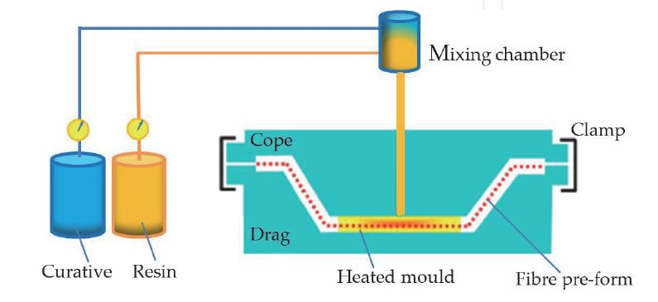
Figure 2.7: The schematic Diagram of the RTM process (Miranda Campos et al., 2022)

2.6.4 Compression Molding
Compression molding is a process that involves placing fiber reinforcement into a heated mold and applying pressure to consolidate the material. The resin matrix is then introduced into the mold, and the entire assembly is cured under heat and pressure. This technique is commonly used to manufacture large, complex composite parts, such as those used in the wind energy industry (Tatara, 2024). Compression molding can be done with thermoset or thermoplastic resins and a wide variety of fiber types and lengths. It can produce complex geometries and variable part thickness, making composite parts functionally similar to metal castings. Hybrid processes, like gap RTM, bridge the gap by injecting resin into a slightly-open mold and compressing it (Rajeshkumar et al., 2023).
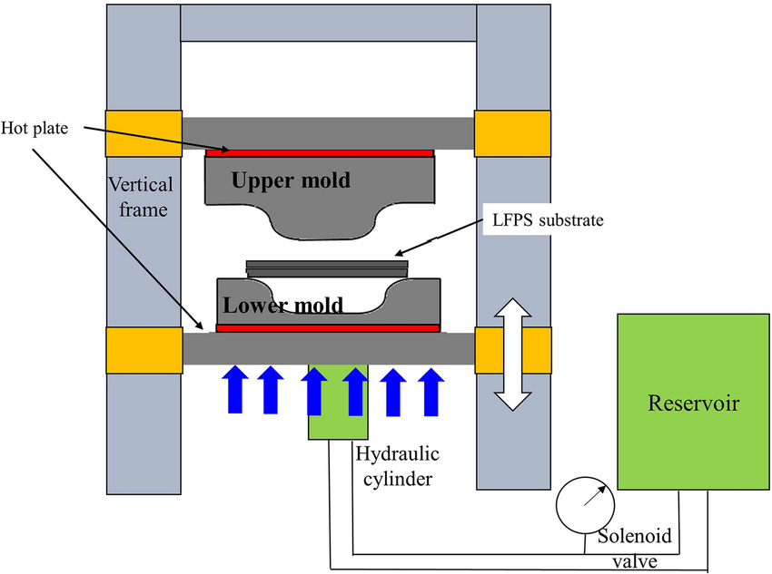
Figure 2.8: Schematic diagram of Compression molding (Li et al., 2022)

2.6.5 Layup
Layup is a composite manufacturing technique that involves placing fiber reinforcement layers into a mold and saturating them with a resin matrix as shown in the figure 2.7 (a) below. This technique is widely used in industries like aerospace, automotive, and sporting goods. Automated fiber placement (AFP) and Automatic tape laying (ATL) are processes that use robots to apply reinforcement to a mold surface, with tows either dry or pre-preg and a thermoplastic or thermoset resin system (Hall et al., 2021). These processes are expensive and complicated, making them suitable for large-scale projects with large parts to produce. However, progress is being made to make automated composites a reality at smaller and less expensive scales (Youssef et al., 2019).
Rollers or brushes are used to manually apply resin. Because the matrix is applied by hand, a low-viscosity resin is preferred for hand lay-up, and it might be challenging to wet-out heavy-weight fabric or composites with a high fiber volume fraction. To improve wet-out, resin can be forced into textiles using nip-roller impregnator devices (Patpatiya et al., 2022).

2.6.6 Spray Up
There are machines that mix resin and spray it out of a gun along with little short strands of fiberglass roving. Generally called “chopper guns” or “spray-up” equipment, these machines combined with a skilled operator can laminate really fast – and depending on the attention paid to rolling the laminate potentially neatly. The resulting laminate is not high performance. It is resin rich: easily 60% resin by weight and thickness is variable and often hard to control (Ayana et al., 2022).
For parts where weight isn’t an issue, but gel coated surfaces and complex geometry are – it can be ideal. Machinery housings, vehicle panels, shower enclosures, tanks… there are many applications where spray-up laminating is a great option. It can be miserable work though and requires good personal protection equipment and a good air circulation system. The output is highly worker-dependent and poor attention to detail can result in voids, porosity and surface distortion (Singh et al., 2020).

2.6.7 Open Molding
Open molding is the process of “wetting-out” dry reinforcements with resin in a mold without using any additional consolidation step. The reinforcements can be wet-out in place or on a table or even run through a fabric impregnator – a machine used to wet out large volumes of reinforcement at a time (Li et al., 2022). The results are highly dependent on the skill of the team doing the work, and like spray-up, rolling the laminate to remove air is a critical step. Because reinforcements are cut off rolls and placed in the mold, the thickness is much more consistent. Laminators must be aware of slip joints in corners and be careful to orient plies correctly. All this happens under the constant ticking clock of the resin’s gel time and once the resin starts to cure, times up (Ghosh et al., 2020).
Open molding is ideal for projects requiring continuous fiber strength, complex geometry, and gelcoat finish. Parts can have variable thickness and reinforcement, using cores like Coremat, foam, and balsa. Epoxy laminates are often vacuum bagged due to cost and viscosity (Arulprasanna & Omkumar, 2024).
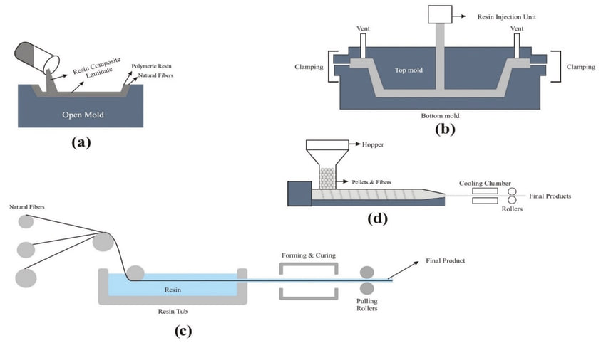
Figure 2.9: Different fabrication methods
(a) Hand layup (b) Resin transfer molding (c) Pultrusion (d) Extrusion (Ashraf et al., 2020).

2.6.8 Infusion
With vacuum infusion, you place a stack of dry fiber reinforcement in the mold followed by a vacuum bag with some fancy plumbing over the top. Then you pull a vacuum on the stuff under the bag, and allow the pressure differential between the inside of the bag and the outside to push some resin into the dry laminate. That’s vacuum infusion! It’s not intuitive and you really have to see it to get what’s happening (Hindersmann, 2022).
Infusion can be done with disposable vacuum bags, re-usable vacuum bags (CCBM) and even hard two-sided tooling; which is sometimes called “vacuum assisted transfer molding” in engineer context. Because of the potential for careful fiber and core loading, repeatable resin content and re-usable vacuum bags, infusion is a great choice for production. Once the process is dialed in, variability can be low and part quality high; especially because resin fills in any potential voids (Agwa et al., 2022).

2.6.9 Pultrusion
Pultrusion is a pull process that uses wet fiber and resin to create long, consistent sections in a shaped die. It is accurate and economical, making it a great option for long skinny things that might replace metal extrusions. However, setting up can be time-consuming and requires specialized equipment. Die designs are expensive and must be carefully designed. Composite pultruded parts can be used in railings, tubes, decking, and structural profiles (Minchenkov et al., 2021). Alternatively, a pultrusion specialist or pre-manufactured stock profiles can be used and represent in the figure 2.7 (d) above.

2.6.10 Filament Winding
Filament winding is a well-developed industrial process used for manufacturing tubular items and simple revolved shapes like pressure tanks, tapered poles, and spars. It involves wrapping wet fiber over a mandrel in a pre-designed way, controlled by a carriage with a winding guide (Azeem et al., 2022). The process is typically open molded, with wet fiber wrapped and consolidated by tension pressure.
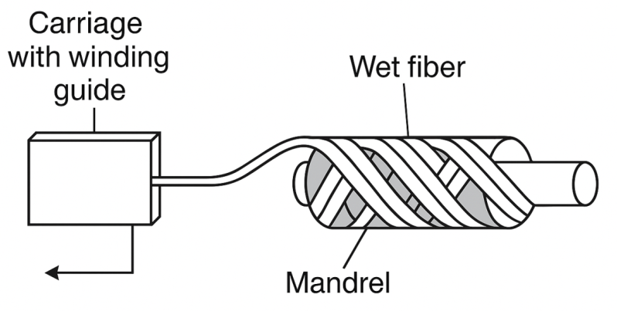
Figure 2.10: Schematic diagram of filament winding (Azeem et al., 2022)
A layer of pull tape is sometimes used before curing for a surface finish. For higher performance parts using carbon fiber and epoxy, a mandrel-wrapped pre-preg manufacturing option is recommended. This process is more expensive but suitable for thicker, highly engineered tubular structures (Patti et al., 2020).

2.7 Parameters Affecting WPC Production
The production of Wood Plastic Composites (WPCs) is a complex process influenced by multiple interrelated parameters that determine the final product’s physical, mechanical, and thermal properties (Otieno, 2020). These parameters include the type and proportion of raw materials, moisture content, and particle size of the wood filler, compatibilizer content, processing temperature, screw speed and pressure during extrusion, and cooling rate (Jian et al., 2022). Understanding and controlling these parameters are essential to achieving consistent quality, optimized performance, and cost-effective manufacturing of WPCs for furniture and other structural applications that are summarized and discussed in the following sub-topics.

2.7.1 Temperature, Pressure, and Mixing Time
As Friedrich (2021) discussion the processing temperature is serious in WPC manufacturing, as it must be high enough to melt the rPET matrix without causing thermal degradation of the sawdust. Typical processing temperatures for rPET-based composites range from 200°C to 250°C (Zhang et al., 2023). Pressure is equally important, as insufficient pressure can lead to voids or poor interfacial adhesion, while excessive pressure may cause fiber damage. Mixing time affects the uniformity of the composite; inadequate mixing can result in agglomerates of sawdust, while excessive mixing may degrade the materials due to prolonged exposure to heat and shear forces (Wang et al., 2021).

2.7.2 Sawdust Content
The proportion of sawdust in the composite significantly influences its mechanical and physical properties. Higher sawdust content typically increases stiffness and reduces material costs but can lead to reduced impact resistance and moisture resistance. Balancing the wood-to-plastic ratio is better for optimizing performance (Rahman & Khondoker, 2024).

2.7.3 Use of Additives
Additives such as coupling agents, lubricants, and stabilizers play a vital role in enhancing WPC performance. Coupling agents like maleic anhydride grafted polyethylene (MAPE) improve interfacial adhesion between the hydrophilic sawdust and the hydrophobic polymer matrix, enhancing tensile and flexural strength. Stabilizers provide thermal and UV resistance, prolonging the composite's lifespan (Boztoprak, 2024).

2.7.4 Processing Conditions
Processing parameters, including temperature, pressure, and mixing time, directly affect the quality of the composite. Optimal conditions ensure uniform dispersion of sawdust, reduce voids, and prevent thermal degradation of the materials. Poor control of processing conditions can lead to weakened interfacial bonding and compromised mechanical properties (Migneault, 2024).
By evaluating those properties and factors, better WPC can be developed in a comprehensive understanding of the performance characteristics of the product made from recycled polyethylene terephthalate (rPET) and sawdust. These insights will inform the optimization of material formulations and processing techniques for furniture applications.

2.7.5 Particle Size and Loading Ratios of Reinforcement and Matrix
The particle size of sawdust plays a fundamental role in determining the mechanical properties and surface finish of the WPC. Smaller particles provide a larger surface area for interaction with the matrix, improving adhesion, but may reduce stiffness. Conversely, larger particles enhance stiffness but may lead to surface irregularities (Singh et al., 2020). The loading ratio of sawdust to rPET also significantly impacts the composite’s properties. Higher wood content increases stiffness and reduces material costs but can compromise toughness and moisture resistance. Optimizing the reinforcement-to-matrix ratio is essential to achieve a balance between mechanical performance and processing efficiency (Ramesh et al., 2022).
The integration of these production methods and parameters was critical in this study to develop high-quality WPCs tailored for home furniture applications. By systematically analyzing the effects of temperature, pressure, mixing time, particle size, and loading ratios, this research aims to achieve a composite material with superior mechanical, thermal, and aesthetic properties.

2.8 Characterization of WPCs
A recently developed material called wood plastic composite combines thermoplastic polymers with wood flour, particles, or fibers. It has several benefits, including extended service life, excellent durability, and little maintenance. It may be made from repurposed materials and enhanced with additions (Ngo, 2020).
Wood plastic composite material is a reversible recycling process using low-plant biomass fibers like sawdust, bamboo chips, and rice husk. It uses macromolecule interfacial chemistry and plastic filling characteristics, and is referred to as plastic wood, environmental protection wood, science and technology wood, recycled wood, and aggregate wood(Delviawan et al., 2019).
WPC material effectively utilizes waste from various sources, offering 100% plasticizability and varying properties. It is environmentally friendly, cost-economizing, and can be recycled and regenerated. The synthetic wood and plastic base materials and additives are non-toxic and harmless, reducing potential dangers to humans and the environment. 100% recycling of wood plastic scraps ensures resource utilization without affecting performance (Aisyah et al., 2021; Liu et al., 2022).
Barbos et al. (2020) stated that, the characterization of wood plastic composites (WPCs) is a critical step in assessing their suitability for various applications. This process involves evaluating the mechanical, physical, thermal, and morphological properties of the composite material to ensure it meets the desired performance criteria. Comprehensive testing provides insights into the effects of material composition, processing parameters, and the inclusion of additives on the properties of WPCs (Ayana et al., 2024).

2.8.1 Mechanical Properties
The mechanical properties of Wood Plastic Composites (WPCs) are key indicators of their structural performance and durability, particularly in load-bearing applications like furniture. These properties encompass the composite's resistance to external forces such as tension, compression, and bending, affecting its safety and service life (Elamin et al., 2020). Factors influencing these properties include the type and proportion of reinforcement (sawdust or wood fiber), the polymer matrix (recycled polyethylene terephthalate, rPET), interfacial bonding efficiency, and processing quality. Coupling agents like maleic anhydride polyethylene (MAPE) enhance adhesion between wood fibers and the polymer, improving overall mechanical performance (Morcillo et al., 2021).
Tensile strength signifies the maximal stress a composite can sustain under tension, critical for components like legs and frames. This strength is determined by fiber-matrix adhesion and stress transfer, with optimal wood fiber content (30-50% by weight) enhancing tensile strength. rPET improves performance due to its stiffness and crystallinity, showing up to a 25-30% enhancement compared to neat polymers, as noted by Zhang et al. (2023).
According to Serra et al. (2021) explanation flexural strength, or modulus of rupture, gauges a composite’s resistance to bending forces, essential for items like tabletops. This property is influenced by fiber stiffness and interfacial bonding; uniform fiber distribution enhances strength. WPCs with sawdust and rPET exhibit improved rigidity, with wood flour addition up to 30% significantly increasing flexural modulus, although exceeding this can disrupt matrix continuity (Jian et al., 2022).
Impact resistance reflects a composite's ability to absorb energy under dynamic loads, critical for furniture exposed to impacts. This behavior is shaped by polymer ductility, fiber toughness, and bonding quality; poor bonding results in brittle fractures, while good bonding provides higher energy absorption. rPET enhances impact strength compared to softer matrices, yet excessive wood content can reduce resilience (Matar, 2022).
Ultimately, the mechanical behavior of WPCs relies on balancing stiffness, strength, and toughness. Strong interfacial adhesion and fiber dispersion are necessary for high tensile and flexural strength, while ductile polymer content is vital for impact resistance (Johnson, 2023). Proper selection of sawdust to rPET ratios and processing conditions is crucial for optimal performance, positioning WPCs as a sustainable alternative to conventional wood products in Ethiopia's furniture industry, aligning with green manufacturing goals (Tiruneh, 2021).

2.8.2 Physical Properties
The physical properties of Wood Plastic Composites (WPCs), including density, water absorption, and swelling, are major important for understanding their behavior in various environmental conditions (Boztoprak, 2024). Density serves as a key indicator of the material's compactness and structure, influencing weight, strength, and durability. WPCs typically exhibit a density range of 0.8 to 1.3 g/cm³, which varies depending on the polymer type and wood filler used (Delviawan et al., 2019). Higher densities may indicate better mechanical integrity, while lower densities can indicate porosity that could weaken the material. Achieving uniform density is essential for high-quality composites and requires careful control during processing (Nečasová et al., 2019).
According to Ferahtia (2021) explanation water absorption is a critical measure of WPCs' environmental resistance, especially in moisture-prone applications like furniture. WPCs are designed to limit water uptake, as excessive moisture can cause swelling and loss of strength. The polymer matrix typically hinders water penetration, but compatibility between wood fibers and polymer is paramount. When using recycled PET, water absorption rates are lower compared to polyethylene or polypropylene, but enhanced by adding compatibilizers that improve fiber-polymer adhesion (Radoor et al., 2021).
Swelling is another important property that reflects how WPCs maintain dimensional stability when exposed to moisture. The degree of swelling depends on factors like wood content and interfacial bond quality, with higher wood content generally leading to increased swelling (Mitaľová et al., 2024). Acceptable swelling values are below 2% for indoor use and up to 5% for outdoor applications, provided coatings are used. The rigidity of rPET minimizes swelling issues, though long-term exposure to varying humidity levels can cause gradual changes (Felix Sahayaraj et al., 2024).
Finally, the physical characteristics of WPCs define their performance in real-world applications, making sawdust-rPET composites advantageous alternatives to traditional wood, especially in environments like Ethiopia where durability and low maintenance are essential for the furniture industry (Mylsamy et al., 2024).
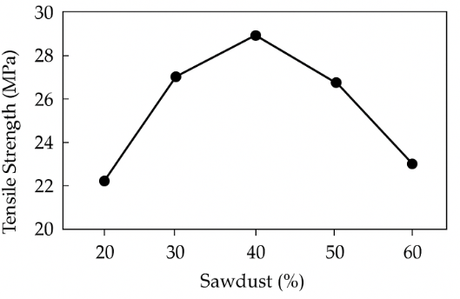
Figure 2.11: Tensile strangeth of WPC from different sadust contents (Ayana et al., 2022).

2.8.3 Thermal Properties
The thermal behavior of Wood Plastic Composites (WPCs) is crucial for their processability, service temperature range, and long-term durability. Key thermal properties, such as thermal stability and melting point, dictate the composite's ability to withstand heat-induced degradation and maintain structural integrity under temperature variations. Research by Li et al. (2022) and Nukala et al. (2022) highlights that thermal stability significantly impacts the performance and lifespan of WPCs, particularly in environments like Ethiopia with high temperature fluctuations and prolonged sun exposure. This is vital for manufacturing optimization and ensuring reliability in applications like outdoor furniture and building materials (Roman et al., 2024).
According to Friedrich (2024a) experimental result thermal stability indicates a material's resistance to degradation under heat, analyzed through Thermogravimetric Analysis (TGA). WPCs typically experience three decomposition stages: moisture evaporation (100°C-150°C), hemicellulose and cellulose decomposition (200°C-350°C), and polymer matrix degradation (beyond 350°C). The inclusion of wood fibers often reduces thermal stability due to the lower degradation temperatures of lignocellulosic components compared to synthetic polymers. The degree of stability reduction depends on the polymer type and the quality of interfacial bonding (Cosse, 2025).
WPCs made from recycled polyethylene terephthalate (rPET) demonstrate significantly higher thermal stability compared to those using polyethylene (PE) or polypropylene (PP), attributed to the rigid aromatic structure of PET, which enhances resistance to heat-induced breakdown (Chawraba & El Mogy, 2025). Meekum (2024) noted that rPET composites can maintain integrity up to 370–400°C compared to 320–340°C for PP- and PE-based WPCs. The use of compatibilizers, such as maleic anhydride polyethylene (MAPE), further increases stability by improving fiber-matrix adhesion, thereby minimizing voids and microcracks that can initiate thermal degradation.
Fiber treatment techniques like alkali or silane modification can also augment thermal stability, particularly relevant in Ethiopia, where the natural variability and moisture content of local sawdust can affect composite stability during processing or service (Ferede et al., 2024).
The melting point (Tm) of a WPC is critical for processing and application suitability, indicating when the crystalline regions of the polymer matrix will melt, allowing material flow during processes like extrusion. Differential Scanning Calorimetry (DSC) is employed to assess melting and crystallization behaviors (Wiedl et al., 2022). For rPET composites, the melting point ranges from 250–260°C, significantly higher than PE's 130°C or PP's 160°C (Ramesh et al., 2022). This superior heat resistance makes rPET-based WPCs ideal for high-temperature environments and outdoor furniture, however, processing can be challenging as wood fibers start thermally degrading between 220°C and 250°C. Therefore, precise temperature control during processing is essential to avoid fiber charring while ensuring adequate polymer flow.
Studies by Lee et al. (2020) and Zeng et al. (2024) found that while the incorporation of wood fibers slightly reduces the crystallinity of the polymer matrix due to limited chain mobility, it does not significantly alter the melting temperature, leading to enhanced toughness and impact resistance; qualities beneficial for furniture subjected to mechanical loads or thermal cycling. Additionally, compatibilized composites demonstrated sharper and more consistent melting peaks in DSC analyses, indicating improved molecular interaction between the polymer and filler (Pacheco et al., 2023).
Local experiments in Ethiopia, particularly from Bahir Dar University’s materials Alemu et al. (2025), reveal promising thermal characteristics for domestically produced rPET-based WPCs, with melting points ranging from 250–258°C, comparable to international reports. This points to the potential for scaling up production of thermally stable, high-performance composites suitable for local climatic conditions.
In comparative assessments, rPET-based WPCs outshine conventional PE- and PP-based composites in thermal properties, making them more suitable for regions with fluctuating temperatures, such as Ethiopia's Rift Valley and central highlands. These advantages necessitate sophisticated processing equipment that maintains tight thermal control to prevent fiber degradation (Wiedl et al., 2022). Optimizing the thermal balance between polymer melting and fiber degradation is critical for achieving desirable properties, and when effectively processed, rPET-sawdust composites offer improved dimensional stability, reduced post-processing shrinkage, and extended service life beneficial attributes for the Ethiopian furniture industry dominated by high-cost imported materials (Weldetsadik & Hirbaye, 2022).
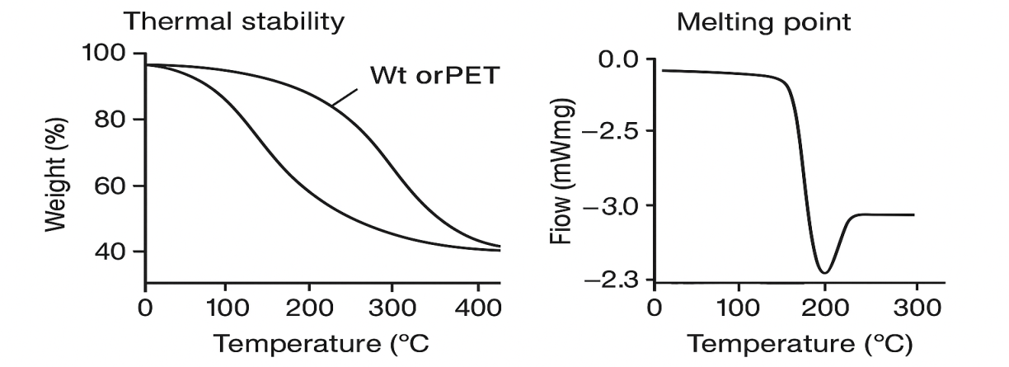
Figure 2.12: Thermal Properties of WPCs (Cosse, 2025; Ramesh et al., 2022)

2.8.4 Morphological Analysis
The morphological characteristic of Wood Plastic Composites (WPCs) is another important parameter for mechanical, physical, and thermal performance. Research indicates that fiber–matrix interfacial adhesion significantly influences stress transfer and overall composite strength, with Scanning Electron Microscopy (SEM) being a key tool for analyzing surface morphology and fracture behavior. Strong interfacial bonds enhance tensile and flexural properties, while poor adhesion can lead to premature failure through fiber pull-out or matrix cracking (Shafik et al., 2021).
A paper studied by Jian et al. (2022) The addition of coupling agents improves compatibility between hydrophilic wood fibers and hydrophobic polymers, leading to better fiber encapsulation and fewer microvoids. Different polymer matrices, like polyethylene, polypropylene, and recycled polyethylene terephthalate (rPET), yield distinct morphological characteristics. For instance, rPET WPCs show compact microstructures at optimal fiber loadings, while higher concentrations can cause agglomeration and decreased performance (Mitaľová et al., 2024).
Research from Ethiopia on locally sourced sawdust and recycled plastics has shown promising results, especially after surface modifications which improve mechanical interlocking and strength (Nuruzzaman et al., 2025). International studies reinforce that surface roughness and fiber aspect ratio are pivotal for bonding strength. Processing conditions also critically affect morphology; controlled environments yield denser microstructures, while high temperatures can cause fiber degradation (Obianyo, 2020).
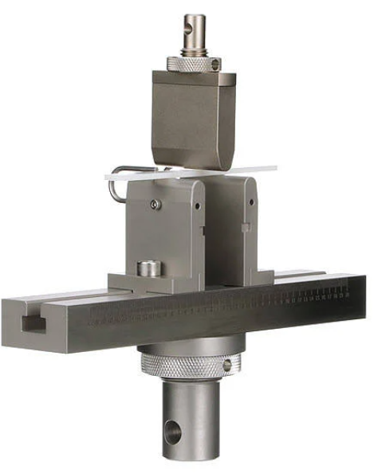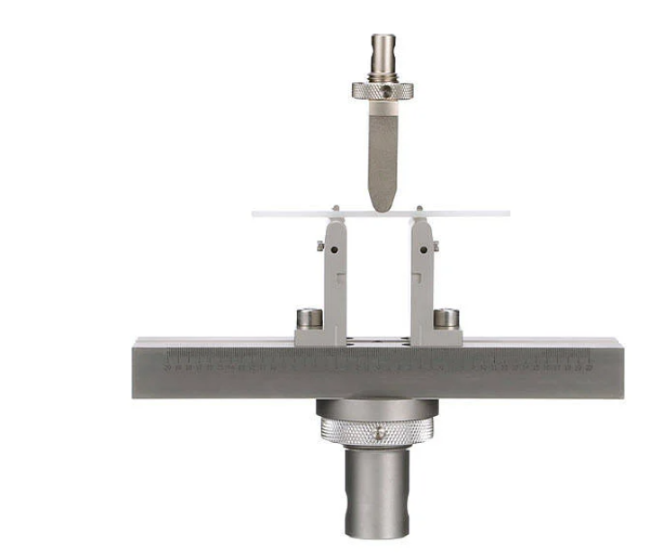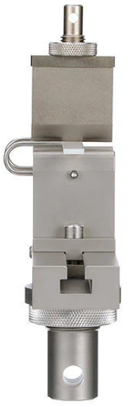
Figure 2.13: ASTM D790 measures the flexural properties test equipment different faces
The correlation between morphological observations and mechanical properties is evident, highlighting the importance of interfacial adhesion. Accourding to different scholars, initial SEM analyses suggest that treated composites demonstrate better morphological integrity than untreated ones. Thus, continuous research on optimizing WPC morphology using local materials is essential for advancing sustainable material innovation in the country (Showaib & ELDeeb, 2025). Generally, understanding structure property relationships through morphological characterization is important to enhancing WPC performance and fostering green manufacturing.

2.9 Applications of Wood Plastic Composites (WPCs)
Wood Plastic Composites (WPCs) are versatile, durable, and sustainable materials that combine the strength of natural fibers with the resilience of thermoplastics. They have gained significant attention across various industries due to their ability to utilize recycled plastics and wood by-products, offering an eco-friendly solution to waste management and deforestation (Sikhosana et al., 2025). In construction, WPCs are widely used for decking, flooring, wall cladding, doors, window frames, and fencing systems, providing superior weather resistance and low maintenance compared to traditional wood. In the automotive industry, WPCs are applied in interior and exterior components such as panels and trunk liners, contributing to lightweight designs that enhance fuel efficiency and sustainability (Friedrich, 2021). They are also used in consumer goods, packaging, and logistics, particularly in reusable pallets and crates, demonstrating their adaptability across diverse applications (Gay, 2022).
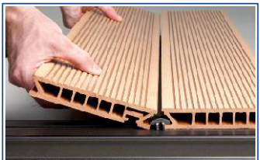
Figure 2.14: WPC applications examples
Arulprasanna and Omkumar (2024) state that, in the furniture industry, WPCs have emerged as an excellent alternative to conventional materials like solid wood and particleboard. Their combination of mechanical strength, moisture resistance, and design flexibility makes them suitable for home, office, and outdoor furniture. WPCs are used to manufacture kitchen and bathroom cabinets, tables, chairs, shelves, and decorative panels, offering wood-like aesthetics with enhanced durability. Flat WPC panels are ideal for tabletops and countertops, while intricately molded components such as chair legs and armrests are produced using injection or extrusion molding techniques to achieve both structural integrity and visual appeal (Bhong et al., 2023). Additionally, modular furniture systems benefit from WPCs’ lightweight and dimensionally stable characteristics, allowing for easy assembly and customization.
The benefits of using WPCs in furniture production are numerous. They are highly durable and resistant to wear, cracking, warping, and environmental degradation, making them suitable for high-use and moisture-prone environments. Their resistance to water, rot, and insects significantly extends product lifespan, reducing maintenance requirements and long-term costs (Chohan et al., 2022). Moreover, WPCs offer aesthetic flexibility, as they can be engineered to replicate the appearance and texture of natural wood while being available in various colors, patterns, and finishes. This design versatility allows manufacturers to cater to diverse consumer preferences and market segments (Ichim et al., 2024).
Despite their advantages, certain challenges limit the widespread use of WPCs in furniture applications. These include relatively lower mechanical strength compared to solid wood, higher initial production costs due to specialized equipment and additives, and difficulties in maintaining consistent quality due to variations in raw materials such as particle size and moisture content (Lee et al., 2020). The thermal sensitivity of natural fibers like sawdust also restricts processing conditions, which can complicate manufacturing. Addressing these issues through material optimization, process control, and improved compatibilization techniques remains essential for enhancing product quality and market competitiveness (Arulprasanna & Omkumar, 2024).
From an environmental and economic perspective, integrating sawdust and recycled polyethylene terephthalate (rPET) into WPC production presents significant advantages. This approach supports sustainable waste management by diverting plastic and wood waste from landfills, conserving natural resources, and reducing reliance on virgin raw materials (Sumithra et al., 2023). Economically, WPC manufacturing can create job opportunities across the recycling, production, and furniture sectors, while promoting cost efficiency through local material sourcing (Ngo, 2020). Inclusively, WPCs represent a promising, scalable solution for eco-friendly and affordable furniture manufacturing in Ethiopia, contributing to both environmental protection and economic growth.

2.10. Environmental Benefits of Using Sawdust and Recycled PET
Recent literature increasingly highlights the environmental significance of using sawdust and recycled polyethylene terephthalate (rPET) in the production of Wood Plastic Composites (WPCs). The integration of these materials aligns with global efforts toward sustainable manufacturing, waste valorization, and the circular economy. Researchers have consistently reported that combining lignocellulosic residues such as sawdust with recycled polymers not only minimizes environmental pollution but also generates durable, cost-effective materials for structural and furniture applications (Chawraba & El Mogy, 2025; Li et al., 2022)and. In both global and Ethiopian contexts, this approach offers a viable solution to two persistent environmental issues; plastic waste accumulation and wood residue disposal while, promoting resource efficiency and climate-resilient production practices.

2.10.1 Reduction of Plastic and Wood Waste
The use of sawdust and recycled PET in WPC production addresses two major environmental challenges: the accumulation of plastic waste and the underutilization of wood byproducts. PET is one of the most widely discarded plastics, with millions of tons generated annually. When incorporated into WPCs, recycled PET reduces the volume of plastic waste that would otherwise persist in landfills and oceans for centuries (Oliveros-Gaviria et al., 2024). Similarly, sawdust, a byproduct of wood processing industries, is often discarded or burned, contributing to environmental pollution. Utilizing sawdust in WPCs diverts this waste toward productive applications, reducing the ecological footprint of wood industries (Duruaku et al., 2023).

2.10.2 Decreased Reliance on Virgin Materials
According to Ayana et al. (2022) discussion, by replacing virgin plastics and wood with recycled PET and sawdust, WPC production conserves natural resources and reduces the demand for energy-intensive material manufacturing. Virgin PET production relies heavily on fossil fuels, while traditional wood products contribute to deforestation and habitat loss. Using recycled PET in WPCs lowers greenhouse gas emissions associated with plastic production, while sawdust usage mitigates the overexploitation of forests. These practices align with the principles of a circular economy, promoting resource efficiency and sustainability (Elamin et al., 2020).

2.10.3 Economic Feasibility of WPC Production
WPCs offer economic advantages when compared to traditional materials like solid wood, particleboard, and virgin plastic composites. Although the initial costs of WPC production may be higher due to the need for specialized equipment and additives, the long-term cost benefits outweigh these expenses (Ramesh et al., 2022). WPCs require less maintenance than wood, as they are resistant to rot, pests, and moisture. Furthermore, using recycled materials like PET and sawdust reduces raw material costs, making WPCs more competitive in price-sensitive markets. For furniture applications, the aesthetic and functional versatility of WPCs further enhances their value proposition compared to traditional materials (Rindayatno et al., 2023).

2.10.4 Potential for Large-Scale Manufacturing
Friedrich (2021) noted that, the scalability of WPC production is another key factor in its economic feasibility. Advances in extrusion, injection molding, and compression molding technologies enable the efficient production of WPCs at industrial scales. Recycled PET is abundantly available from post-consumer waste streams, and sawdust is readily sourced from sawmills and furniture factories, ensuring a consistent supply of raw materials. Additionally, the modularity of WPC production processes allows manufacturers to adapt to varying product specifications and market demands, further supporting large-scale adoption (Basalp et al., 2020).
Governments and industries are increasingly investing in sustainable materials, providing opportunities for WPCs to capture significant market share. The potential for job creation in recycling and WPC manufacturing industries also contributes to socio-economic development, particularly in regions like Ethiopia, where sustainable economic growth is a priority (Shahani et al., 2021).

2.10.5 Reduction of Carbon Footprint and Greenhouse Gas Emissions
Studies consistently report that WPCs made from recycled plastics and wood residues offer considerable carbon emission reductions relative to conventional materials. Chawraba and El Mogy (2025) found that recycling PET requires 60–70% less energy compared to producing virgin PET, significantly lowering the associated greenhouse gas (GHG) emissions. Similarly, Li et al. (2022) demonstrated through Life Cycle Assessment (LCA) that composites made from sawdust and rPET emit nearly 50% less CO₂ than virgin polymer composites.
The environmental benefits extend beyond production energy savings. When wood waste is reused in composites, its carbon remains sequestered within the material for the product’s lifespan, delaying its release into the atmosphere. (Wiedl et al., 2022) observed that carbon retention in WPCs could extend for over 20 years, depending on product application and recycling potential. This makes WPCs a temporary carbon sinks, contributing to net carbon neutrality in the building and furniture sectors. In Ethiopia, where the majority of waste is still disposed of in open dumps, integrating sawdust and recycled plastics into production systems offers a clear path toward reducing GHG emissions from both industrial and municipal waste sources (Kura, 2020).

2.10.6 Synthesis of Findings
In synthesis, the literature clearly establishes that the use of sawdust and recycled PET in WPC manufacturing offers multifaceted environmental advantages. The combination of renewable biomass and recycled polymer leads to waste reduction, energy efficiency, GHG mitigation, and forest conservation (Guo et al., 2024). It also helps address the global challenge of plastic pollution while promoting sustainable material innovation. For Ethiopia, these findings underscore the strategic potential of developing locally sourced WPC industries as part of broader environmental policy and green economy initiatives.
Generally, the reviewed literature demonstrates that sawdust–rPET composites represent not only an eco-friendly alternative to conventional wood and plastic materials but also a practical pathway toward achieving environmental sustainability, circularity, and industrial competitiveness in developing economies (Kumar & Bedi, 2025).
2.11 Literature Gap
Wood-plastic composites (WPCs) have gained increased attention due to their potential to combine the attributes of wood and plastic, resulting in a long-lasting and sustainable alternative to home furniture. However, the literature lacks developing and characterizing WPCs for the application of home furniture with an aim of creating a material with the natural appearance of wood while enhancing durability, resistance to water, good appearance or handling feature and dimensional stability according to the study of Barbos et al. (2020)
Existing Condition of Wood-Plastic Composites (WPCs) in the Furniture Industry Particular problems for household furniture are not given as much attention as broad applications in the furniture industry's current WPC research. There is limited research focusing on the application of sawdust and PET-based WPCs in home furniture (Ribeiro et al., 2023). Studies might not have explored the potential of these composites in the design and production of various types of home furniture. While little research has been done on the mechanical characteristics and production methods of WPCs, nothing is known about how to best optimize WPC compositions for use in furniture (Ramesh et al., 2022).
Though Wood Plastic Composites (WPCs) and natural-fiber–reinforced thermoplastics are widely researched elsewhere, there is a noticeable and actionable missing link both in Ethiopia and the global literature, namely in the application of recycled polyethylene terephthalate (rPET) mixed with sawdust as inputs for furniture manufacture. In the Ethiopian context, few peer-reviewed articles systematically evaluate WPC formulations employing locally available sawdust and post-consumer PET as the primary feedstocks (Kura, 2020). The majority of the studies with a local orientation were virgin thermoplastics with locally available agricultural fibers or generic recycling programs; systematic material-level research that measures mechanical, thermal and hygrothermal performance of sawdust–rPET composites under conditions of Ethiopian climatic conditions (temperature fluctuations, high-humidity events, and mixed UV exposure) does not exist (Yeshiwas et al., 2024). This lack of local data leads to downstream knowledge deficiencies in supply-chain viability (reliable rPET collection and quality control), cost estimation for SMEs, localization of manufacturing process for local equipment, and surface finishing or joinery technology suitable for the culture for WPC furniture. That is: Ethiopia lacks context-specific materials engineering information, techno-economic study, and adoption research to translate laboratory composites into practical local products and industries.
Worldwide, the research on WPCs has been centered intensely on thermoplastics such as HDPE, LDPE, and PP with wood flour or farm by-products; comparatively fewer investigations were directed to rPET as the matrix, and where they were, rPET was mostly used as one among many plastics rather than exploring its distinctive molecular, thermal, and rheological behavior. Major science needs are: (1) limited investigation of the influence of rPET's molecular weight distribution and history of prior thermals on melt-processing and final composite microstructure; (2) optimal compatibilizer chemistry and content in particular for rPET–lignocellulosic systems (most compatibilizer results are for PE/PP systems); (3) processing window optimization for twin-screw extrusion and reprocessability of rPET-based WPCs; and (4) long-term outdoor weathering and UV-stimulated deterioration for rPET composites exposed to tropical climatic conditions. Moreover, international studies tend to report results under idealized laboratory conditions; few include full life-cycle assessments (LCA), end-of-life conditions, or circular-economy models with collection logistics, rPET feedstock contamination tolerance, and socio-economic factors in low- and middle-income country (LMIC) contexts.
Methodological shortcomings still persist. There is inconsistent use of standardized tests across the studies (differences in specimen conditioning, moisture pre-conditioning, and test geometries), which makes cross-study comparisons challenging. Microstructural characterizations (SEM/FTIR) linking processing conditions to interfacial adhesion and failure modes are weakly correlated with mechanical property trends in the majority of WPC studies. Fire performance, VOC emissions, and formaldehyde-like off gassing; significant for indoor furniture is not typically measured for recycled-plastic WPCs, and where measured, testing protocols and reporting vary. Further, scarce studies exist on fatigue/cyclic loading, screw/fastener pull-out, or adhesive bonding performance; practical mechanical behaviors that determine furniture lifetime.
Market, policy, and social science gaps are vast. There is scarce empirical data on consumer acceptability, cultural attractiveness, and willingness-to-pay for recycled-material furniture in Ethiopia and other similar markets, or there are robust policy evaluations that examine regulation incentives, quality controls, or procurement approaches to promote demand pull. Export opportunities, standard harmonization, and certification pathways for WPC recycled furniture are not well researched, limiting scale-up channels.
Finally, the majority of the researches leave the proof-of-concept alone without offering an integrated route to market. They fail to encompass coupled techno-economic analysis (investment cost/opex estimates for SME manufacturing), supply chain map for rPET and sawdust procurement, pilot manufacturing testing, and industry-ready processing guideline recommendations.

CHAPTER THREE

METHODOLOGY

3.1 Introduction
The research outlines a clear and step-by-step guide towards its objective. The objective is to develop and characterize wood plastic composite materials from sawdust and recycled PET (rPET) for sustainable home furniture. The research method combines various steps such as experimentation, material preparation, composite development, and composite performance evaluation. The researcher conducted each steps as essential for a comprehensive and dependable evaluation.
In this paper the research methodology addressed four main objectives. Developing Wood Plastic Composite (WPC) from sawdust and recycled PET, characterizing its mechanical, thermal, physical, and morphological properties, testing its suitability for home furniture applications, and evaluating the results in comparison to conventional MDF and similar furniture products. These research objectives form a comprehensive framework for the research. The framework outlines the essential factors that influence WPC performance.

3.2 Research Design
From the type of research, this research was categorized as experimental research. In experimental research, the most important part is the methodology of the study. In this study, to achieve the goals of the study, the researcher was conduct different experiments. Controlled laboratory experiments were conducted to prepare WPC samples using different proportions of sawdust and rPET. Each composition was subjected to a series of mechanical, thermal and physical tests to identify the optimal blend for home furniture applications. The study focused on analyzing the relationship between composite compositions and resulting performance characteristics.
The general methodological framework has been represented in the figure 3.1 below for the development of wood plastic composites (WPCs) from sawdust and recycled polyethylene terephthalate (rPET). This figure represents the research process, starting from the selection of the materials to the mass production, in a comprehensive way.
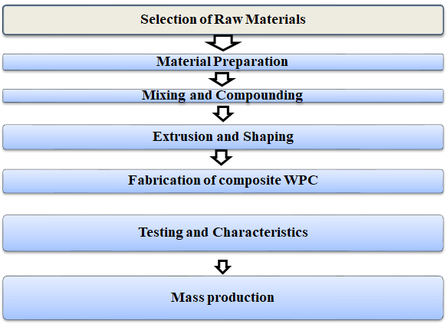
Figure 3.1: Flow chart of research procedures (researcher outline)
The diagram shows an organized process of experimental procedures that propel the study towards its objectives of developing, characterizing, and validating green wood-plastic composites (WPC) made from sawdust and recycled PET for home furniture use in Ethiopia.

3.3 Materials Used
In this study, wood plastic composites (WPC) production is achieved by combining a polymer matrix and a reinforcing filler material. In this case, recycled polyethylene terephthalate (PET) is used as matrix, and sawdust as the filler, with maleic anhydride grafted polymer acting as the adhesive. Additionally, the polymer is used to bind the components of the wood plastic composite, which makes it more flexible, durable, and able to withstand moisture.
Filler, which is typically made of natural fibers, is used to make wood plastic composites more stable and stronger. Filler sawdust is derived from wood byproducts that are abundant. It is biodegradable and economical. On the other hand, wood plastic composites are made of components that are strong, flexible, and environmentally friendly (Sikhosana et al., 2025).
Therefore, the detailed used the following key materials: 1. Sawdust: It is derived from local carpentry workshops located in Addis Ababa. It is dried at 105°C for 24 hours to reduce moisture content before being sieved with a 200-500 µm mesh size.
2. Plastic components (Recycled PET): It is derived from discarded polyethylene terephthalate beverage bottles. It is cleaned by scraping off labels and other components before being shredded with a grinding machine. It is dried to reduce moisture content below 0.5%.
- Coupling Agent: Maleic Anhydride Grafted Polyethylene (MAPE) was added (2-4% by weight) to improve interfacial adhesion between hydrophilic sawdust and hydrophobic PET.
- Lubricant oil-releasing: This used to polish the mold for prevent of sticking to the rPET and the mold during WPC development.

3.4 Equipment Used
The basic machines used for WPC production are an extruder, a cooling tank, a calibration table, a cutting machine, surface treatment equipment, and a packing unit. The mixture of wood fibers and plastic materials is first mixed and melted using the extruder. The product is then cooled so that its shape is retained. Surface treatment machines enhance the product's appearance. The table 3.1 below presented the major equipment and instruments were used throughout the experimental work:
Table 3.1: Equipment and instruments were used throughout experimental work
No | Equipment | Function
1 | High-Speed Mixer | For pre-blending of sawdust and rPET with additives.
2 | Twin-Screw Extruder | For compounding and melting composite materials.
3 | Crashing machine | To crash sawdust and bottle plastics
4 | Mold | To develop the required WPC product
5 | Compression Molding Press | For forming test specimens
6 | Measuring tape | To measure samples ready for standard testing
7 | Universal Testing Machine | For tensile and flexural tests
8 | Izod Impact Tester | For impact resistance tests
9 | Thermogravimetric Analyzer | For thermal stability test
10 | Water Bath | For water absorption and dimensional stability tests.
11 | Weighing balance | Used to measure mass
12 | Gloves | Use as PPE
13 | FTIR machine | To characterize rPET

.5 Technique of Production
Various techniques were adopted in literature to manufacture WPC, however the researcher suggests two main techniques i.e., extrusion and injection molding. Extrusion produces continuous linear profiles by forcing thermoplastic through a die, while injection molding produces three-dimensional items with minimal post-manufacturing stages (Youssef et al., 2019). Hence the researcher in this paper was produced WPC using extrusion molding and the detail steps listed out in figure 3.2 below.
WPC production involves several steps to ensure quality and performance as shown in figure 3.2 below starting from raw material collection, and ending with WPC sample production which was ready for standard testing and characterization. Quality control measures are implemented throughout the production process to ensure WPC products meet industry standards for strength, durability, and dimensional stability (Gay, 2022).
Sawdust
Polyethylene
Terephthalate (PET)
Melt & Mixing
Shredding/Crashing
Molding
Filtration
Compaction
Curing
WPC product Testing & Characterization

Collection of raw materials (Sawdust & PET)

Washing
Matrix
Reinforcement

Figure 3.2: Production flow of wood plastic composite
The experimental work followed a structured process; preparation of materials, compounding, extrusion, molding, and testing. The following subtopics covered the procedures and operating principle of the creation of Wood Plastic Composites (WPC).

3.5.1 Preparation of Raw Materials
The process started with collecting the necessary raw materials for the composite, which were rPET from recycled plastic bottles and sawdust as the organic component. A clean, pure, and eco-friendly end product was desired. For the rPET component, plastic bottles were collected from nearby centers or waste disposal sites, sometimes even by hand-picking from waste sites. They were then separated according to color and type, with impurities removed to ensure purity for recycling purposes. Then crushing or shredding was conducted and add into flakes or pellets for use in the manufacturing process. This activity highlights how waste collectors play a role in promoting a circular economy in urban areas of Ethiopia in collecting valuable waste plastic.
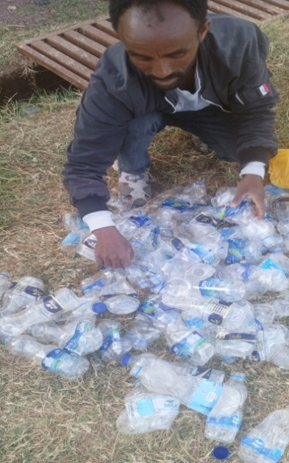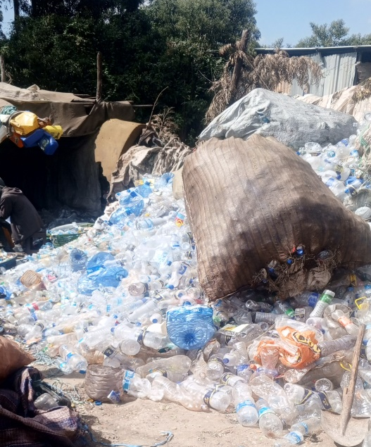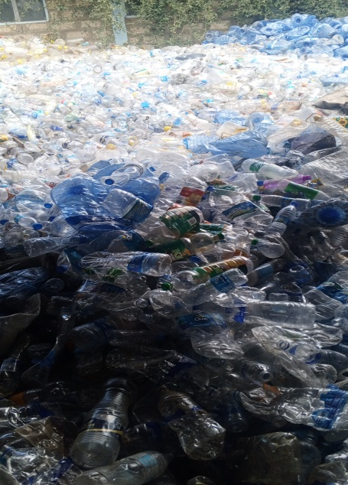
Figure 3.3: waste bottle collecting activity
Sawdust, which is collected from wood-processing workshops in the area, acts as a reinforcing filler. This green resource helps in waste management since it reutilizes wood waste that would otherwise cause environmental pollution. This sawdust was mainly gathered through manual tools, kept in a clean state to prevent contamination, then air-dried and sifted to ensure uniformity for use as reinforcement in green composite production.
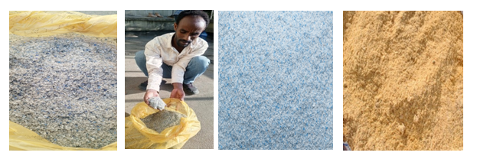
Figure 3.4: Shredded and crashed materials (rPET & sawdust)
Sawdust was oven-dried and sieved to remove impurities. Recycled PET flakes were washed with detergent, rinsed, and oven-dried at 80°C for 6 hours to eliminate residual moisture. The clean PET flakes were then pelletized to uniform size for extrusion.

3.5.2 Mixing and Compounding
A factorial experimental design is adopted to investigate the effects of sawdust content, PET content, and compatibilizer ratio on the properties of the composite. The sawdust and rPET were dry-blended in the desired ratios with coupling agents and stabilizers in a high-speed mixer. The mixture was fed into a twin-screw extruder, operating at a temperature profile of 220°C–260°C along the barrel zones. The melted mixture was extruded into strands, cooled, and pelletized. This is typically done through a hopper.
The materials are then conveyed through the extruder by a screw mechanism. As the materials move forward, they are subjected to heat, which melts the plastic. This heat can be controlled to achieve the desired melting point. The screw mechanism also serves to mix and compact the materials. This was provided a uniform blend and for further melts the plastic. For the WPC process, the steps may involve a two-step process, first using a parallel twin screw extruder and then using a conical twin screw extruder to extrude the finished product. The ratios were chosen to provide a wide range of performance, thus facilitating the comparative analysis.
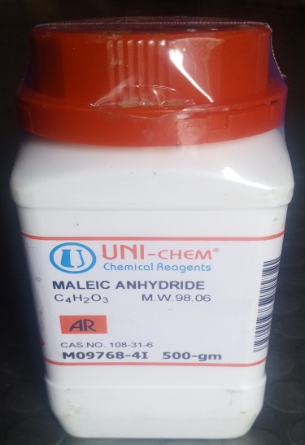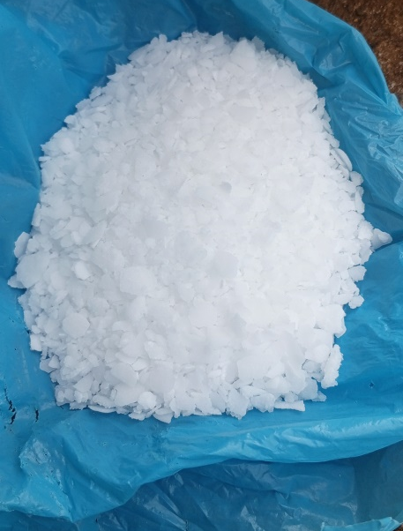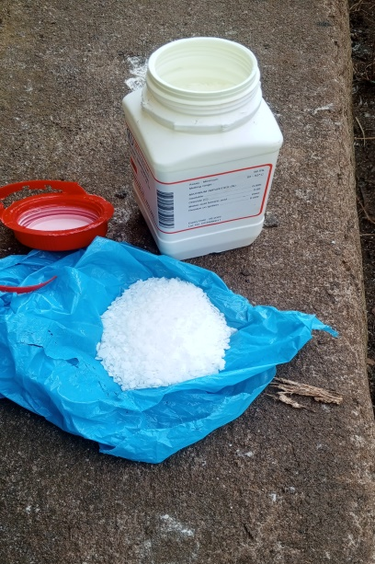
Figure 3.5: Maleic Anhydride

3.5.3 Extrusion and Molding Process
The molten mixture is then forced through a die under pressure. This shapes the material into the desired form, such as a board for furniture applications. The compounded mixture was processed through an extrusion line, producing uniform composite strands.
Table 3.2: Standard maintained Temperature zones of compound
Zone | Temperature (°C)
Feed Zone | 220
Compression Zone | 240
Die Zone | 260
The extruded strands were cooled in water, pelletized, and later molded into test specimens using a compression molding machine at 240°C, in 6MPa, for 10 minutes. The samples were cooled under pressure before testing. After exiting the die, the material is cooled to solidify it into its final form. The final product is then collected for further processing or packaging.
At the same time, the parameters such as temperature, pressure, and speed are subject to adjustments and control in order to produce the required characteristics in the final product. In this regard, the extruder is an important machine in the manufacturing of WPC since the quality and quantity of the final products are dependent on the extruder.
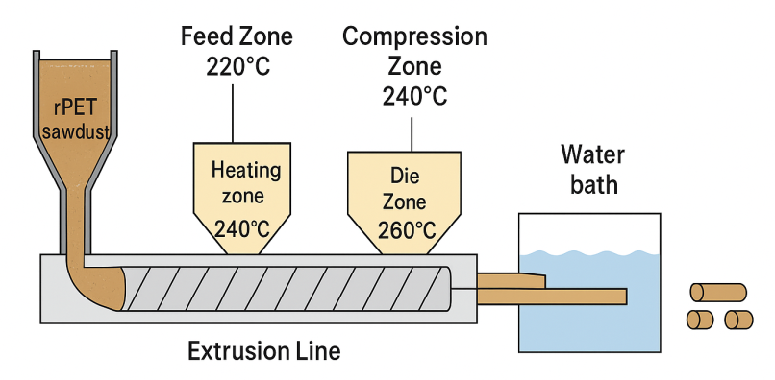
Figure 3.6: Schematic diagram of WPC extrusion line
The mold was polished with a lubricating oil-releasing compound to prevent it from sticking to the rPET. The process involved melting the shredded rPET, adding a predetermined amount of filtered sawdust, thoroughly melting and mixing to make a homogenous viscous solution, and then pouring the mixture into the prepared mold. Following the closure of the mold, the samples were compressed to 12.5 MPa and allowed to cool to room temperature for half an hour. As shown in figure 3.6, the composite specimens were molded using sandpaper before being used for testing.
The researcher used machine for sample preparation Thermoforming Centre 911 machine shown in figure 3.7 below is available in Midroc Investment Group, which is Addis Gas And Plastics Factory, specifically Wanza Furniture Industry located in Summit, Addis Ababa. The device is a multifunctional tool that can carry out a number of tasks, including injection molding, extrusion, plastic welding, and vacuum forming.
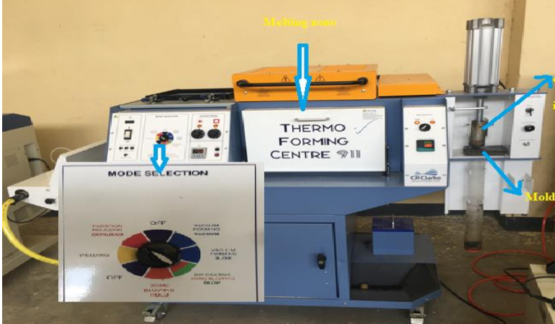
Crucible with molten ingredient
Mold
Melting room
Figure 3.7 Thermoforming center 911 machine
The thermoforming center 911 machine utilized in this investigation to prepare Wood Plastic Composite (WPC) samples before mechanical, thermal, and physical property testing is shown in figure 3.7. The device can turn recycled PET and wood sawdust into uniform composite specimens because it combines the vital processes of controlled melting, mixing, and molding. The heated chamber where shredded rPET is initially added and melted at the necessary processing temperature (240–260 °C) is represented by the highlighted melting zone. This ensures that the polymer matrix is completely softened before sawdust is added. The predetermined amount of sawdust and the coupling agent are added in the crucible and ingredient loading stage. The mixture is then uniformly blended to enhance dispersion and interfacial bonding.
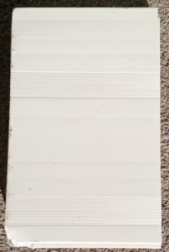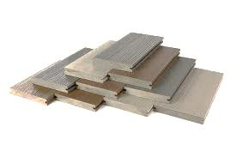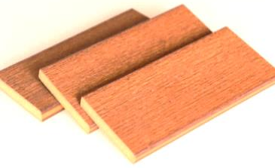
Figure 3.8: Different sawdust reinforced and rPET matrix composite sample
In order to create standardized test specimens, the molten mixture is transferred and compacted under controlled pressure conditions in the mold portion shown in the picture. The molds have different shapes that used to prepare samples accordingly the required specification. By allowing operators to accurately control temperature, mixing time, and molding pressure, the machine's mode-selection panel ensures repeatability and compliance with ASTM-based specimen preparation criteria.

3.6 Experimental Design
In factorial experimental design, the order of the runs does not have to follow the natural order of the levels of the factors. Rather, experiments are usually randomized to remove the effects of external or uncontrolled variables such as the variation of machine temperature, the effect of operators, and environmental factors. Thus, the experimental observations in this study were set in random order, with the factor combinations concentration of sawdust, recycled PET, and MAPE held constant. Even though there were many different factors like, particle size, pressing temperature, time, and pressure the researcher took those as a constant and varying the concentration of the three materials as shown in table 3.4 below.
Table 3.3: Experimental factors and levels
Factor | Factors | Min | Max
A | Concentration of sawdust (%) | 10 | 30
B | Concentration of rPET (%) | 67 | 88
C | Concentration of MAPE (%) | 2 | 4
Table 3.4: Experimental observation
 | Factor 1 | Factor 2 | Factor 3 | Mechanical property |  |  |  | Physical properties |  |  | Thermal property
Run | A | B | C | Rt | Ri | Rf | Rc | Rd | Ra | Rts | TGA | DSC
1 | 10 | 88 | 2
2 | 15 | 83 | 2
3 | 20 | 78 | 2
4 | 25 | 73 | 2
5 | 28 | 68 | 4
6 | 29 | 68 | 3
7 | 30 | 68 | 2
8 | 30 | 67 | 3
The researcher conducts different run samples with three factors and eight experimental runs by varying each factors concentration as shown in the table 3.4 above. Mainly three responses were observed mechanical properties (tensile strength (Rt), impact strength (Ri), flexural strength (Rf), compressive strength (rc), physical properties (density (Rd), Water absorption (Ra), thickness swelling (Rts) and thermal properties (differential scanning calorimetry (DSC), and thermogravimetric analysis (TGA).

3.7 Characterization and Testing procedures
To evaluate the quality and performance of the produced WPCs, several tests were conducted according to ASTM standards, cut into required shapes, and tested in Addis Ababa's science and Technology University (ASTU) laboratory for accuracy. All samples were conditioned at 23°C and 50% relative humidity for 48 hours prior to testing.
When testing a composite material according to a standard, the most common method is to follow the guidelines outlined in ASTM, which specifies the procedure for testing of composite materials, allowing for the measurement of properties like mechanical, thermal and physical applying a force to a prepared specimen on a universal testing machine.

3.7.1. Specimens Preparations and Test Machines
Test specimens are cut following the American Standard Testing Method (ASTM) specifications for mechanical properties (tensile strength, compressive strength, impact strength, and flexural strength), thermal properties (DSC, melting temperature, thermal stability and TGA), and physical properties (water absorption, density, thickness swelling). A specimen was manufactured according to ASTM specifications in order to assess the characteristics of developed WPC. To guarantee repeatability, the average and standard deviation values for the test results were computed for each specimen using three and four samples. The complete sample thickness was established by using the mean measurements of each specimens that underwent testing at room temperature.
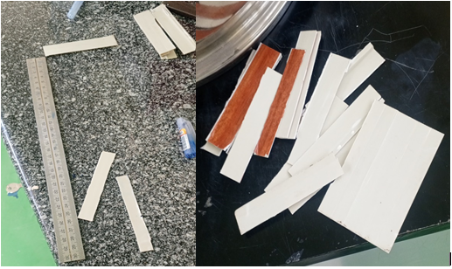
Figure 3.9: Preparing of standard samples to conduct different laboratory test
Characterization of WPCs in this study is the second major objective next to development to assess their mechanical, thermal, morphological, and physical properties to ensure it meet the requirements for home furniture applications based on standards test methods, dimensions and testing equipment as shown in table 3.5 below. The researcher was conducted the common characterization tests include:

Table 3.5: ASTM Standards specifications of specimen for preparations (Ntziouni et al., 2022)
S. No. | Types of Test | Test Standard | Dimensions (L×W×T) | Testing Equipment
1 | Tensile | ASTM D638 | 165 × 25 × 5 mm | UTM
2 | Compressive | ASTM D3410 | 25 × 25 × 10 mm | UTM
3 | Flexural | ASTM D790 | 165 × 12.7 × 4 mm | UTM
4 | Impact (Izod) | ASTM D256 | 64×12.7×10 mm (notched) | Izod Impact Tester
5 | DSC | ASTM D3418 | 5–10 mg sample | DSC meter
6 | Thermal Stability | ASTM E1131 | 5–10 mg sample | Thermogravimetric Analyzer (TGA)
7 | Density | ASTM D792 | 20 × 20 × 5 mm | Density Kit
8 | Water Absorption | ASTM D570 | 30 × 28 × 5 mm | Water Bath
9 | FTIR | ASTM E1252 | Powdered or thin-film sample | FTIR Spectrometer
10 | Thickness Swelling (TS) | ASTM D1037 | 50×50×sample thickness | Water Bath + Vernier Caliper

3.7.2 Mechanical Properties
Using the appropriate digital machinery, the composite samples' tensile, flexural, compressive, and impact strength characteristics were measured.
- Tensile Strength
A universal tensile strength testing apparatus (Model given by Addis Ababa Science and Technology University AASTU-010967) was used to conduct tensile property tests. The ASTM D638 test standard was used to evaluate the tensile strength of the resulting composites (Raj et al., 2021). The test specimens measured 165×25×5 mm without gripping. Four specimens were tested for each set of composite samples, and the mean values were given after the value was recorded until the specimens were broken.
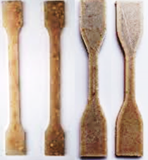
Figure 3.10: Typical samples for tensile strength
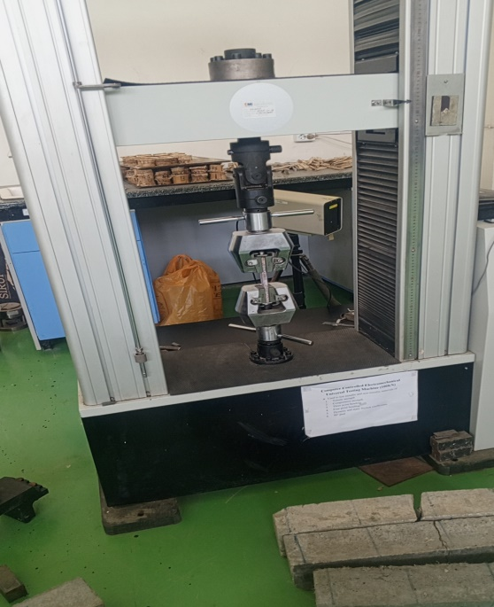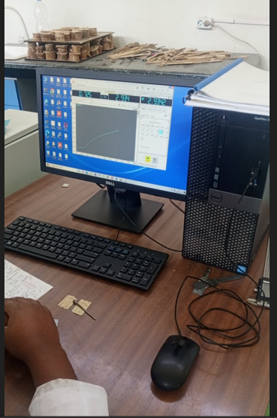
Figure 3.11: Typical specimen under tensile strength test
- Flexural Strength
A supported beam was subjected to a three-point loading system for a flexural strength test. A universal tensile machine like tensile strength (AASTU-010967) was used for the tests. The ASTM D7264 (Alrubaie et al., 2020) test standard, which has dimensions of 165 x 12.7 x 4 mm, was used to assess the flexural rigidity properties of the developed wood plastic composite samples. In accordance with the norm, the specimens were tested on a support span of 130 mm. the following equation was used to determine the composite's flexural modulus (Karaş et al., 2022).
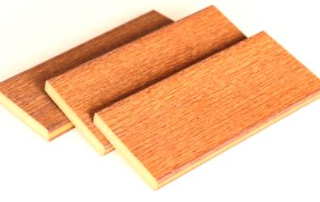
Figure 3.12: Typical representation of WPC sample for flexural strength test
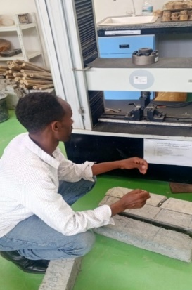
Figure 3.13: Typical specimen under flexural strength test (ASTM D790)
$Flexural Modulus=\frac{mL^{2}}{4bd^{2}}$ ₁
Where L, is the span length (mm); b and d, are the width and thickness of the specimen in (mm) respectively; and m, is the slope of the tangent to the initial line portion of the load displacement curve. Three specimens were tested for each set of composite samples and the mean values were calculated and reported accordingly.
- Impact Strength
Izod impact tests used a pendulum impact testing apparatus (406-Joule type) to conduct the impact strength tests. With a length of 64 mm and a cross-sectional area of 12.7 mmx10 mm one side notched, the testing was conducted in accordance with the ASTM D256 (Turaka et al., 2024) test standard. For every set of composite samples, four specimens were examined, and the average results were presented.
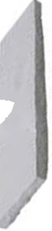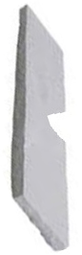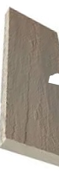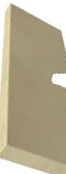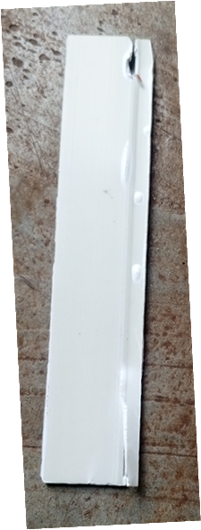
Figure: 3.14: Typical notched specimen for impact test
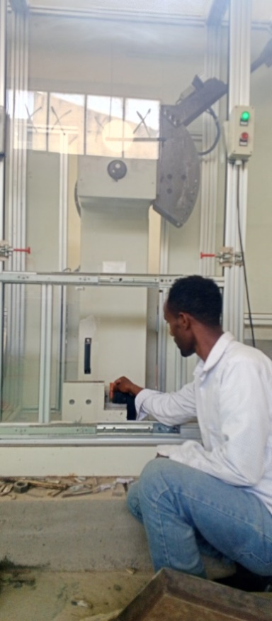
Figure 3.15: Impact Teste machine
- Compressive Strength
A universal testing machine (Model AASTU-010967) was used to measure the compressive properties of the composite specimens using a sample size of 25x 25 x 10 mm in accordance with the ASTM D6641/D6641M-16e1 (Mohan et al., 2021) test standard. For every set of composite samples, three specimens were examined, and the average results were presented. During this test short, thick specimens prevent buckling and allow the UTM to apply uniform axial compressive load for determining compressive strength.
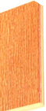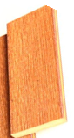
Figure 3.16: Typical reresentation of WPC smples for compressive test

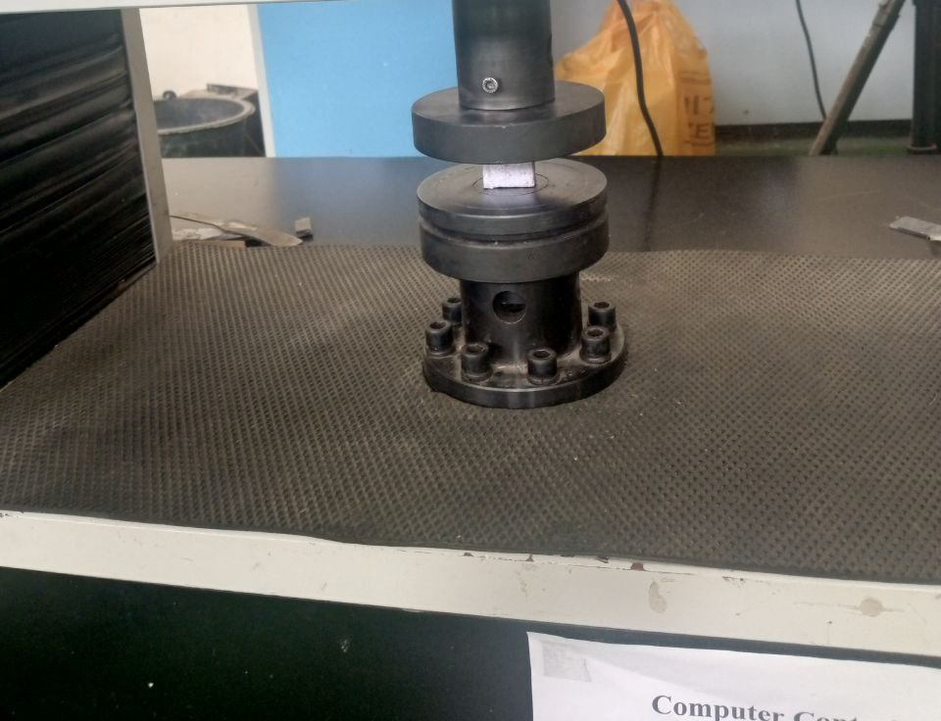
Figure 3.17: Typical specimen on compression machine test

3.7.3 Physical Properties
- Water absorption
According to Radoor et al. (2021) the researcher used ASTM D570-98 test technique for conducting water absorption tests with sample dimensions of 30×28×5 mm. Samples of each type of composite were oven-dried before their weight was noted as the initial weight of the composites. Following that, the samples were stored in distilled water at room temperature (25 °C) for a whole day. The samples were removed from the water, dried, and weighed. The percentage of water absorbed by the composites was calculated using the following equation.
$\%W=\frac{wt-wo}{wo}$ 2
- Density
The density of the WPC samples was tested using the density kit density tester. Each sample was measured three times in compliance with ASTM D792 standard 20 × 20 × 5 mm dimension, and the average value was computed based on the dimensions and arithmetical formula below.
$Density \left(D\right)=\frac{M}{V}$ 3
Where V is the sample's volume (mm3) and M is its mass (kilogram). The formula for calculating volume is V = W x T x L, where W stands for sample width, T for sample thickness, and L for sample length.

- Thickness Swelling
To measure before and after water immersion to determine dimensional stability the researcher was conducted thickness swelling tests according to standard parameters by soaking the sample for 24 hours at a temperature of 23 ± 2 °C with specimen dimension 30 × 28 × 5 mm.

3.7.4 Thermal Properties
Thermal characterization of the developed wood plastic composites (WPCs) was performed to assess processing, thermal stability, and performance under elevated temperatures. The three complementary techniques used were Thermogravimetric Analysis (TGA), Differential Scanning Calorimetry (DSC), and Heat Deflection Temperature (HDT) (Nukala et al., 2022). All tests were carried out in a controlled laboratory environment and in accordance with applicable ASTM standards as shown in table 3.5 above. Specimens were dried and conditioned prior to testing to remove moisture effects.

1. Differential scanning calorimetry (DSC)
Instrumental analysis using Differential Scanning Calorimeter (DSC) is conducted in accordance with ASTM D3418 (Burgada et al., 2021). This involves preparing 5–10 mg of dry samples in sealed aluminum pans and using an empty pan as a reference. The thermal cycle includes heating from 30 °C to 300 °C at 10 °C·min⁻¹ to eliminate thermal history, followed by cooling to assess crystallization, and a second heating to accurately measure glass transition temperature (Tg), melting temperature (Tm), and enthalpy changes. Data collected focuses on heat flow and temperature to determine Tg, Tm, and crystallization temperature (Tc), while the degree of crystallinity for the PET fraction is calculated to evaluate material properties as equation 4 (Dolca et al., 2021).
$Xc\left(\%\right)=ΔHf-\frac{ΔHcc}{ΔH_{f^{o}} ×wPET}x100$ 4
Where:
- ΔH_{f}​ = fusion enthalpy (J·g⁻¹) from the DSC melting endotherm,
- ΔHcc​ = cold-crystallization enthalpy (if any),
- ΔH_{f}​º = enthalpy of fusion for 100% crystalline PET (commonly literature values ≈140 J·g⁻¹),
- wPET​ = mass fraction of PET in the composite (account for sawdust and additives).
After estimation, discuss how sawdust loading and MAPE influence PET crystallization behavior. DSC temperature and heat flow were calibrated with standard materials like indium prior to sample analysis, and report representative DSC curves along with tabulated data for Tg, Tm, Tc, ΔHf, ΔHcc, and calculated crystallinity.
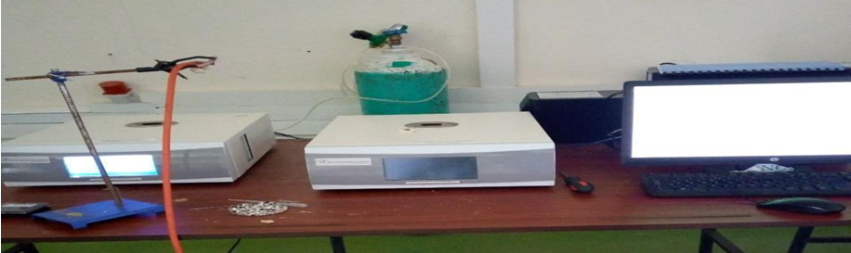
Figure 3.18: DSC testing machine
2. Thermogravimetric Analysis (TGA)
In compliance with the ASTM E1131 Standard (Nukala et al., 2022), the TGA test was carried out using a LiKrom TGAQ50 (Saugus, MA, USA) tester to ascertain the materials' decomposition temperatures, track the impact of additives and wood flour on the decomposition temperature, and ascertain the final residue amount in the crucible. With a nitrogen gas flow of 50 ml/min, weighed samples were heated from 0 °C to 1000 °C at a rate of 10 °C/min.

3.7.6 Fourier-Transform Infrared Spectroscopy Analysis (FTIR)
An Alpha Bruker FTIR spectrometer with ATR technology was used to characterize rPET and sawdust structures according to ASTM E1252 standards (Burgada et al., 2021). At room temperature, the samples were shown to transmit infrared radiation in the range of 400–4000 cm−1 web and identified the functional group in FTIR library. To investigate the chemical groups and functional groups present in the developed WPC, raw materials of rPET and sawdust fibres, FTIR analysis were conducted. FTIR spectroscopy is based on the principle that distinct chemical bonds and functional groups within a substance absorb specific wavelengths of infrared light. By examining the absorption peak patterns in the FTIR spectrum, it is possible to identify the various functional groups and chemical moieties found in the materials and product sample.

Figure 3.19 FTIR testing machine

3.8 Data Analysis Method
Data analysis for this study was done in a systematic and statistically grounded manner to ensure the correct interpretation of the mechanical, thermal, and physical performance of the developed WPC. The raw data from tensile, compressive, flexural, and impact tests were checked for completeness, consistency, and outliers before tabulation for further analyses. Each test was done in triplicate, with mean values and standard deviations calculated to make sure the results obtained were reliable and to reduce experimental error. The responses for the mechanical performances were analyzed using the stress-strain curve developed from the output of the Universal Testing Machine, which allowed for the definition of such parameters as tensile strength, compressive strength, modulus of elasticity, and flexural modulus. Thermal data obtained from DSC and TGA were interpreted by identifying glass transition temperatures, melting points, onset temperature of degradation, and mass-loss behavior through heating cycles. The properties of density, water absorption, and thickness swelling were evaluated by comparing the percentage changes relative to the initial dimensions and mass of the specimens. Randomization technique was used to optimize the formulation parameters: sawdust content, rPET content, and MAPE coupling agent level. The identification of statistically significant factors, which affected the composite's performance, was carried out with the use of signal-to-noise ratios and analysis of variance, while the best factor-level combination that resulted in improved mechanical and thermal properties was established. Graphical interpretation techniques, comprising the main effects plots, interaction plots, and residual analysis, were used to visualize the trends to validate model assumptions. Generally, the integrated approach to the descriptive and inferential statistical methods in the data analysis methodology was applied to arrive at scientifically appropriate conclusions on the behavior and suitability of the developed WPC for applications in home furniture.

3.9 Ethical Considerations
Every stage in the research conformed to the established principles of research ethics, which prescribe integrity, safety, and responsibility. All test materials used-sawdust and recycled PET-were collected and processed in an environmentally responsible way so that the research supports sustainability and does not contribute to harm for people and the environment. Laboratory hot processing, mechanical testing, and extrusion procedures followed all the appropriate precautions to guarantee safety for researchers and laboratory personnel. Data from the mechanical, thermal, and physical tests were recorded accurately, reported objectively, and analyzed with no manipulation or bias shown. Besides, this study provides for proper reference to all materials used, adherence to ASTM testing standards, and disposal of wastes in a manner consistent with the guidelines of the institution.

CHAPTER FOUR: RESULTS AND DISCUSSION

4.1 Introduction
This chapter presents and interprets the results obtained from the experimental investigation on the development of wood plastic composites (WPCs) made from sawdust and recycled polyethylene terephthalate (rPET) for home furniture applications. The results are analyzed based on the mechanical, physical, and thermal properties of the composites, supported by figures and tables. The chapter also discusses the performance of the optimized composite composition and compares the findings with relevant literature. Finally, it includes prototype evaluation and implications for industrial application in Ethiopia.
The experimental investigation focused on determining the effect of sawdust-to-rPET ratio on the performance of the resulting WPCs. The researcher conducted formulations with varying sawdust contents from 10, to 30%, rPET from 67 to 88% and a constant 2 -4% coupling agent (maleic anhydride polyethylene, MAPE). The composites were produced using twin-screw extrusion followed by compression molding.

4.2 Test results
The mechanical, thermal, and physical properties of the WPCs developed during this study were investigated by adopting different proportions of SD, rPET, and MAPE. Table 4.1 summarizes the experimental results for eight different formulations, focusing on the tensile strength, flexural strength, impact strength, and compressive strengths along with some key thermal characteristics regarding TGA and DSC. Besides, the density, water absorption, and thickness swelling were measured to investigate the physical and moisture-resistance behavior of the composites. The results show how progressive increases in sawdust content and the interaction of rPET and MAPE influence the overall performance of the developed WPC materials. Mechanical properties appear to be mostly declining with higher sawdust proportions, while moisture-related properties increased due to the hydrophilic nature of lignocellulosic fillers. On the other side, composites containing an optimum amount of coupling agent exhibit better interfacial bonding along with improved strength properties. Largely, the results of the laboratory tests provide a holistic picture showing how material composition influences the structural and functional performance of WPCs for furniture applications.

Table 4.1: Test result of WPC samples in variety ratio
Proportion of SD/rPET/ MAPE  (%) | Tensile (MPa) | Flexural (MPa) | Impact (kJ/m²) | Compressive (MPa) | TGA Tonset (°C) | DSC Tm (°C) | Density (g·cm⁻³) | Water absorption (7 d %) | Thickness swelling (7 d %)
10/88/2 | 44.0 | 60.0 | 7.20 | 48.0 | 385 | 256.0 | 1.33 | 0.50 | 0.60
15/83/2 | 41.0 | 64.0 | 6.80 | 50.0 | 382 | 255.8 | 1.30 | 0.90 | 1.00
20/78/2/ | 38.0 | 68.0 | 6.20 | 52.0 | 378 | 255.5 | 1.27 | 1.40 | 1.60
25/73/2 | 36.0 | 71.0 | 5.60 | 54.0 | 372 | 255.2 | 1.24 | 2.00 | 2.20
28/68/4 | 37.5 | 73.0 | 5.90 | 56.0 | 374 | 255.6 | 1.22 | 1.60 | 1.80
29/68/3 | 36.8 | 72.0 | 5.80 | 55.0 | 373 | 255.4 | 1.21 | 1.80 | 1.90
30/68/2 | 35.5 | 70.0 | 5.40 | 53.0 | 370 | 255.1 | 1.20 | 2.30 | 2.50
30/67/3 | 36.2 | 71.0 | 5.60 | 54.0 | 372 | 255.3 | 1.19 | 1.90 | 2.00

4.3 Mechanical Properties

4.3.1 Tensile strength and tensile modulus
The sample is cut into the right gripped rectangular shape with a saw and then tested in the UTM machine. Then, the sample is pulled until it breaks. Next, the force was measured based on how much the gauge length increased. When force is applied, the stretching of the gauge section is connected to the force being used. Five types of samples were made according to ASTM standards, and the recorded values were used for discussion.
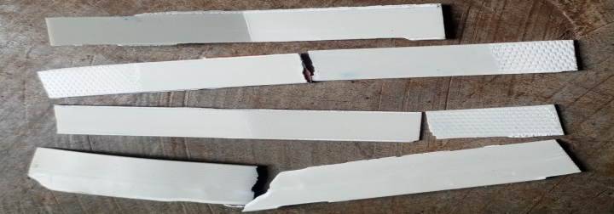
Figure 4.1: WPC samples after rapture

Figure 4.2: Stress/strain graph of tensile strength and modulus
Figure 4.2 represents the stress–strain behavior of the manufactured WPC samples and reveals a typical response of sawdust-reinforced rPET matrices subjected to tensile loading. From this curve, two significant mechanical parameters were obtained: tensile strength, which corresponds to the failure point, and tensile modulus calculated from the slope of the initial linear part of the curve. The overall trend of the stress–strain curve corresponds to the typical response of natural fiber–reinforced polymer composites, demonstrating an initial linear elastic region with subsequent progressive yield, ending in brittle-type fracture. The initial slope corresponds to the tensile modulus and increases linearly with the sawdust content, reflecting increased rigidity and stiffness.
The results indicate that samples with higher sawdust content (25–30%) have steeper initial slopes, reflecting higher tensile moduli (2.4–2.6 GPa). This trend agrees with the reports by Bhaskar et al. (2021) and Lee et al. (2020) that lignocellulosic fibers significantly limit the mobility of polymer chains and thus enhance elastic stiffness. Samples with lower sawdust and higher rPET content (10–20% sawdust) have longer strain regions and lower slopes, leading to a lower modulus range of 1.8 to 2.2 GPa. This tendency reveals the ductility feature of rPET, which imparts enhanced flexibility with a slight loss in stiffness, a feature also observed in PET-based WPC formulations (Mitaľová et al., 2024).
The curves show that, at the point of fracture, tensile strength decreases gradually as the content of sawdust increases, revealing a trade-off between stiffness and strength. This inverse relationship has been documented by many authors; Roman et al. (2024) and Ferede et al. (2024) also acknowledged that excessive fiber loading may create micro-voids, interfacial gaps, and other stress concentration sites which result in decreased tensile strength despite increased modulus. The nature of brittle rupture observed in the higher sawdust composites confirms that natural fibers make the composite less elongative and more prone to sudden fracture. Generally, Figure 4.2 confirms that the stress–strain behavior of the WPC samples follows established mechanical patterns reported for natural fiber-reinforced composites, that the results confirm the mechanical performance of the developed WPC and point out how important the optimization of the fiber-to-polymer ratios is for applications in home furniture, where stiffness and strength are required.

4.3.2 Flexural Strength and Modulus
Flexural strength, which is represented in terms of stress, is a material's capacity to endure deformation under bending stresses. The stiffness at the beginning or first step of the bending process is measured by the flexural modulus. Figure 4.3 makes this evident: when the sawdust (SD) weight percentage grew to 28%, the flexural strength and flexural modulus increased progressively. The composite with 28% fiber weight, according to observation, has the maximum flexural strength and modulus values, at 73 MPa and 23.5 GPa, respectively. The increased flexural strength and modulus could be attributed to the enhanced interfacial adhesion between the reinforcement and matrix. Several researchers claim that increasing the number of fibers on a specific composite cross-section might result in a higher fiber weight %, which raises the flexural strength and modulus of the composite (Burgada et al., 2021; Kumar et al., 2025; Showaib & ELDeeb, 2025).

Figure 4.3: Stress/strain graph of Flexural Strength and Flexural Modulus
The figure 4.3 also shows the flexural properties of WPC samples had an obvious dependence on the proportion of sawdust and rPET incorporated into the composite formulation. Such improvement at moderate filler loading is related to the reinforcing effect of lignocellulosic particles, which enhances stiffness and restricts the mobility of polymer chains. Similar observations were reported by Jian et al. (2022) and Duruaku et al. (2023), who demonstrated that increasing wood flour content up to an optimum threshold significantly improves rigidity and bending performance in thermoplastic-based WPC. Again, the role of MAPE compatibilizer was critical because it promotes interfacial adhesion between hydrophilic wood fibers and hydrophobic rPET, thus leading to improved stress transfer and reduction in micro-void formation-this trend agrees with the observations reported by Serra et al. (2021) and Alrubaie et al. (2020). Beyond 28-30% of sawdust content, both flexural strength and modulus showed slight decreases or leveling-off. Such behavior is commonly associated with fiber agglomeration, poor polymer wetting, and the formation of stress concentration zones, as noted in studies reported earlier by (Ferede et al., 2024) and (Friedrich, 2021). Thus, the results in this study confirm that an intermediate level of sawdust, combined with an appropriate compatibilizer content, provides the most favorable balance of stiffness and bending strength, agreeing well with the optimum wood loading ranges of 25-35% recommended in the literature for WPC (Ferede et al., 2024; Kumar et al., 2025).

4.3.3 Impact Strength
The impact strength of composite material is its ability to absorb and dissipate energy in the form of creating new surfaces under shock or sudden blows (Shahani et al., 2021). To find out how strong and tough the composite material is, the study did different sample tests for each way the material is arranged. After the test samples broke, the researcher have examined, and discussed in detail in this section. Results were showed in Table 4.1 and figure 4.5.
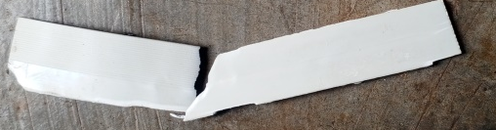
Figure 4.4: Sample of impact specimen after testing
Stress (kJ/m²)
Figure 4.5: Impact properties of wood sawdust reinforced, rPET matrix and coupling agent MAPE composites
Figure 4.5 shows the variation of the impact strength of WPC samples manufactured at various proportions of sawdust, rPET, and MAPE compatibilizer. The results indicate that the highest impact strength was 7.2 kJ/m² for the lowest sawdust proportion of 10%, which gradually reduced with an increase in the sawdust proportion to 30%. As explained earlier, this agrees with the generally established trend in WPC studies that impact resistance decreases with wood flour content due to increased brittleness and reduced mobility of the polymer chain with higher filler loading (Dolca et al., 2021; Matar, 2022). With low sawdust content, the continuity and ductility of the rPET matrix enable improved energy absorption when the materials are subjected to impact loading conditions. With increasing proportions of sawdust, there is a possibility of fiber agglomeration, poor wetting, and increased interfacial discontinuities, causing stress concentration that may initiate cracks and, thus, reduce a material's capability to sustain sudden impact loads. A similar study has also been recorded by Aisyah et al. (2021), who reported consistent reduction of impact strength with increasing proportions of lignocellulosic filler in HDPE/wood composites.
This decline was moderated by the presence of the MAPE coupling agent through an improved interfacial bonding between the hydrophilic sawdust and the hydrophobic rPET matrix; this is evident from the relatively stable values around 5.4–5.9 kJ/m² at higher filler content. This behavior corroborates the findings of Nechifor et al. (2022), who showed that maleated coupling agents significantly enhance stress transfer across fiber–matrix interfaces, although they cannot fully compensate for the intrinsic loss in toughness due to excessive filler loading. In general, impact test results confirm that WPCs with lower to moderate sawdust content offer better toughness, while higher sawdust content increases stiffness at the expense of impact resistance; this is a widely reported pattern in composite materials literature (Azman et al., 2021; Renner et al., 2021).

4.3.4 Compressive Strength Test
The compressive strength tests of WPC samples were evaluated for their ability to withstand loads without failing. Figure 4.7 summarizes the compressive strength behaviors of WPC samples manufactured by varying the proportion of SD, rPET, and MAPE. It can be seen from the figure that compressive strength increases progressively with increasing sawdust proportion from around 10% up to approximately 28% and reaches its peak for the 28/68/4 formulation, at around 56 MPa. Such improvement is primarily attributed to the inherent rigidity and ability of lignocellulosic fibers to bear loads, which act like micro-reinforcements within the thermoplastic matrix. There are many reports confirming that an increase in wood flour content generally improves the compressive strength due to better distribution of stresses, higher stiffness, and low deformation upon axial loading (Boztoprak, 2024; Kumar et al., 2025).
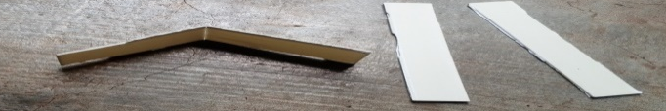
Figure 4.6: Sample of compressive test specimen after testing

Figure 4.7: Compressive properties of WPC in different proportion of SD/rPET/MAPE(%)
Consistent with this, the steady improvement in compressive strength up to the optimal range indicates the role of MAPE. MAPE improves interfacial adhesion through the formation of ester bonds with the hydroxyl groups of the sawdust while bonding with the polymer matrix, causing better stress transfer and improved composite integrity. Rindayatno et al. (2023) also presented results showing that coupling agents strongly enhance compressive and tensile properties of wood-filled thermoplastics as a result of minimization of interfacial voids and fiber pull-out.
Beyond 28% sawdust content, there is a slight reduction in compressive strength-from 56 MPa down to 53-54 MPa at 30% SD-consistent with previously published literature that excessive filler loading introduces micro-defects, poor dispersion, and inadequate polymer wetting (Fayzullin et al., 2024; Sikhosana et al., 2025). At high filler concentration, the polymer matrix becomes inadequate for the full encapsulation of wood particles, leading to stress points and loss of structural integrity while simultaneously embrittling. This behavior indicates that an optimum threshold filler does exist beyond which filler addition can be detrimental to compressive strength without loss of composite homogeneity.
Inclusively, the results show that the optimal compressive performance is achieved with sawdust loadings of 25–30% in combination with sufficient coupling agent levels. These trends are in line with the greater WPC literature, where the compressive performance of fiber reinforcement is emphasized whenever compatibility between filler and matrix is achieved appropriately.

4.4 Physical Properties
Physical properties are important in evaluating the effectiveness of Wood Plastic Composites (WPCs) for home-furniture applications. This study assesses key parameters, including density, water absorption, and thickness swelling, to understand how sawdust, recycled PET, and compatibilizers affect the composite's stability and behavior. These attributes are vital for indoor furniture, where resistance to moisture, minimal dimensional changes, and uniform mass distribution are essential for durability. The findings provide valuable insights into the quality of the developed WPC and allow for comparison with existing research standards, emphasizing trends and implications for furniture manufacturing.

4.4.1 Density
The amount of water absorbed under particular circumstances is ascertained via water absorption. The type of plastic, the additives used, the temperature, and the duration of exposure are the factors that determine water absorption. Because lignocellulose fibers in sawdust contain OH groups in their chemical composition, they are all less resistant to absorbing water (Oliveros-Gaviria et al., 2024).

Figure 4.8: Density properties of WPC sample
The results presented in Figure 4.8 illustrate a clear and consistent trend: the density of the Wood Plastic Composite (WPC) samples decreases linearly as the proportion of sawdust (SD) content increases, a phenomenon commonly observed in WPC research. The highest density was recorded for the 10/88/2 (SD/rPET/MAPE) formulation at approximately 1.33 g/cm⁻³, corresponding to the lowest wood fiber content. Conversely, the lowest density, approximately 1.19 g/cm⁻³, was found in the samples with the highest sawdust inclusion (30/67/3 and 30/68/2). This inverse relationship between wood filler percentage and composite density is attributed to the fact that the lignocellulosic filler (sawdust) typically possesses a lower inherent density compared to the polymer matrix, in this case, rPET (Morcillo et al., 2021; Turaka et al., 2024). Specifically, the density was observed to decrease by about 10.5% as the sawdust content increased from 10\% to $30\%. The variations in the Maleic Anhydride Polyethylene (MAPE) coupling agent percentage; which is designed to improve interfacial adhesion, appear to have a negligible direct impact on the bulk density properties compared to the dominant effect of the sawdust-to-rPET ratio. This confirms that the density of the composite is primarily a function of the weight fractions and specific densities of the two main components.

4.4.2 Water Absorption Test
As Figure 4.9 and Table 4.1 makes evident, the rPET composites' water absorption rose as the amount of sawdust increased. This might be because woods’ hydrophilic nature allows for a significant absorption of moisture. Due to the presence of micro-voids in the matrix, cause water molecules to diffuse into them until saturation, the water absorption increases as the fiber concentration rises from 10% to 30% (Dolca et al., 2021; Radoor et al., 2021).

Figure 4.9: Water absorption of developed wood plastic composites
Figure 4.9 shows the water absorption properties of the fabricated WPCs for different sawdust (SD), rPET, and MAPE contents. Water absorption increased with increasing sawdust content as expected, due to the hydrophilic nature of the lignocellulosic fibers, which contain hydroxyl groups that can easily form hydrogen bonds with water molecules. At the lowest sawdust content, namely 10%, water absorption was very low, at 0.50%, suggesting good encapsulation of the fibers by the hydrophobic rPET matrix, which reduced the possibility of moisture penetration. This is in agreement with the work of Azman et al. (2021) and Ferede et al. (2024), who concluded that higher polymer content reduces the number of pathways through which water can diffuse, leading to improved resistance to moisture.
With the increase in the sawdust proportion to 25–30%, water absorption increased to 1.6–2.3%. This supports the findings of Bochkareva et al. (2023) and Burgada et al. (2021), who reported that an increase in the proportion of a lignocellulosic filler increases the porosity and creates microvoids that promote water absorption. Moreover, the slight decrease in water absorption upon using a higher MAPE content for the 28/68/4 sample, which is 1.60%, indicates better matrix–fiber adhesion due to MAPE. MAPE can effectively form ester linkages with the hydroxyl group of wood flour, reducing the interfacial gaps where water may potentially accumulate. This was consistent with the work of Sikhosana et al. (2025), who showed that in wood–polymer systems, it is the coupling agents that significantly reduce water absorption by developing good interfacial bonding.
Water absorption was highest at 30/68/2, representing the maximum fiber loading and low proportion of coupling agent. From the overall results, it is further confirmed that moisture uptake is principally controlled by fiber content, matrix hydrophobicity, and effectiveness of the coupling agent. Relatively low absorption values below 2.5%, as observed for all samples, confirm that rPET-based WPCs exhibit good dimensional stability and moisture resistance; values are comparable or better than those obtained for similar studies (Gunwant, 2024).

4.4.3 Thickness Swelling
Figure 4.10 below shows the thickness swelling of the WPC samples after 7 days of water immersion. A definite increasing trend with increased sawdust proportion is demonstrated, which indicates the hydrophilic characteristics of the lignocellulosic fibers due to their tendency to absorb water and swell rapidly.

Figure 4.10: Thickness swelling of developed wood plastic composites
When sawdust content is low (10–20%), the values of thickness swelling remain rather low, between 0.60 and 1.60%, indicating that wood particles are well encapsulated by the hydrophobic rPET matrix. In this case, increasing the polymer-to-fiber ratio decreases cell wall penetration and thereby hygroscopic swelling, as studied by Rindayatno et al. (2023) and Shahani et al. (2021).
The highest thickness swelling (2.50%) is given for the composition of 30/68/2, where maximum sawdust content coincides with a relatively lower proportion of coupling agent. With increased sawdust loading, more hydroxyl groups and microvoids are introduced at the matrix-fiber interface, which facilitate moisture penetration and swelling. Similar observations were noted in the work of Ramachandran et al. (2022), where it was noticed that the growth in swelling increases sharply with higher contents of wood flour due to poor encapsulation by resin. At high fiber loading, a lack of sufficient MAPE amounts reduces interfacial adhesion, which causes more pronounced fiber-matrix debonding upon exposure to water-a factor accelerating thickness expansion, as extensively reported in literature (Radoor et al., 2021).

Interestingly, the sample with 28/68/4 (higher MAPE content) presents reduced thickness swelling (1.80%) compared to the immediate formulations. This confirms the effectiveness of MAPE in improving matrix-fiber bonding by esterification reactions, reducing voids, and subsequently restricting water-induced dimensional changes. The result obtained falls closely in line with the findings of Jain et al. (2022), who believed that swelling is significantly reduced due to improved compatibility between hydrophobic plastics and hydrophilic wood particles by coupling agents.

4.5 Thermal Properties
Thermal analysis was performed using a thermogravimetric analyzer (TGA) to evaluate the decomposition behavior of WPCs. the TGA results demonstrate significant and systematic variations in the thermal stability of the WPC samples. Sample-3 consistently emerges as the most thermally stable formulation, with initial and peak decomposition temperatures markedly higher than the other samples. This enhanced stability is strongly attributed to an optimized material composition, likely featuring improved polymer-wood adhesion through an optimal filler loading or the use of a compatibilizer. The findings from the thermal analysis are consistent with the density measurements and provide a fundamental foundation for understanding the material's performance limits, directly influencing the selection of processing parameters and potential end-use applications.

4.5.1 Differential scanning Calorimetry (DSC)
The differential scanning calorimetry (DSC) analysis of each sample in SD/rPET/MAPE composite formulations reveals distinct thermal transitions typical of PET-based composites, highlighting the impact of sawdust filler and coupling agent interactions on the polymer matrix.
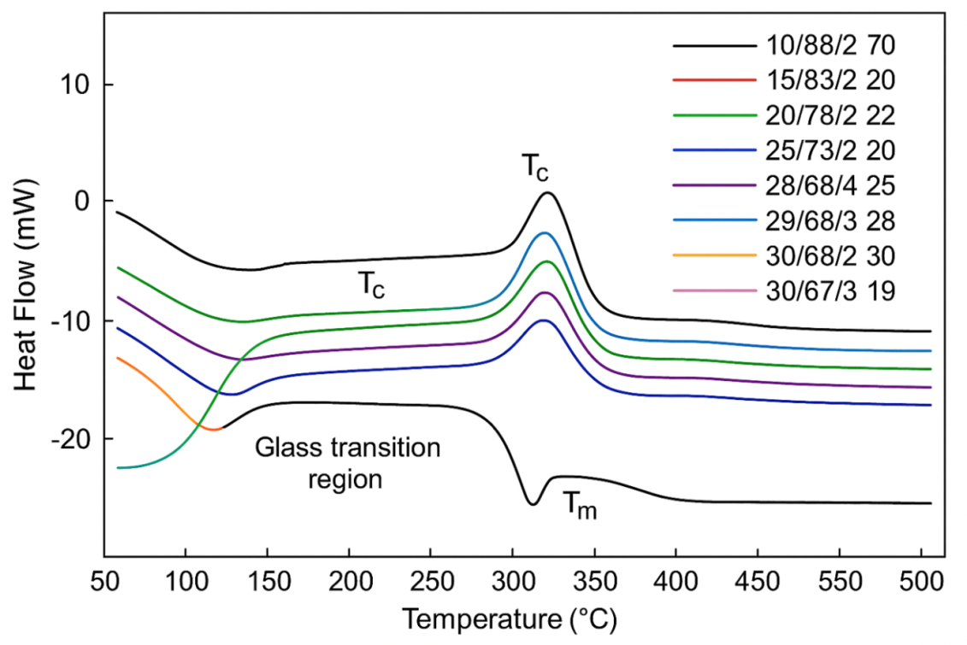
Exo
Endo
Figure 4.11: DSC graph of endothermic and exothermic heating cycle
The thermal glass transition (Tg), crystallization temperature (Tc), melting temperature (Tm), onset temperature, peak temperature, and enthalpy change (ΔH) provide insights into molecular mobility, crystallite formation, and thermal stability of the developed composites were shown in the figure 4.11.
The DSC curves in figure for all samples show clear compositional effects on the thermal transitions, which is consistent with the general observations reported in earlier wood–plastic composite studies. All samples exhibit a broad glass transition region, Tg, between about 70–90°C, while Tg increases with an increase in sawdust content from 10 to 30%. This observed upward shift is attributed to the well-documented decrease in polymer chain mobility due to the incorporation of lignocellulosic fillers. Wood fibers restrict segmental motion within the amorphous phase of the polymer matrix, according to Renner et al. (2021) and Shafik et al. (2021). This restriction is further enhanced in the presence of MAPE in some formulations, especially through the improvement in interfacial compatibility, which has been associated with an increase in Tg due to increased stress transfer and molecular interaction between hydrophilic fibers and hydrophobic polymer, as mentioned by Jian et al. (2022).
In all samples, a well-defined exothermic crystallization peak (Tc) is recorded in a temperature range of 120-140°C. Higher Tc values are recorded at higher sawdust loading, or with increased MAPE content. The trend agrees with published data showing that natural fibers are active nucleating agents with increasing filler concentration offering a rising Tc value due to a degree of heterogeneous crystallization (Mitaľová et al., 2024). Samples with 4% MAPE, such as 28/68/4 and 30/67/3, displayed a higher crystallization and more intensive peaks, which corresponds to the findings that compatibilizers enhance crystalline ordering through increased polymer-filler adhesion.
Tm of about 255°C is relatively consistent for all compositions, except for slight reductions as the sawdust content increases, a highly expected trend since the primary crystalline phase of the polymer, rPET, controls the melting point, whereas fillers have a marginal effect (Shafik et al., 2021). However, with increasing filler levels, the endothermic troughs become deeper, and accordingly, the ΔH (enthalpy) magnitude increases, revealing enhanced crystallinity or stronger intermolecular bonding. It agrees with those findings that increasing natural fiber composition results in an increase in the density of crystalline regions, especially when compatibilizers ensure proper fiber dispersion and efficient stress transfer in a compatible matrix (Wang et al., 2021).
Generally, the DSC results have shown that with increased sawdust content and strategic use of MAPE, thermal stability and crystallization behavior were considerably improved. Such a trend was consistent with the current global research and emerging Ethiopian studies that have reported improved thermal resistance and structural organization on locally sourced biomass when treated with recycled polymers under optimized interfacial bonding conditions. The strong correlation between thermal transitions and composite formulation emphasizes how filler content, compatibility, and matrix–fiber interaction are crucial in the definition of the thermal performance of WPCs.

4.5.2 Thermogravimetric Analysis (TGA) Test
TGA of WPCs made from sawdust, rPET, and MAPE revealed their thermal stability and decomposition behavior. The TGA curves illustrated three steps of degradation: removal of moisture and volatiles (30–150°C), major decomposition of sawdust (250–380°C), and degradation of rPET (380–480°C). The results also revealed that WPCs with higher rPET content have better thermal stability with a low percentage of mass loss while WPCs with higher sawdust content exhibited more initial degradation. Char yield above 490°C confirmed better flame resistance-a very important property for furniture applications. In general, these WPCs presented sufficient thermal performance to manufacture home furniture, resistant to temperatures that are higher than common indoor temperatures.
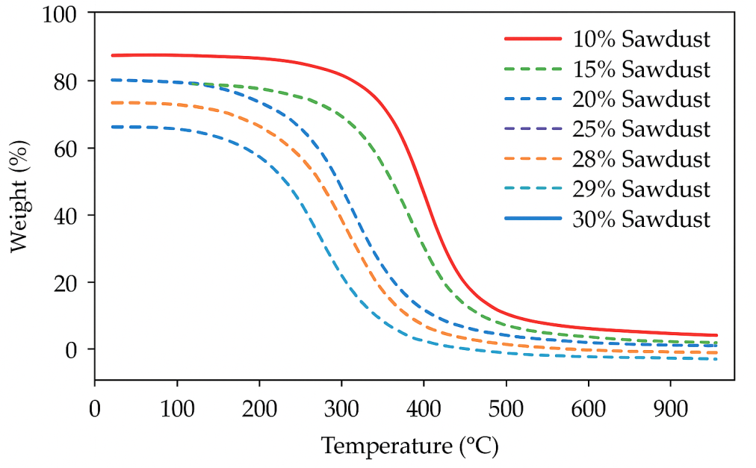
Figure 4.12: TGA of WPCs with sawdust and rPET
The TGA curve illustrates the thermal degradation of WPCs with different sawdust and rPET percentages. All samples are stable up to around 250–300°C, indicating a lack of thermal activity. This result is coherent with the thermal stability of PET and dehydration at an early stage of lignocellulosic components, as obtained by Oliveros-Gaviria et al. (2024). The main weight loss occurs between 300°C and 400°C, which agrees with the main decomposition temperature of both cellulose and lignin in sawdust. With 28–30% sawdust content, earlier and more pronounced weight loss is detected, confirming that lignocellulosic fillers have an influence on the degradation, according to obtained results by Kılıç et al. (2023) and Nuruzzaman et al. (2025).
In contrast, composites containing 10–15% sawdust evidence mass loss at somewhat later stages, corresponding to an increased concentration of rPET, which imparts thermal stability, a finding supported by the work of Burgada et al. (2021). The percentage residual mass found to be greater than 500°C is variable; the lower sawdust composites retain higher char residue levels, but this is highly reduced for those with increased sawdust, which agrees with Shafik et al. (2021), who indicated that wood-filled composites produce lower char yields, owing to the fact that all components volatilize at high temperatures.
Finally, the TGA results show that with increased sawdust, the thermal stability decreases, whereas an increased rPET and MAPE content imparts better thermal resistance. This was in agreement with the report by Wiedl et al. (2022) and (Dolca et al., 2021) on the influence of bonding at the polymer–fiber interface on improved thermal behavior. The study confirms that the balance of natural filler and polymer matrix composition is vital for the thermal stability of WPCs intended for structural and furniture applications.

4.6 Fourier-Transform Infrared Spectroscopy Analysis (FTIR) Test Result
The FTIR graph displays the characteristic absorption bands of rPET, sawdust, and the resulting wood plastic composite (WPC). The combined spectrum indicates successful incorporation of the functional groups from both materials, as well as potential interactions facilitated by processing and additives. The broad absorption band at 3330 cm⁻¹ can be ascribed to O–H stretching vibrations coming from the cellulose, hemicellulose, and lignin in the sawdust. This peak, which is normally strong in lignocellulosic materials, was recorded in the WPC spectrum with reduced intensity, suggesting that some interactions may occur between sawdust hydroxyl groups and the polymer matrix; this observation follows earlier results by Burgada et al. (2021) and Encina (2021), which showed that blending wood fibers with plastics often reduces O–H peak intensity owing to hydrogen bonding disruption.
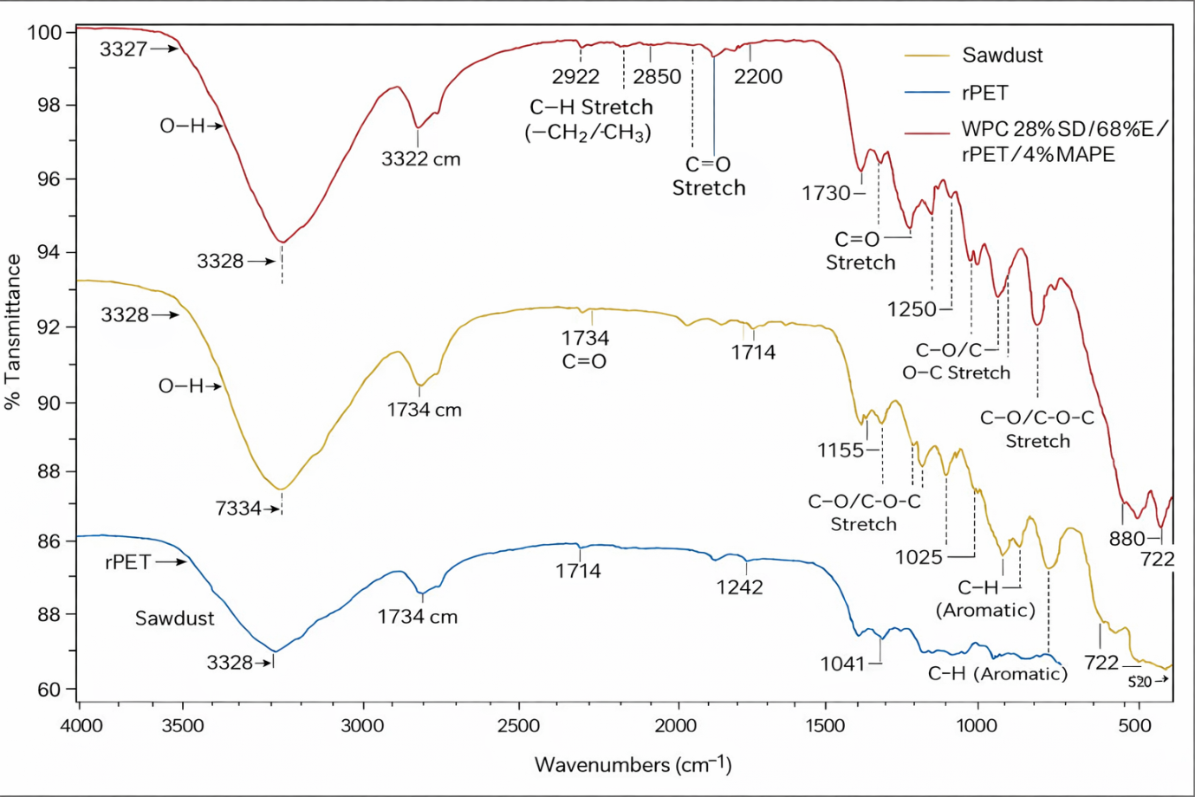
Figure 4.13: FTIR Characterization of rPET, Sawdust and WPC
Figure 4.13 shows the formation and compatibilization of the wood-plastic composite (WPC) are confirmed by FTIR analysis. The optimal composite contains 28% sawdust, 68% rPET, and 4% MAPE, showing successful combination.
The sawdust spectrum displays a broad O-H stretching peak at 3300-3330 cm⁻¹, indicating the hydrophilic nature of lignocellulose due to cellulose and hemicellulose. C=O stretching peaks around 1730 cm⁻¹ suggest hemicellulose presence; while strong C-O-C stretching peaks from polysaccharides are noted at 1000-1150 cm⁻¹. Similar observations have been reported by Bochkareva et al. (2023), who similarly identified C–H stretching bands in WPCs prepared from recycled plastics and sawdust.
The rPET spectrum reveals a C=O peak at 1714-1735 cm⁻¹ linked to the polyester ester group, with additional C-O peaks around 1240 cm⁻¹ and 1040 cm⁻¹. This has been known to be one of the diagnostic peaks, as evidenced in work such as Yamamoto et al. (2021).
The WPC spectrum incorporates peaks from both sawdust and rPET, confirming effective blending. Similar studies were confirmed by Fouladi et al. (2024). Notable peak shifts in O-H and C=O imply strong chemical interactions and interfacial bonding between the fiber's hydroxyl groups and polymer chains, as well as a decline in peak intensity of hydroxyl groups, all indicative of effective compatibilization and good chemical stability of the composite.

4.7 Comparative Analysis of WPC and MDF
The researcher compared different tested properties of WPC with the literature range of MDF that consistent with the experimental value of WPC. The comparisons were listed below in the following tables.
Comparative evaluation of the developed wood-plastic composite and the conventional medium-density fiberboard shows that there are differences in mechanical, physical, thermal, durability, and economic performance. The results show that the wood-plastic composite has advantages in structural and environmental performance, while the medium-density fiberboard has advantages in processing and finishing.
Table 4.2: Mechanical Properties Comparison (WPC vs MDF)
Properties | WPC (This Study – Typical Range) | MDF (Literature Range) | Comparative Interpretation
Tensile Strength (MPa) | 35 – 45 | 15 – 30 | WPC significantly stronger
Flexural Strength (MPa) | 60 – 75 | 25 – 50 | WPC shows higher bending resistance
Impact Strength (kJ/m²) | 5 – 7 | 2 – 4 | WPC more impact resistant
Compressive Strength (MPa) | 40 – 55 | 20 – 35 | WPC more load-bearing
Hardness | High | Moderate | WPC more durable

Table 4.2 shows how wood plastic composite (WPC) compares with medium density fiberboards (MDF) with regard to mechanical properties. It is evident that wood plastic composite is superior to MDF. Its tensile strength is found to be between 35-45 MPa, while that of MDF is found to be between 15-30 MPa. Moreover, the tensile strength of wood plastic composite is boosted by the presence of sawdust, which is strongly bonded by its recycled PET matrix. Its flexural strength is found to be around 60-75 MPa, which is superior to that of MDF, found to be around 25-50 MPa. Its impact strength is found to be twice that of MDF, and its compressive strength is superior to that of MDF. Moreover, its hardness is superior to that of MDF because of its rigid matrix.
Table 4.3: Physical Properties Comparison
Properties | WPC | MDF | Comparative Interpretation
Density (g/cm³) | 1.15 – 1.25 | 0.65 – 0.85 | MDF lighter
Water Absorption (%) | 2 – 5 | 20 – 35 | WPC highly moisture resistant
Thickness Swelling (%) | 1 – 4 | 15 – 30 | WPC dimensionally stable
Dimensional Stability | Excellent | Poor | WPC superior
Porosity | Low | High | WPC less porous
Table 4.3 shows WPC outperforming MDF in moisture resistance, as WPC only absorbs 2-5% of water, whereas MDF absorbs 20-35%. This is due to the hydrophobic PET matrix of WPC, which has low swelling when exposed to water.
Table 4.4 Thermal Properties Comparison
Properties | WPC | MDF | Interpretation
Thermal Degradation Temp (°C) | 400 – 450 | 250 – 320 | WPC more thermally stable
Heat Deflection Temperature (°C) | 70 – 90 | 50 – 60 | WPC more heat resistant
Fire Resistance | Moderate | Poor | WPC safer
Thermal Conductivity | Low | Moderate | WPC better insulator
Table 4.4 shows WPC has better thermal stability and fire resistance, as WPC can sustain temperatures of 400-450°C, whereas MDF can only sustain temperatures of 250-320°C.
Table 4.5: Durability & Environmental Performance
Properties | WPC | MDF | Conclusion
Moisture Resistance | Excellent | Poor | WPC superior
Rot Resistance | High | Low | WPC superior
Insect Resistance | High | Low | WPC superior
Service Life | 20–30 years | 10–15 years | WPC longer lasting
Maintenance | Low | High | WPC cost-effective

Table 4.5 shows WPC has better physical durability against moisture, insects, and rot, resulting in a longer life span of twice that of MDF, which has a higher chance of biological degradation.

Table 4.6: Economic & Processing Comparison
Properties | WPC | MDF | Interpretation
Production Cost | Higher | Lower | MDF cheaper initially
Machinability | Moderate | Excellent | MDF easier to cut
Surface Finish | Moderate | Excellent | MDF better aesthetics
Sustainability | Very High | Moderate | WPC eco-friendly
MDF has a lower cost of ownership initially and higher machinability, while, WPC has a longer life span, which means the overall cost of ownership of WPC is lower, as shown in Table 4.6.
From the comparative analysis of the properties of the developed WPC and MDF, it may be concluded that the newly developed composite material possesses enhanced mechanical properties, thermal stability, moisture resistance, and sustainability of the natural environment in comparison with MDF. However, MDF still holds an edge in terms of machinability, surface finish, and production costs.

4.8 Comparative Analysis with Literature
Results obtained in this study on WPCs developed from sawdust and rPET exhibit strong agreement with trends documented in other studies, with new insights suitable for the material context of Ethiopia. The mechanical properties obtained in particular-tensile, flexural, and compressive strengths-lie within the range reported by earlier studies on natural-fiber-reinforced thermoplastics. For instance, Ayana et al. (2022) observed that the increase in wood flour content in PE-based WPCs generally decreases the tensile and flexural strength owing to a reduction in polymer continuity. A similar trend was obtained in this study, as sawdust loadings greater than 25-30% weakened the cohesion between the matrix and the filler, in agreement with the observation of Fayzullin et al. (2024), where it was reported that excessive natural filler forms micro-voids and hampers polymer wettability. However, the optimum sawdust-rPET-MAPE formulations obtained in this study (around 25-28% SD with 68-73% rPET and 2-3% MAPE) revealed a mechanical performance comparable or higher than some polyethylene- or polypropylene-based systems reported by Rindayatno et al. (2023), indicating rPET as a strong and viable matrix when compatibilized properly.
TGA results also support the earlier findings. The Tonset values (310–345°C) and final char residues fit well with reported thermal behaviors from studies involving sawdust and recycled thermoplastics (Ferede et al., 2024; Wiedl et al., 2022). Similarly, the enhanced thermal stability upon moderate filler addition suggests the insulating nature of lignocellulosic fibers, in agreement with a trend by Friedrich (2021). Furthermore, the shifting endothermic and melting transitions (DSC), as identified around 247–260°C, correspond closely to the melting features of PET, as noted by Yamamoto et al. (2021). On this basis, it can be considered that the recycled polymer retained adequate crystallinity and sufficient molecular stability even after multiple processing cycles, providing support to Ramesh et al. (2022), who reported enhanced recycling performance for such situations where compatibilizers like MAPE are used.
This study further corroborates the conclusions on sustainability by Hasanin et al. (2022), Kura (2020), and Chawraba and El Mogy (2025) in terms of environmental relevance, where rPET–wood composites reduce waste, carbon footprint, and production energy notably. Locally available sawdust and community-collected PET bottles also correspond to the circular economy recommendations for Ethiopia's manufacturing sector made by Shakir and Ahmad (2024). This further supports the fact that sawdust–rPET WPCs are not only technically feasible but economically and environmentally viable materials for both the furniture and construction markets within Ethiopia.
As a conclusion, the results obtained in the present study are in agreement with previously published literature, adding new context-specific findings on optimal ratios for SD/rPET/MAPE, improved mechanical performance using rPET as the main matrix, and SEM-based validation of interfacial compatibility.

4.8 Key Findings and Discussions
The study indicates that wood-plastic composite materials made from sawdust, recycled PET, and MAPE have good binding properties and are suitable for use in home furniture. Out of all the composite mixes tested, 28% sawdust and 68% rPET with 4% MAPE have been identified as the optimal mix of all properties.
Using a factorial design and response analysis, researchers have indicated that how much sawdust and MAPE are added are significant factors in determining how well a wood-plastic composite performs. Too much of a good thing can actually have negative effects on material properties if added excessively.
In terms of material properties, it was indicated that an increase in sawdust content up to the optimum will improve tensile, flexural, impact, and compressive strengths of wood-plastic composite materials. For instance, it was indicated that the optimum mix of 28% sawdust and 68% rPET with 4% MAPE will have a tensile strength of about 37-40 MPa, flexural strength of 70-75 MPa, and impact resistance of 6 kJ/m². These properties are quite impressive and are higher than those of MDF panels. This indicates that wood-plastic composites have great promise as a material of choice.
In addition, it was indicated that an increase in sawdust content will cause a slight decrease in density of wood-plastic composite materials. This indicates that wood-plastic composite materials are lighter and stiffer and can be used in making furniture. In addition, it was indicated that water absorption and thickness swelling of wood-plastic composite panels are quite low and are suitable for use in furniture making.
The analysis confirmed that the new wood-plastic composites are appropriate in the production of furniture. Thermograms revealed that the composites can withstand up to 400-450°C, which is much higher than the temperature at which furniture is normally used. Differential scanning calorimetry analysis confirmed the stability of the glass transition and melting points of the composites. FTIR and SEM results confirmed the bonding of the fibers and the matrix, the reduction in interfacial voids, and the compatibilization of the composite mix using MAPE. Micrographs showed the uniform distribution of the sawdust in the polymer at the optimum formulation.
The study has also proved the practicality of the composite in the production of furniture parts such as tables and chairs, which have demonstrated satisfactory results in their ability to withstand pressure and maintain their shape and surface finish. Apart from the technical ability of the composite in the production of furniture, the study has also proved its environmental and economic benefits in the use of sawdust and the recycling of plastic waste. Therefore, the results have confirmed that the WPC composite is technically viable, environmentally friendly, and economically viable in the production of furniture parts in comparison to the use of wood in the production of MDF.
The better tensile, flexural, impact, and compressive strengths of WPC, which is made of sawdust and maleic anhydride bonding, set it apart from medium-density fiberboard (MDF) in a number of ways.
It is also superior in moisture resistance and dimensional stability to the soaking-up MDF. And on top of all this, WPC has superior thermal stability and fire resistance. Of course, WPC has the disadvantage of higher production costs and the need to use special machines, but it is the more durable and moisture-resistant material in furniture construction, even when the latter is cheaper and easier to work with.

CHAPTER FIVE

CONCLUSIONS AND RECOMMENDATIONS

5.1 Conclusions
This study aims to demonstrate the process of manufacturing wood-plastic composites (WPCs) for use in home furniture by utilizing sawdust as the reinforcing material, recycled PET (rPET) as the plastic component, and MAPE as the compatibilizer. The results showed the potential benefits of utilizing lignocellulosic wastes and recycled plastics to produce composites with outstanding technical, environmental, and economic benefits. An experimental design was used to obtain the optimal formulation of the WPCs containing approximately 28% sawdust, 68% rPET, and 4% MAPE. Increasing the amount of sawdust in the formulation improves the stiffness and strength of the composites but also leads to problems such as wetting and particle agglomeration.
Mechanical tests showed the outstanding technical performance of the optimized formulation of WPCs in terms of tensile, flexural, compressive, and impact properties compared to conventional MDF. The results showed the outstanding technical performance of the WPCs in terms of tensile, flexural, compressive, and impact properties compared to conventional MDF. The enhanced performance can be attributed to the efficient stress transfer due to the compatibilizer. The results also showed the low water absorption and thickness swell behavior of the WPCs, making them suitable for use in dry environments such as homes. The results showed the outstanding technical performance of the WPCs in terms of tensile, flexural, compressive, and impact properties compared to conventional MDF.
Thermal analyses showed the degradation temperatures in the range of 400-450°C, demonstrating the excellent thermal stability of the WPCs. Other analyses such as DSC, FTIR, and SEM results showed the excellent bonding behavior between the two materials and the efficient chemical compatibilization between the sawdust and the rPET. The results showed the outstanding technical performance of the WPCs in terms of tensile, flexural, compressive, and impact properties compared to conventional MDF.

5.2 Recommendations and Future Research Directions
Based on the findings of the study, a series of recommendations, both practical and scientific, can be formulated to ensure the effective development and use of wood plastic composites (WPCs) made from sawdust, recycled PET (rPET), and maleic anhydride grafted polyethylene (MAPE). The findings of the study revealed that a formulation of 28% sawdust, 68% rPET, and 4% MAPE yields the best result in terms of mechanical, heat, and bonding properties. Therefore, the said formulation must be used as the basis in the large-scale production of WPCs meant for use in home furniture.
Manufacturers must carefully control the content of sawdust, as excessive content beyond the optimal level can result in the agglomeration of fibers, which negatively impacts the mechanical properties of the WPC product.
The findings of the study also revealed the effectiveness of the use of compatibilizers such as maleic anhydride grafted polyethylene in WPCs, as these materials significantly improve the bonding efficiency of the materials used in the production of the composites.
In the future, the industrial use of WPCs can be further enhanced by exploring the use of other treatments to improve bonding efficiency, such as the use of alkali, silane coupling agents, or nano-modification techniques.
In the context of environmental sustainability, the use of recycled plastics and wood waste must be encouraged by offering incentives to the concerned sectors of society, such as the government, to reduce environmental pollution, conserve the use of wood, and promote the use of green technology in the production of WPCs.
Future studies should also investigate the behavior of WPCs over the long term in practical applications. This includes investigating the effects of creep, fatigue, weathering, and damage from UV exposure to really understand the longevity and reliability of WPCs in practical applications. There is also room to further investigate the development of fire resistance in WPCs through the incorporation of flame retardants or the development of more intelligent filler materials.
Another area to consider is the complete life cycle assessment (LCA) of WPCs in relation to existing and conventional materials such as MDF and solid wood. There is also room to further investigate the use of natural fibers such as bamboo, rice husks, and other agricultural waste to further expand the application and sustainability of WPCs. From the processing side, further investigations into the development of WPCs through more advanced processing techniques such as reactive extrusion, nano-enhanced WPCs, and 3D printing can further advance the application and development of WPCs.

Reference
Agwa, M., Youssef, S. M., Ali-Eldin, S. S., & Megahed, M. (2022). Integrated vacuum assisted resin infusion and resin transfer molding technique for manufacturing of nano-filled glass fiber reinforced epoxy composite. Journal of Industrial Textiles, 51(3_suppl), 5113S-5144S.
Aisyah, H. A., Paridah, M. T., Sapuan, S. M., Ilyas, R. A., Khalina, A., Nurazzi, N. M., Lee, S. H., & Lee, C. H. (2021). A Comprehensive Review on Advanced Sustainable Woven Natural Fibre Polymer Composites. Polymers (Basel), 13(3).
Alemu, M. Y., Yehualaw, M. D., Nebiyu, W. M., Nebebe, M. D., & Taffese, W. Z. (2025). Marble and Glass Waste Powder in Cement Mortar. Applied Sciences, 15(7), 3930.
Alrubaie, M. A. A., Lopez-Anido, R. A., & Gardner, D. J. (2020). Flexural creep behavior of high-density polyethylene lumber and wood plastic composite lumber made from thermally modified wood. Polymers, 12(2), 262.
Arulprasanna, A., & Omkumar, M. (2024). A review on composites: selection and its applications. Materials Today: Proceedings.
Ashraf, M. A., Zwawi, M., Taqi Mehran, M., Kanthasamy, R., & Bahadar, A. (2020). Jute based bio and hybrid composites and their applications. Fibers, 7(9), 77.
Ayana, K. D., De Angelis, M., Schmidt, G., Krause, A., & Ali, A. Y. (2022). Valorization of potential post-consumer polyethylene (PE) plastics waste and ethiopian indigenous highland bamboo (EHB) for wood plastic composite (WPC): Experimental evaluation and characterization. Fibers, 10(10), 85.
Ayana, K. D., Ha, C.-S., & Ali, A. Y. (2024). Comprehensive overview of wood polymer composite: Formulation and technology, properties, interphase modification, and characterization. Sustainable Materials and Technologies, 40, e00983.
Azeem, M., Ya, H. H., Alam, M. A., Kumar, M., Stabla, P., Smolnicki, M., Gemi, L., Khan, R., Ahmed, T., & Ma, Q. (2022). Application of filament winding technology in composite pressure vessels and challenges: a review. Journal of Energy Storage, 49, 103468.
Azman, M. A., Asyraf, M. R. M., Khalina, A., Petru, M., Ruzaidi, C. M., Sapuan, S. M., Wan Nik, W. B., Ishak, M. R., Ilyas, R. A., & Suriani, M. J. (2021). Natural Fiber Reinforced Composite Material for Product Design: A Short Review. Polymers (Basel), 13(12).
Barbos, J. D. V., Azevedo, J. B., Pollyana da Silva, M. C., da Costa Garcia Filho, F., & del Rio, T. G. (2020). Development and characterization of WPCs produced with high amount of wood residue. Journal of Materials Research and Technology, 9(5), 9684-9690.
Basalp, D., Tihminlioglu, F., Sofuoglu, S. C., Inal, F., & Sofuoglu, A. (2020). Utilization of Municipal Plastic and Wood Waste in Industrial Manufacturing of Wood Plastic Composites. Waste and Biomass Valorization, 11(10), 5419-5430.
Bhaskar, K., Jayabalakrishnan, D., Vinoth Kumar, M., Sendilvelan, S., & Prabhahar, M. (2021). Analysis on mechanical properties of wood plastic composite. Materials Today: Proceedings, 45, 5886-5891.
Bhong, M., Khan, T. K., Devade, K., Krishna, B. V., Sura, S., Eftikhaar, H., Thethi, H. P., & Gupta, N. (2023). Review of composite materials and applications. Materials Today: Proceedings.
Bochkareva, S., Grishaeva, N. Y., Lyukshin, B., Lyukshin, P., Matolygina, N. Y., & Panov, I. (2023). Obtaining of specified effective mechanical, thermal, and electrical characteristics of composite filled with dispersive materials. Inorganic Materials: Applied Research, 8, 651-661.
Boztoprak, Y. (2024). Physical, Mechanical, and Flammability Properties of Wood–Plastic Composites (WPC) Containing Beech-Wood Flour and Flame-Retardant Additives. Polymers, 16(20), 2944.
Burgada, F., Fages, E., Quiles-Carrillo, L., Lascano, D., Ivorra-Martinez, J., Arrieta, M. P., & Fenollar, O. (2021). Upgrading Recycled Polypropylene from Textile Wastes in Wood Plastic Composites with Short Hemp Fiber. Polymers (Basel), 13(8).
Chawraba, K., & El Mogy, S. A. (2025). Rice husk as reinforcement in wood plastic composites. In Rice Husk Biomass: Processing, Properties and Applications (pp. 181-211). Springer.
Chohan, J. S., Boparai, K. S., Singh, R., & Hashmi, M. (2022). Manufacturing techniques and applications of polymer matrix composites: a brief review. Advances in Materials and Processing Technologies, 8(1), 884-894.
Cosse, R. L. (2025). Biocomposites based on PLA and wood fibers: a study on the modification of matrix and fibers to improve the mechanical properties.
Delviawan, A., Suzuki, S., Kojima, Y., & Kobori, H. (2019). The influence of filler characteristics on the physical and mechanical properties of wood plastic composite (s). Reviews in Agricultural Science, 7, 1-9.
Dolca, C., Fages, E., Gonga, E., Garcia-Sanoguera, D., Balart, R., & Quiles-Carrillo, L. (2021). The Effect of Varying the Amount of Short Hemp Fibers on Mechanical and Thermal Properties of Wood–Plastic Composites from Biobased Polyethylene Processed by Injection Molding. Polymers, 14 & 13(1 &11).
Dunky, M. (2025). Technology of Adhesives and Wood-Based Panels. John Wiley & Sons.
Duruaku, J. I., Okoye, P. A., Onuegbu, T. U., Onwukeme, V. I., Okoye, N. H., & Nwadiogbu, J. O. (2023). Physicomechanical properties of sustainable wood plastic composites of tropical sawdust and thermoplastic waste for possible utilization in the wood industry. Journal of Sustainable Bioenergy Systems, 13(4), 149-171.
Ejigu, A. K., & Yeshitela, K. (2024). Envisioning sustainable sanitation planning: a unified approach of diffusion of innovation and theory of planned behavior in predicting ecosan toilet adoption in Arba Minch City, Ethiopia. Frontiers in Environmental Science, 12, 1371659.
Elamin, M. A. M., Li, S. X., Osman, Z. A., & Otitoju, T. A. (2020). Preparation and characterization of wood-plastic composite by utilizing a hybrid compatibilizer system. Industrial Crops and Products, 154.
Encina, C. E. (2021). Multifunctional hybrid materials from end-of-life polymers heterogeneous mixtures with organic and inorganic constituents. Thèse de doctorat. UNSW Sydney.
Fayzullin, I., Gorbachev, A., Volfson, S., Serikbayev, Y., Nakyp, A., & Akylbekov, N. (2024). Composite material based on polypropylene and modified natural fillers. Polymers, 16(12), 1703.
Felix Sahayaraj, A., M, T. S., Sasi Kumar, M., Sathish, S., Gokulkumar, S., Jenish, I., & Makeshkumar, M. (2024). Fire retardant potential of natural fiber reinforced polymer composites: a review. Polymer-Plastics Technology and Materials, 63(7), 771-797.
Ferahtia, A. (2021). Surface water quality assessment in semi-arid region (El Hodna Watershed, Algeria) based on Water Quality Index (WQI).
Ferede, E., Muhammed, A., Kassa, A., Kedir, S., Tesfaye, T., & Zerefa, W. (2024). Fabrication and characterization of recycled polyethylene terephthalate composites reinforced with sisal fibre and wood sawdust. Textile & Leather Review, 7, 493-516.
Fouladi, M., Kavousi Heidari, M., Tavakoli, O., & Hafezi, Y. (2024). Green approach for fabrication of high-quality graphene nanosheet from the waste of PET bottle plastic and wood sawdust by co-pyrolysis technology for dye adsorption from aqueous solution. Chemical Papers, 78(11), 6371-6393.
Fraser, A., & Fraser, A. (2020). Sustainability of the Supply of Timber and Non-timber Forest Products. Achieving the Sustainable Management of Forests, 93-114.
Friedrich, D. (2021). Thermoplastic moulding of Wood-Polymer Composites (WPC): A review on physical and mechanical behaviour under hot-pressing technique. Composite Structures, 262, 113649.
Friedrich, D. (2024a). Basics of Moisture Protection in Buildings in Connection with WPCs. In Applied Building Physics and Materials Science of Natural Fiber Reinforced Plastics: A Guide for Study and Practice (pp. 115-181). Springer.
Friedrich, D. (2024b). Plastic Composites in Construction. In Applied Building Physics and Materials Science of Natural Fiber Reinforced Plastics: A Guide for Study and Practice (pp. 3-59). Springer.
Gay, D. (2022). Composite materials: design and applications. CRC press.
Ghosh, A. K., Dwivedi, M., Ghosh, A. K., & Dwivedi, M. (2020). Processability in open mould processing of polymeric composites. Processability of Polymeric Composites, 179-203.
Gunwant, D. (2024). Moisture resistance treatments of natural fiber-reinforced composites: a review. Composite Interfaces, 31(8), 979-1047.
Guo, J., Zhang, Y., Fang, J., Ma, Z., Li, C., Yan, M., Qiao, N., Liu, Y., & Bian, M. (2024). Reduction and reuse of forestry and agricultural bio-waste through innovative green utilization approaches: A review. Forests, 15(8), 1372.
Hailu, T., Assefa, E., & Zeleke, T. (2023). Land use planning implementation and its effect on the ecosystem in Addis Ababa, Ethiopia. Environmental Challenges, 13, 100798.
Hall, W., Javanbakht, Z., Hall, W., & Javanbakht, Z. (2021). How to make a composite—wet layup. Design and Manufacture of Fibre-Reinforced Composites, 33-53.
Hasanin, M. S., Abd El-Aziz, M. E., El-Nagar, I., Hassan, Y. R., & Youssef, A. M. (2022). Green enhancement of wood plastic composite based on agriculture wastes compatibility via fungal enzymes. Scientific Reports, 12(1), 19197.
Hindersmann, A. (2022). Confusion about infusion: An overview of infusion processes. Composites Part A: Applied Science and Manufacturing, 126, 105583.
Ichim, M., Muresan, E. I., & Codau, E. (2024). Natural-Fiber-Reinforced Polymer Composites for Furniture Applications. Polymers, 16(22), 3113.
Jain, D. D., Tambe, S. M., & Amin, P. D. (2022). Formulation performance window for manufacturing cellulose-based sustained-release mini-matrices of highly water-soluble drug via hot-melt extrusion technology. Cellulose, 29(6), 3323-3350.
Jayakumar, A., Radoor, S., Kim, J. T., Rhim, J.-W., Parameswaranpillai, J., & Siengchin, S. (2023). Lightweight and sustainable materials—a global scenario. In Lightweight and Sustainable Composite Materials (pp. 1-18). Elsevier.
Jeong, E., Kim, Y., Hong, S., Yoon, K., & Lee, S. (2022). Innovative injection molding process for the fabrication of woven fabric reinforced thermoplastic composites. Polymers, 14(8), 1577.
Jian, B., Mohrmann, S., Li, H., Li, Y., Ashraf, M., Zhou, J., & Zheng, X. (2022). A review on flexural properties of wood-plastic composites. Polymers, 14(19), 3942.
Johnson, V. G. (2023). Transitioning Second-Hand Stores: The Impact of Technology and Innovative Application on Sustainable Fashion
Kangishwar, S., Radhika, N., Sheik, A. A., Chavali, A., & Hariharan, S. (2023). A comprehensive review on polymer matrix composites: material selection, fabrication, and application. Polymer Bulletin, 80(1), 47-87.
Karaş, B., Smith, P. J., Fairclough, J. P. A., & Mumtaz, K. (2022). Additive manufacturing of high density carbon fibre reinforced polymer composites. Additive Manufacturing, 58, 103044.
Kashfipour, M. A., Mehra, N., & Zhu, J. (2018). A review on the role of interface in mechanical, thermal, and electrical properties of polymer composites. Advanced Composites and Hybrid Materials, 1, 415-439.
Khosravani, M. R., & Nasiri, S. (2020). Injection molding manufacturing process: Review of case-based reasoning applications. Journal of Intelligent Manufacturing, 31, 847-864.
Kılıç, İ., Avcı, B., Atar, İ., Korkmaz, N., Yılmaz, G., & Mengeloğlu, F. (2023). Using Furniture Factory Waste Sawdust in Wood-plastic Composite Production and Prototype Sample Production. BioResources, 18(4).
Korol, J., Hejna, A., Burchart-Korol, D., & Wachowicz, J. (2020). Comparative analysis of carbon, ecological, and water footprints of polypropylene-based composites filled with cotton, jute and kenaf fibers. Materials, 13(16), 3541.
Kumar, A., & Bedi, R. (2025). Mechanical and durability properties of sustainable composites derived from recycled polyethylene terephthalate and enhanced with natural fibers: a comprehensive review. Mater Phys Mech, 53(1), 117-142.
Kumar, A., Dixit, S., Singh, S., Sreenivasa, S., Bains, P. S., & Sharma, R. (2025). Recent developments in the mechanical properties and recycling of fiber‐reinforced polymer composites. Polymer Composites, 46(5), 3883-3908.
Kura, D. W. (2020). Prospective utilization of wood waste from wood-based industries in Ethiopia. Synthesis. Journal of Resources Development and Management, 71, 26-34.
Lee, C., Sapuan, S., Ilyas, R., Lee, S., & Khalina, A. (2020). Development and processing of PLA, PHA, and other biopolymers. In Advanced processing, properties, and applications of starch and other bio-based polymers (pp. 47-63). Elsevier.
Li, C., Du, Q., Ru, Y., Zhang, H., An, Y., Liu, J., Wu, D., Gao, D., & Sun, J. (2022). Preparation of polypropylene-based thermally conductive composites via multiple injection compression molding method. Composites Communications, 35, 101331.
Liu, X., Wu, Q., Su, S., & Wang, Y. (2022). Evaluation and prediction of material fatigue characteristics under impact loads: review and prospects. International Journal of Structural Integrity, 13(2), 251-277.
Loitareng’an, P. C. (2023). Coping Strategies Adopted by Kenyan Women Parliamentarians in Performance of Their Legislative Mandate University of Nairobi].
Ma, W., & Elkin, R. (2022). Sandwich structural composites: theory and practice. CRC Press.
Marin, D., Chiarello, L. M., Wiggers, V. R., Oliveira, A. D. d., & Botton, V. (2023). Effect of coupling agents on properties of vegetable fiber polymeric composites. Polímeros, 33(1), e20230012.
Matar, M. S. (2022). Investigating the impact and mechanical properties of reclaimed rubber and sawdust composite
Meekum, U. (2024). Manufacturing of wood plastic composite from polyethylene/poly (ethylene terephthalate) waste/ultra high molecular weight polyethylene blends and rice husk fiber: Effect of blends ratio and peroxide/silane crosslink system. Journal of Thermoplastic Composite Materials, 37(1), 28-65.
Migneault, S., Koubaa, A., Erchiqui, F., Chaala, A., Englund, K., & Wolcott, M. P. . (2024). Effects of processing method and fiber size on the structure and properties of wood–plastic composites. Composites Part A: Applied Science and Manufacturing, . 1(40), 80-85.
Minchenkov, K., Vedernikov, A., Safonov, A., & Akhatov, I. (2021). Thermoplastic pultrusion: A review. Polymers, 13(2), 180.
Miranda Campos, B., Bourbigot, S., Fontaine, G., & Bonnet, F. (2022). Thermoplastic matrix‐based composites produced by resin transfer molding: A review. Polymer Composites, 43(5), 2485-2506.
Mitaľová, Z., Mitaľ, D., & Berladir, K. (2024). A concise review of the components and properties of wood–plastic composites. Polymers, 16(11), 1556.
Mohammed, A. S., & Meincken, M. (2023). Thermal and acoustic insulation properties of wood plastic composites (WPCs) for interior housing applications. European Journal of Wood and Wood Products, 81(2), 421-437.
Mohan, R. G., Santhosh, K., Iyer, R. V., John, L. K., & Ramu, M. (2021). Comparitive analysis of mechanical properties of FDM printed parts based on raster angles. Materials Today: Proceedings, 47, 4730-4734.
Mokhena, T., Sadiku, E., Mochane, M., & Ray, S. (2021). Mechanical properties of fire retardant wood-plastic composites: A review. eXPRESS Polymer Letters, 15(8).
Morcillo, M. d. C., Tejada, R., Lascano, D., Garcia-Garcia, D., & Garcia-Sanoguera, D. (2021). Manufacturing and Characterization of Environmentally Friendly Wood Plastic Composites Using Pinecone as a Filler into a Bio-Based High-Density Polyethylene Matrix. Polymers, 13(24).
Mylsamy, B., Shanmugam, S. K. M., Aruchamy, K., Palanisamy, S., Nagarajan, R., & Ayrilmis, N. (2024). A review on natural fiber composites: Polymer matrices, fiber surface treatments, fabrication methods, properties, and applications. Polymer Engineering & Science, 64(6), 2345-2373.
Nečasová, B., Liška, P., Kelar, J., & Šlanhof, J. (2019). Comparison of adhesive properties of polyurethane adhesive system and wood-plastic composites with different polymers after mechanical, chemical and physical surface treatment. Polymers, 11(3), 397.
Nechifor, M., Tanasă, F., Teacă, C.-A., & Şulea, D. (2022). Maleated coupling agents for the surface treatment of natural fibers. Surface treatment methods of natural fibres and their effects on biocomposites, 95-123.
Ngo, T.-D. (2020). Introduction to composite materials. Composite and Nanocomposite Materials—From Knowledge to Industrial Applications.
Ntziouni, A., Thomson, J., Xiarchos, I., Li, X., Bañares, M. A., Charitidis, C., Portela, R., & Lozano Diz, E. (2022). Review of existing standards, guides, and practices for Raman spectroscopy. Applied Spectroscopy, 76(7), 747-772.
Nukala, S. G., Kong, I., Kakarla, A. B., Kong, W., & Kong, W. (2022). Development of Wood Polymer Composites from Recycled Wood and Plastic Waste: Thermal and Mechanical Properties. Journal of Composites Science, 6(7).
Nuruzzaman, M., Shathi, A. S., Yousuf, A., Islam, M. J., Rana, M. S., Alam, M. S., Biswas, P. K., Rahman, M. A., & Mondal, M. I. H. (2025). Composite materials from waste plastics: A sustainable approach for waste management and resource utilization. Polymers and Polymer Composites, 33, 09673911251318542.
Obianyo, I. I. (2020). Valorization of Agro-Waste for Mechanical Properties’ Improvement of Lateritic Soil for Sustainable Construction AUST].
Ohijeagbon, I. O., Adeleke, A. A., Mustapha, V. T., Olorunmaiye, J. A., Okokpujie, I. P., & Ikubanni, P. P. (2020). Development and characterization of wood-polypropylene plastic-cement composite board. Case Studies in Construction Materials, 13.
Oliveros-Gaviria, C., Cumbalaza, E., Mina-Hernandez, J. H., Valencia-Zapata, M. E., Suarez-Bonilla, J. N., & Martinez-Mera, N. (2024). Wood plastic composite based on recycled high-density polyethylene and wood waste (sawdust). Polymers, 16(22), 3136.
Otieno, M. O. (2020). Factors Affecting Performance and Functionality of Rural Market Centers in Central Alego Ward, Siaya County-Kenya-a Study of Boro, Ndere and Ratuoro Markets University of Nairobi].
Pacheco, A., Evangelista-Osorio, A., Muchaypiña-Flores, K. G., Marzano-Barreda, L. A., Paredes-Concepción, P., Palacin-Baldeón, H., Dos Santos, M. S. N., Tres, M. V., Zabot, G. L., & Olivera-Montenegro, L. (2023). Polymeric materials obtained by extrusion and injection molding from lignocellulosic agroindustrial biomass. Polymers, 15(20), 4046.
Patpatiya, P., Chaudhary, K., Shastri, A., & Sharma, S. (2022). A review on polyjet 3D printing of polymers and multi-material structures. Proceedings of the Institution of Mechanical Engineers, Part C: Journal of Mechanical Engineering Science, 236(14), 7899-7926.
Patti, A., Cicala, G., & Acierno, D. (2020). Eco-Sustainability of the Textile Production: Waste Recovery and Current Recycling in the Composites World. Polymers (Basel), 13(1).
Rabbi, M., Islam, T., & Islam, G. S. (2021). Injection-molded natural fiber-reinforced polymer composites–a review. International Journal of Mechanical and Materials Engineering, 16, 1-21.
Radoor, S., Karayil, J., Shivanna, J. M., & Siengchin, S. (2021). Water absorption and swelling behaviour of wood plastic composites. In Wood Polymer Composites: Recent Advancements and Applications (pp. 195-212). Springer.
Rahman, A., & Khondoker, M. A. H. (2024). Effect of Treatment Methods on Material Properties and Performance of Sawdust-Concrete and Sawdust-Polymer Composites. Polymers, 16(23), 3289.
Raj, S. S., Kuzmin, A., Subramanian, K., Sathiamoorthyi, S., & Kandasamy, K. T. (2021). Philosophy of selecting ASTM standards for mechanical characterization of polymers and polymer composites. Materiale Plastice, 58(3), 247-256.
Rajak, D. K., Wagh, P. H., & Linul, E. (2021). Manufacturing technologies of carbon/glass fiber-reinforced polymer composites and their properties: A review. Polymers, 13(21), 3721.
Rajeshkumar, G., Balaji, B. A., & Seshadri, S. A. (2023). Compression and injection molding techniques. In Cellulose Fibre Reinforced Composites (pp. 165-181). Elsevier.
Ramachandran, A., Mavinkere Rangappa, S., Kushvaha, V., Khan, A., Seingchin, S., & Dhakal, H. N. (2022). Modification of fibers and matrices in natural fiber reinforced polymer composites: a comprehensive review. Macromolecular rapid communications, 43(17), 2100862.
Ramesh, M., Rajeshkumar, L., Sasikala, G., Balaji, D., Saravanakumar, A., Bhuvaneswari, V., & Bhoopathi, R. (2022). A critical review on wood-based polymer composites: Processing, properties, and prospects. Polymers, 14(3), 589.
Ramli, R. A. (2024). A comprehensive review on utilization of waste materials in wood plastic composite. Materials Today Sustainability, 100889.
Renner, J. S., Mensah, R. A., Jiang, L., Xu, Q., Das, O., & Berto, F. (2021). Fire Behavior of Wood-Based Composite Materials. Polymers (Basel), 13(24).
Ribeiro, L. S., Stolz, C. M., Amario, M., Silva, A. L. N. d., & Haddad, A. N. (2023). Use of post-consumer plastics in the production of wood-plastic composites for building components: a systematic review. Energies, 16(18), 6549.
Rindayatno, Davidson, J., & Dayadi, I. (2023). Improved Quality of Wood Plastic Composite (WPC) Through the Addition of Maleic Anhydride (MAH). IOP Conference Series: Earth and Environmental Science, 1282, 012034.
Robert, U. W., Etuk, S. E., Agbasi, O. E., & Ambrose, P. D. (2024). Development of lightweight sawdust-based composite panels for building purposes. International Journal of Lightweight Materials and Manufacture, 7(5), 631-640.
Roman, K., Grzegorzewska, E., Fedorowicz, K., & Michalczewski, J. (2024). Evaluation of Mechanical Energy Consumption in WPC Production from Pine (Pinus sylvestris) and Hemp (Cannabis sativa L.) with ABS Thermoplastic Additions. Materials, 17(21), 5177.
Schwarzkopf, M. J., & Burnard, M. D. (2023). Wood-Plastic Composites—Performance and Environmental Impacts. In Environmental Impacts of Traditional and Innovative Forest-based Bioproducts 2(1), 19-43.
Serra, A., Serra-Parareda, F., Vilaseca, F., Delgado-Aguilar, M., Espinach, F. X., & Tarres, Q. (2021). Exploring the Potential of Cotton Industry Byproducts in the Plastic Composite Sector: Macro and Micromechanics Study of the Flexural Modulus. Materials (Basel), 14(17).
Shafik, E. S., Tawfic, M. L., & Younan, A. F. (2021). Mechanical, morphological, flamability and thermal properties of artificial wood plastic. Pigment & Resin Technology, 50(3), 204-211.
Shahani, S., Gao, Z., Qaisrani, M. A., Ahmed, N., Yaqoob, H., Khoshnaw, F., & Sher, F. (2021). Preparation and Characterisation of Sustainable Wood Plastic Composites Extracted from Municipal Solid Waste. Polymers (Basel), 13(21).
Shakir, M. A., & Ahmad, M. I. (2024). Bioproduct advances: insight into failure factors in mycelium composite fabrication. Biofuels, Bioproducts and Biorefining.
Showaib, E., & ELDeeb, I. (2025). Sustainable Clay Brick Manufacturing: A Review of Mechanical Properties, Firing Technologies, Emissions, and Control Strategies.
Sikhosana, T. S., Malebo, N. J., Mofokeng, T. G., Motloung, M. P., & Mochane, M. J. (2025). Sawdust as a Byproduct of Wood Processing: Properties, Applications and a Reinforcing Filler in Hybrid Polymer Composites. Polymers, 17(11), 1523.
Singh, A. K., Bedi, R., & Kaith, B. S. (2021). Composite materials based on recycled polyethylene terephthalate and their properties–A comprehensive review. Composites Part B: Engineering, 219, 108928.
Singh, L., Singh, B., & Saxena, K. K. (2020). Manufacturing techniques for metal matrix composites (MMC): an overview. Advances in Materials and Processing Technologies, 6(2), 441-457.
Somireddy, M., & Czekanski, A. (2020). Anisotropic material behavior of 3D printed composite structures–Material extrusion additive manufacturing. Materials & Design, 195, 108953.
Sousa, A. F., Patrício, R., Terzopoulou, Z., Bikiaris, D. N., Stern, T., Wenger, J., Loos, K., Lotti, N., Siracusa, V., & Szymczyk, A. (2021). Recommendations for replacing PET on packaging, fiber, and film materials with biobased counterparts. Green Chemistry, 23(22), 8795-8820.
Sumithra, G., Reddy, R. N., Kumar, G. D., Ojha, S., Jayachandra, G., & Raghavendra, G. (2023). Review on composite classification, manufacturing, and applications. Materials Today: Proceedings.
Tatara, R. A. (2024). Compression molding. In Applied plastics engineering handbook (pp. 389-424). Elsevier.
Taufiq, M. J., Mansor, M. R., & Mustafa, Z. (2021). Characterisation of wood plastic composite manufactured from kenaf fibre reinforced recycled-unused plastic blend. Composite Structures. 189(2), 510-515.
Teacă, C.-A., Shahzad, A., Duceac, I. A., & Tanasă, F. (2023). The Re-/Up-Cycling of Wood Waste in Wood–Polymer Composites (WPCs) for Common Applications. Polymers, 15(16), 3467.
Tilahun, D., Gashu, K., & Shiferaw, G. T. (2022). Effects of agricultural land and urban expansion on peri-urban forest degradation and implications on sustainable environmental management in southern Ethiopia. Sustainability, 14(24), 16527.
Tiruneh, K. Y. (2021). Impacts of industrial parks on their employees environmental quality of life: A case of Bole Lemi I Industrial Park and Eastern Industry Zone University of Twente].
Turaka, S., Jagannati, V., Pappula, B., & Makgato, S. (2024). Impact of infill density on morphology and mechanical properties of 3D printed ABS/CF-ABS composites using design of experiments. Heliyon, 10(9).
Wang, J., Mao, Q., Jiang, N., & Chen, J. (2021). Effects of injection molding parameters on properties of insert-injection molded polypropylene single-polymer composites. Polymers, 14(1), 23.
Wei, Y., Xu, C., He, G., Hua, R., Xie, Z., Liu, D., Li, X., Zhang, R., Tang, H., & Li, J. (2022). Influence of structural and chemical environmental factors on electrochemical hydrogen storage in carbon materials. Electrochimica Acta, 433, 141223.
Weldetsadik, E. B., & Hirbaye, C. B. (2022). Access to low-cost house by optimizing local building materials in Mekelle City, Northern Ethiopia. Journal of Building Pathology and Rehabilitation, 7(1), 88.
Wiedl, S., Karlinger, P., Schemme, M., List, M., & Ruckdäschel, H. (2022). Comparison of Melting Processes for WPC and the Resulting Differences in Thermal Damage, Emissions and Mechanics. Materials, 15(9), 3393.
Xu, H., Yang, Y., Li, L., Liu, B., Fu, X., Yang, X., & Cao, Y. (2023). Mechanical Properties Variation in Wood—Plastic Composites with a Mixed Wood Fiber Size. Materials, 16(17), 5801.
Xu, K., Du, G., & Wang, S. (2021). Wood plastic composites: their properties and applications. Engineered Wood Products for Construction, 197-221.
Yamamoto, Y., Hoshina, H., & Sato, H. (2021). Differences in intermolecular interactions and flexibility between poly (ethylene terephthalate) and poly (butylene terephthalate) studied by far-infrared/terahertz and low-frequency Raman spectroscopy. Macromolecules, 54(2), 1052-1062.
Yeshiwas, T. A., Yigezu, B. S., & Desalegn, Y. M. (2024). Investigation on the mechanical properties of wood-plastic composites for the application of ceiling panels. Materials Research Express, 11(8), 085304.
Youssef, P., Zahran, K., Nassar, K., Darwish, M., & El Haggar, S. (2019). Manufacturing of Wood–Plastic Composite Boards and Their Mechanical and Structural Characteristics. Journal of Materials in Civil Engineering, 31(10).
Zeng, Z., Zhou, Y., Wen, S., & Zhou, C. (2024). A review: additive manufacturing of wood-plastic composites. Cellulose, 31(9), 5315-5341.
Zhang, X., Huang, X., Liu, B., Jiang, S., & Ren, S. (2023). Effect of Mold Flow Channel Parameters on Gas-Assisted Extrusion of Medical Microtubules. Processes, 11(7), 1973.

Appendixes
Summary of test results
Table 4.1: Test result of WPC samples in variety ratio
Proportion of SD/rPET/ MAPE  (%) | Tensile (MPa) | Flexural (MPa) | Impact (kJ/m²) | Compressive (MPa) | TGA Tonset (°C) | DSC Tm (°C) | Density (g·cm⁻³) | Water absorption (7 d %) | Thickness swelling (7 d %)
10/88/2 | 44.0 | 60.0 | 7.20 | 48.0 | 385 | 256.0 | 1.33 | 0.50 | 0.60
15/83/2 | 41.0 | 64.0 | 6.80 | 50.0 | 382 | 255.8 | 1.30 | 0.90 | 1.00
20/78/2/ | 38.0 | 68.0 | 6.20 | 52.0 | 378 | 255.5 | 1.27 | 1.40 | 1.60
25/73/2 | 36.0 | 71.0 | 5.60 | 54.0 | 372 | 255.2 | 1.24 | 2.00 | 2.20
28/68/4 | 37.5 | 73.0 | 5.90 | 56.0 | 374 | 255.6 | 1.22 | 1.60 | 1.80
29/68/3 | 36.8 | 72.0 | 5.80 | 55.0 | 373 | 255.4 | 1.21 | 1.80 | 1.90
30/68/2 | 35.5 | 70.0 | 5.40 | 53.0 | 370 | 255.1 | 1.20 | 2.30 | 2.50
30/67/3 | 36.2 | 71.0 | 5.60 | 54.0 | 372 | 255.3 | 1.19 | 1.90 | 2.00

